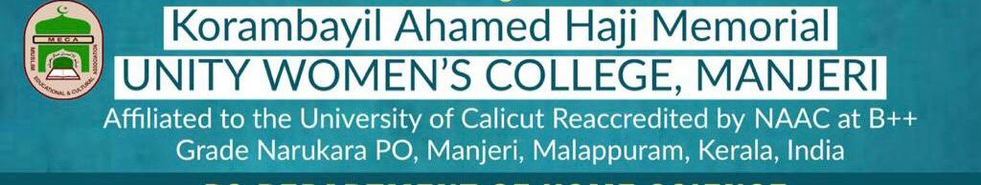
DEPARTMENT OF MATHEMATICS
Report of Activities of the Year 2021-22
Faculty Members:
Sl No. | Name | Designation
1 | Abdul Rof V | Assistant Professor & Head
2 | Ashitha PA | Assistant Professor
3 | Dr. Bajeel PN | Assistant Professor
4 | Fathima Thenci | Assistant Professor on contract (Statistics)
5 | Hafeefa O | Assistant Professor on contract(Mathematics)

- Workshop on Basic Logic and Number Theory:
Department organized a 3-day inter-collegiate on Basic Logic and Number Theory for weaker students of BSc Mathematics to prepare them for University Examinations. Fathima Parveen, Swathi VV (Research Scholars, NIT Calicut) and KKM Hussain (HSST, Govt. Higher Secondary School, Cheruvanchery) were the resource persons.50 students from various colleges attended the workshop.

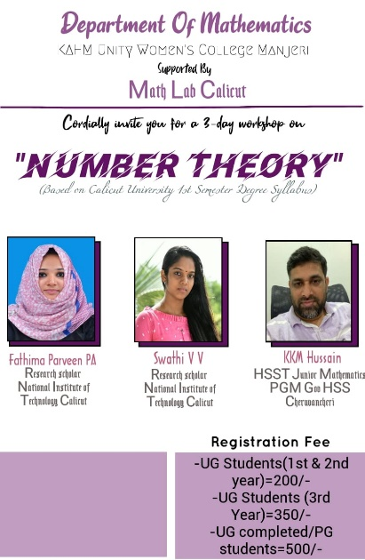

- Experiential Learning Workshop on Differential and Integral Calculus:
Department organized a 2-day experiential learning workshop to illustrate the applications of derivatives and integrals. Mr. Sirajudheen MP (Head, Department of Mathematics, Sir Syed College, Talipparamba) and Nizamudheen V(Research Scholar, Farook College, Kozhikkode) were the resource persons. About 80 students from various colleges attended the workshop
.

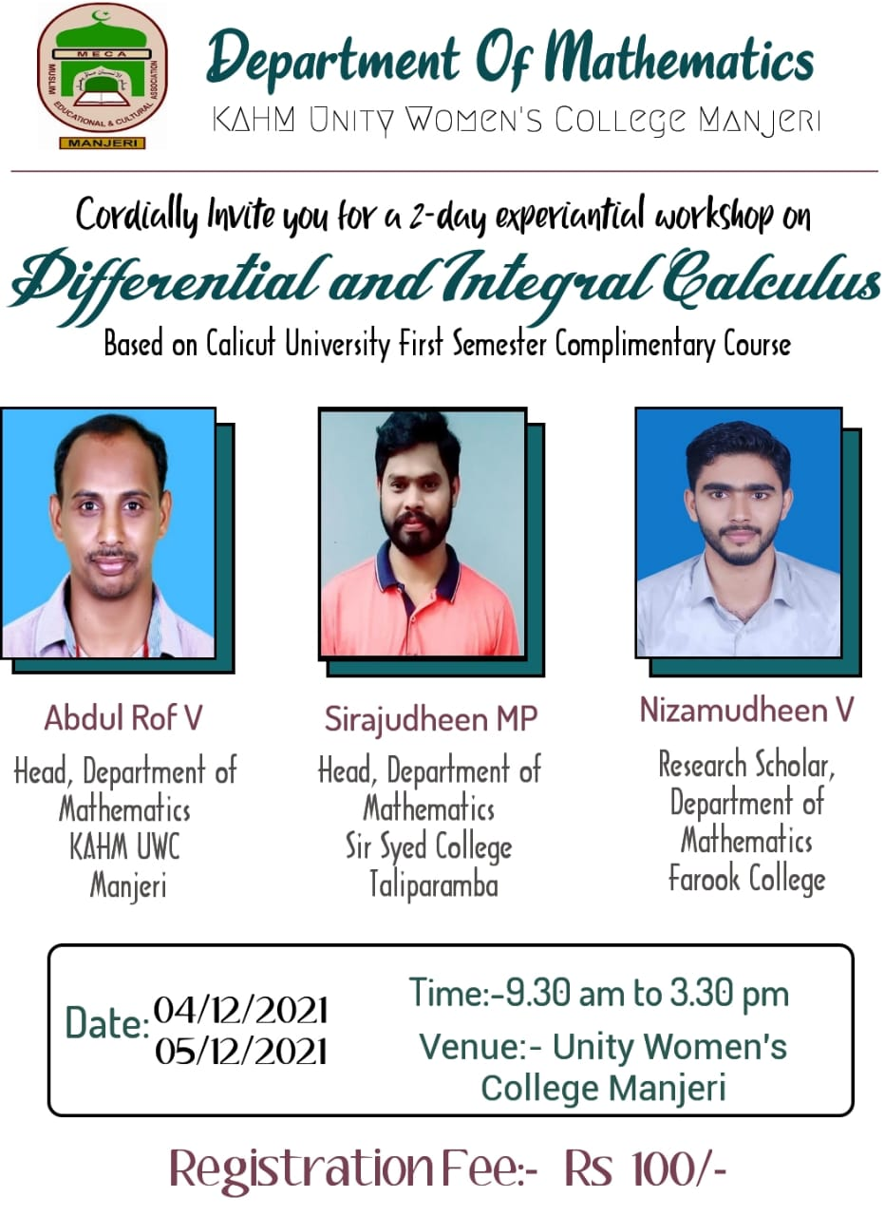
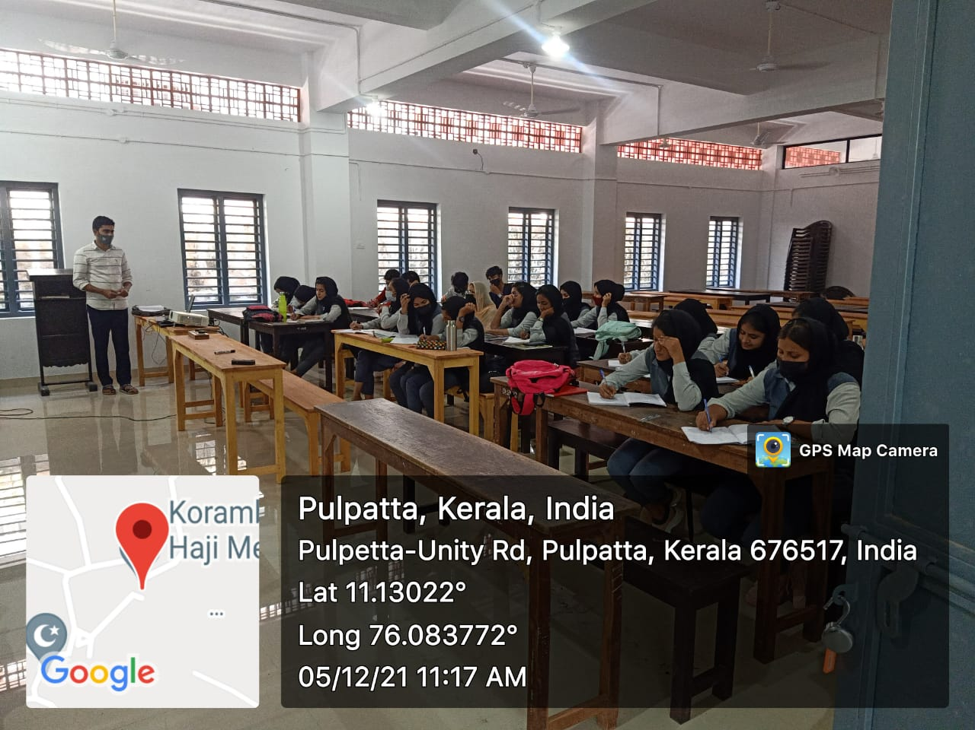

- Orientation Programme on Career Based Government Competitive Exams
An orientation programme was conducted for BSc Mathematics students based on Kerala PSC, SSC and UPSC examinations on 03/12/2022, to motivate them for govt jobs. Dr. Haris PG, Department of Physics, Sir Syed College Talipparamba was the resource person.
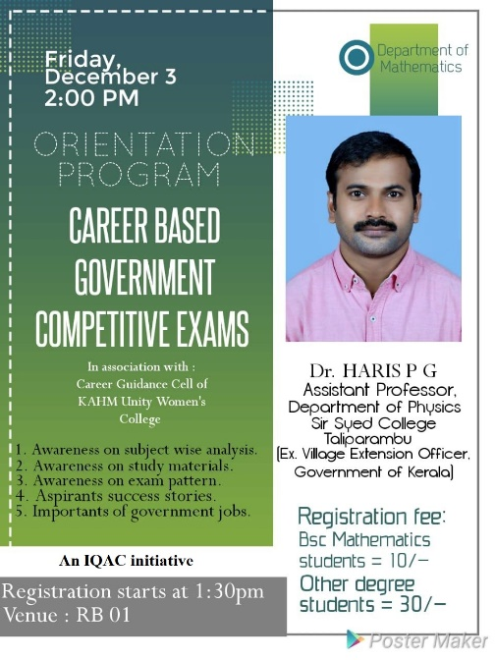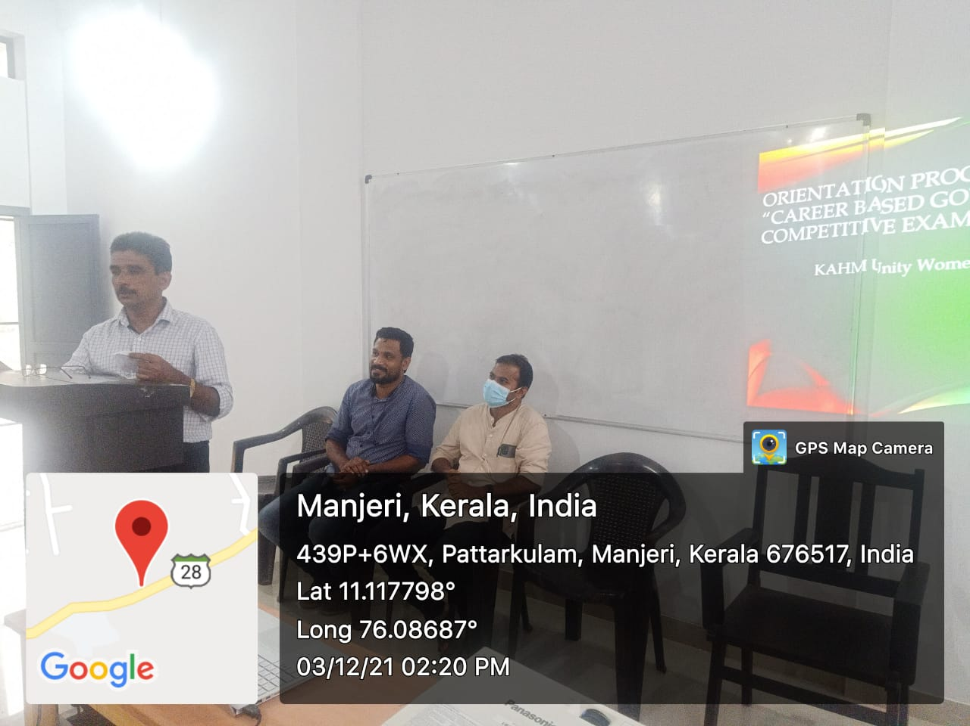
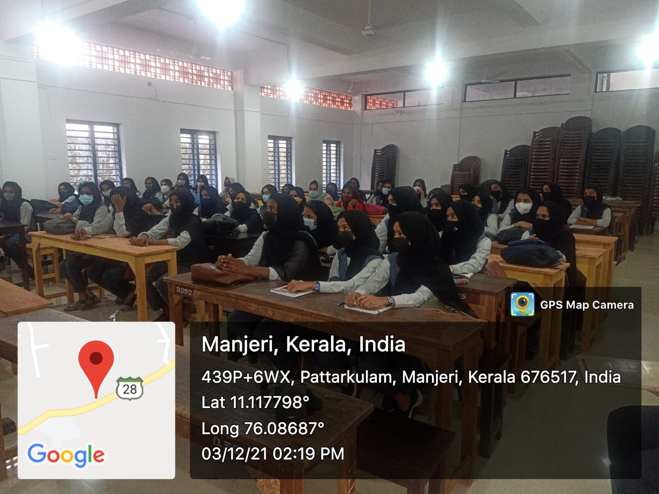

- One-week National Mathematics Day Celebration
Department organized one-week long celebration in connection with National Mathematics Day 2021.
- Explore Mathematical Science

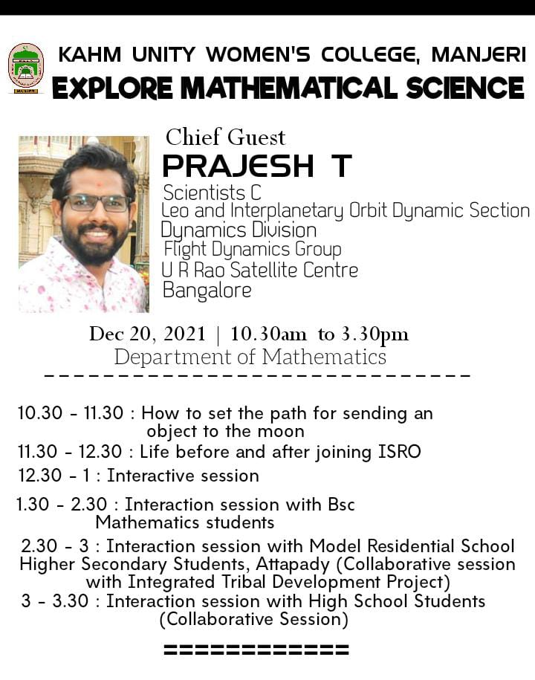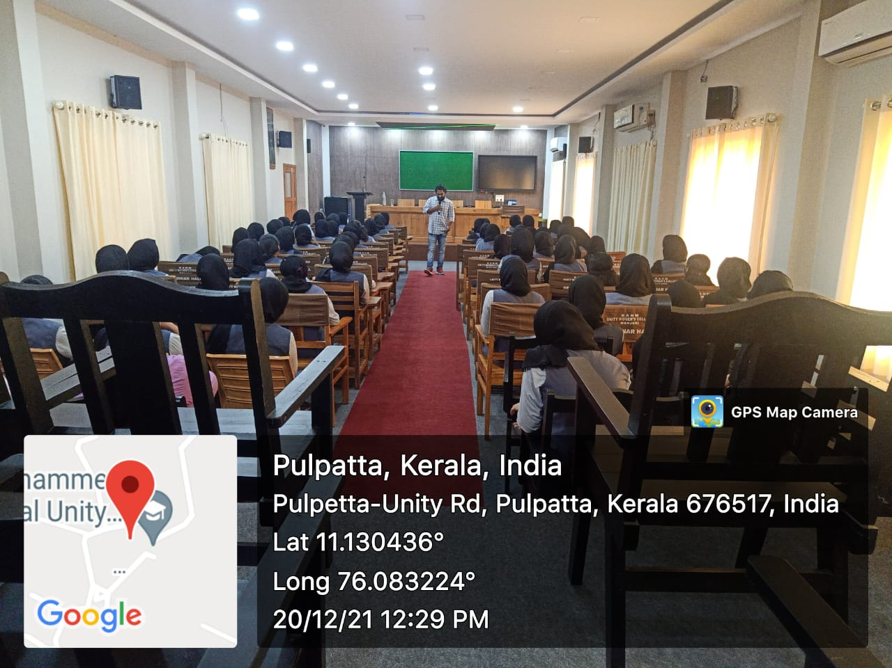

- Audio recording competition:
A competition was held among the students to narrate the biography of the legendary mathematician Srinivasa Ramanujan and the topper was given the chance to present the same in the Yuvavani Programme of All India Radio Manjeri FM.
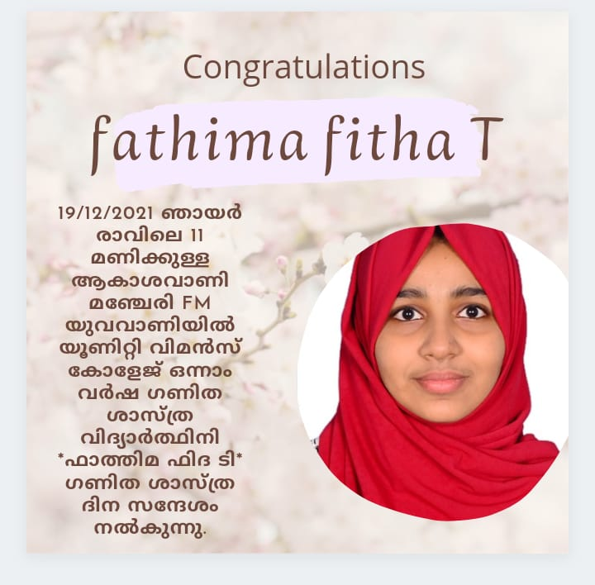
- Honouring ceremony of retired Mathematics Teachers:
Department honoured Prof. K.M. Jamaludhin(Retired Head, Department of Mathematics, DGMMES Mampad College) and Dr. V. Rajendran( Retired Head, Department of Mathematics, PSMO College, Tirurangadi) on 22nd December 2021.
- Torus Math Exhibition:
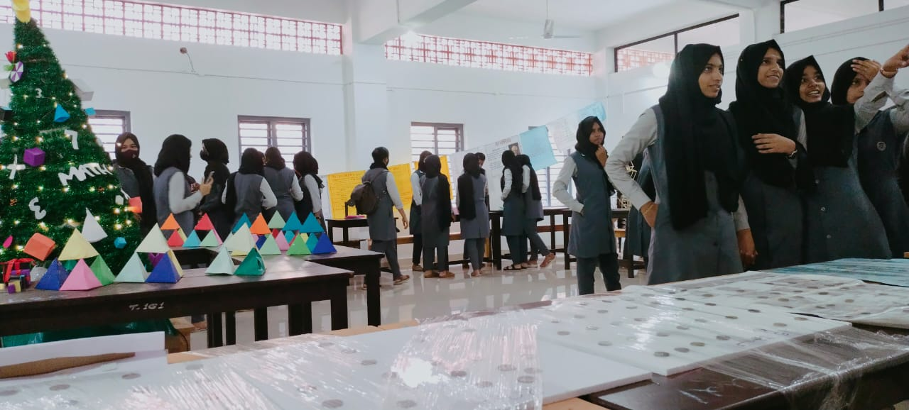
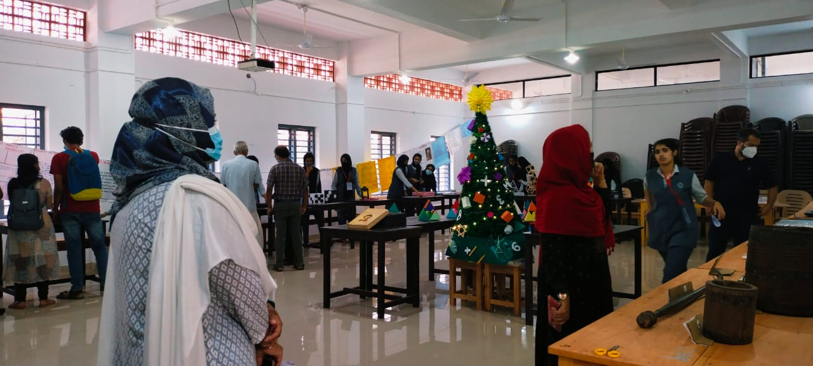

- Geometric Chart and Number Chart Competition for High School Students:
As the extension activity of the Department, inter school competitions were conducted for geometric chart preparation and number chart preparation. Winners were awarded the cash prizes.
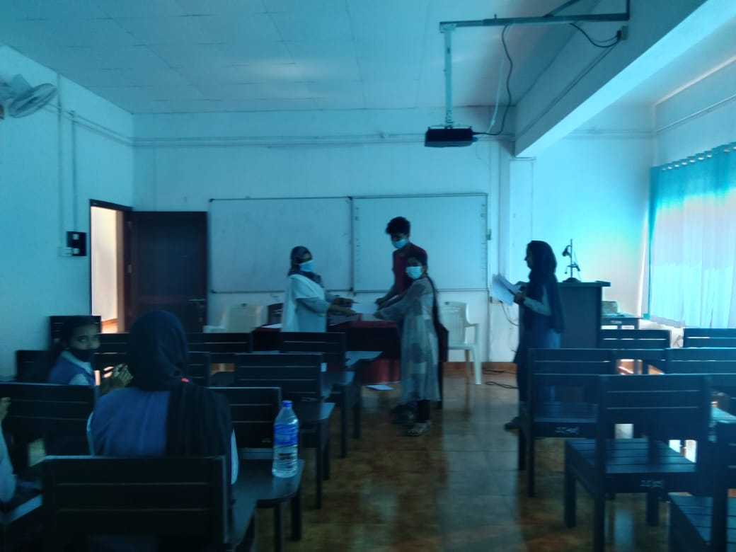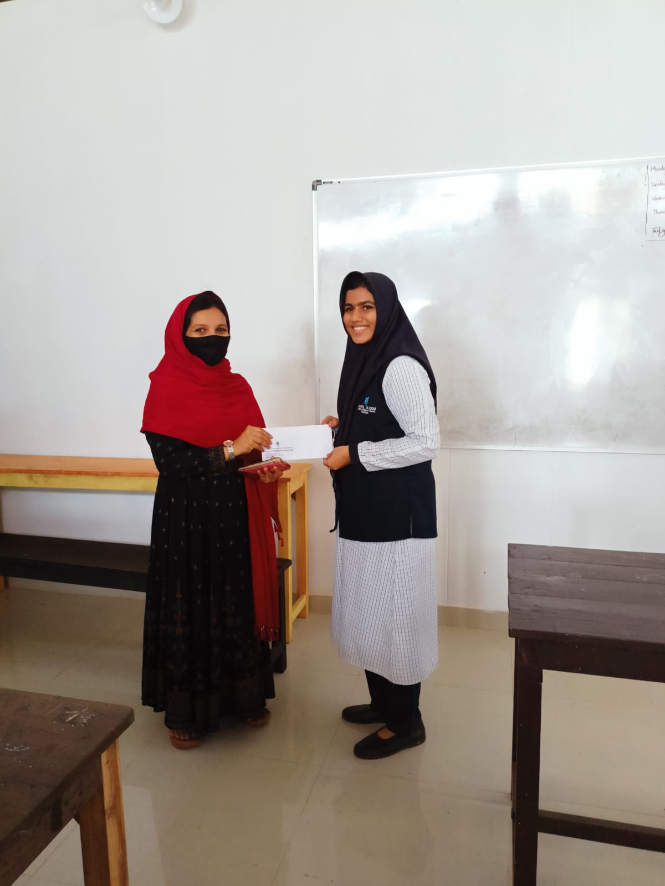

- Me and Mathematics: A session was organized on 21st December 2021 to share the experiences of teachers with mathematics. Students got a chance to hear the role of mathematics in the studies and career of the teachers in various disciplines.
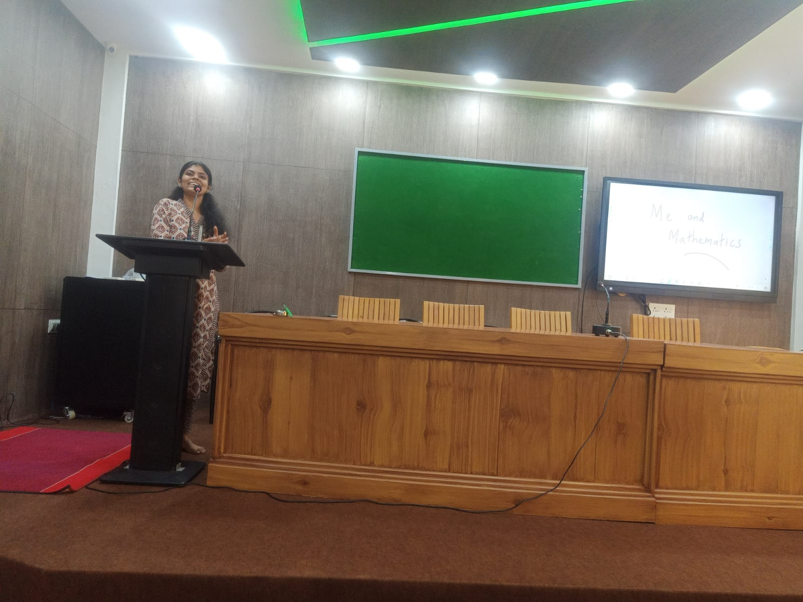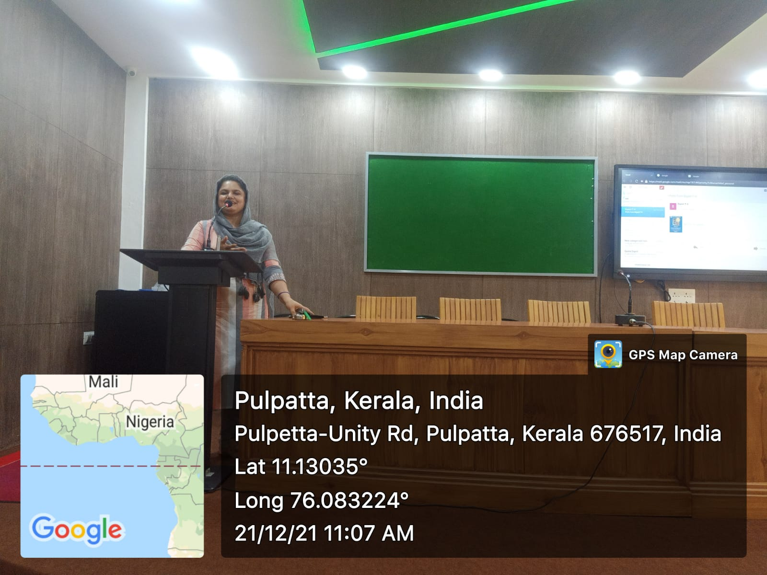
- Screening of the Movie The Man Who Knew Infinity
The movie aboutSrinivasa Ramanujan ‘The Man Who Knew Infinity’ was screened as a part of National Manhematics Day Celebration on 23rd December 2022.
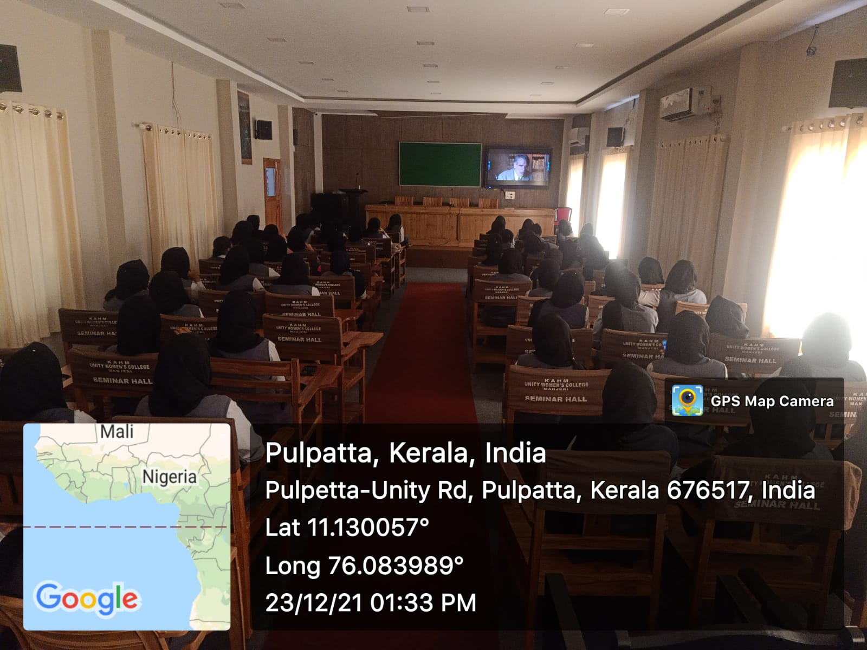
- Nature Camp ‘Making Sense of the Nature Through Mathematical Understanding’ at Wayanad
Department organized a two day nature camp on 27th and 28th December 2021at Black Eagles Camp Chembra entitled ‘Making Sense of the Nature Through Mathematical Understanding’ as an initiative of experiential learning and to enable the students appreciate the mathematics in nature. An online session on Mathematics in nature was conducted in the camp followed by a walk through the forest to identify mathematical patterns in the nature. An online session on the topic ‘Mathematics in Nature’ was presented by Dr. Sunil Mathew, NIT Calicut. Dr. Shahida. A.T(Assistant Professor DGM MES Mampad College) and Dr. Babitha Shibin attended the camp and a panel discussion was held on the topic ‘Genesis of a natural water flow; A mathematical outlook’ .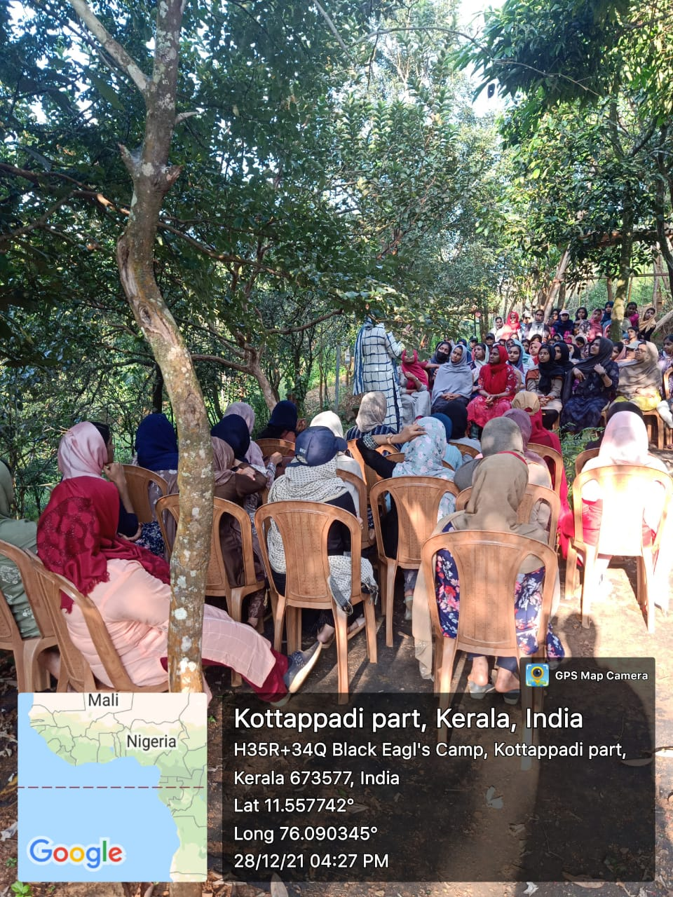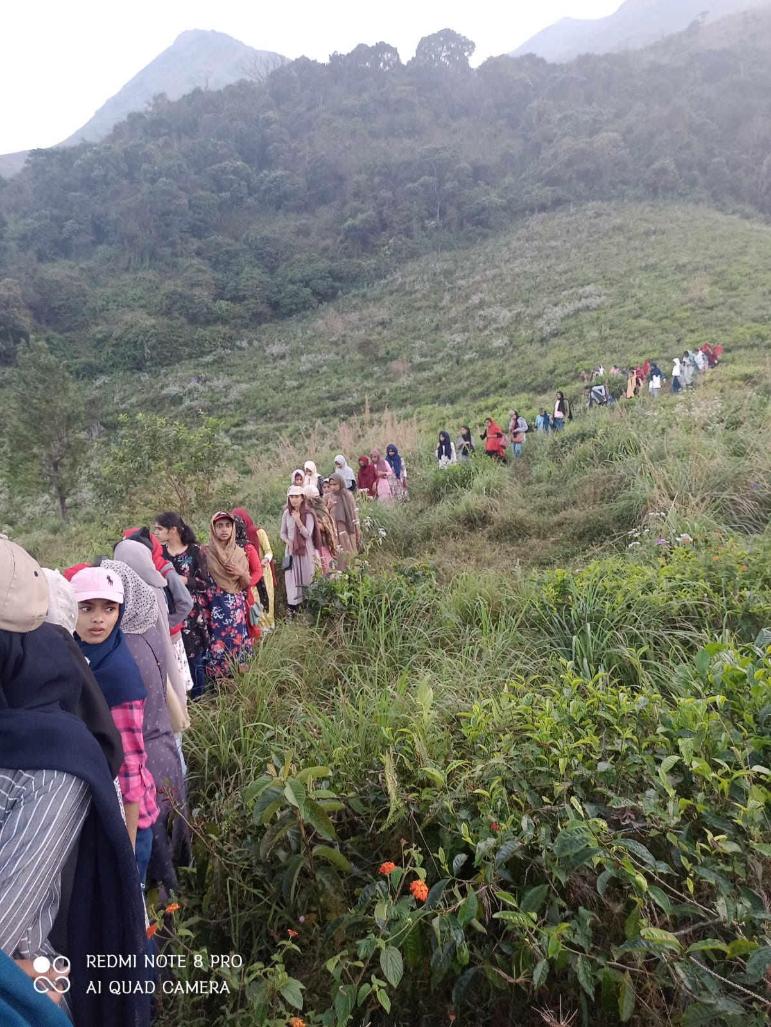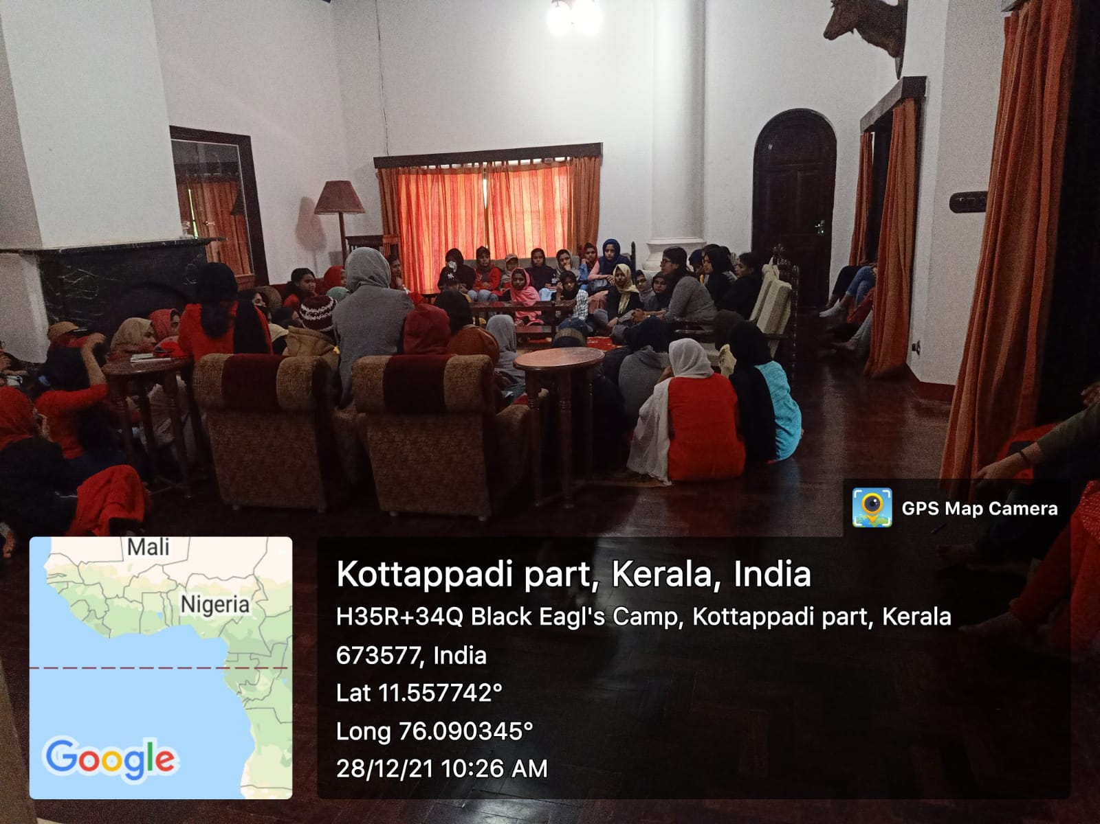

- Webinar on Introduction to e-Learning Programmes and Internships
Department organized an online talk on e-learning progrmmes and internships on 12th March 2022 to help the students for doing internships during their course and to familiarize the e-learning platforms like swayam-NPTEL, coursera, edX etc.The session was handled by Dr.Rubell Marion Lincy G, Assistant Professor,IIIT Kottayam.
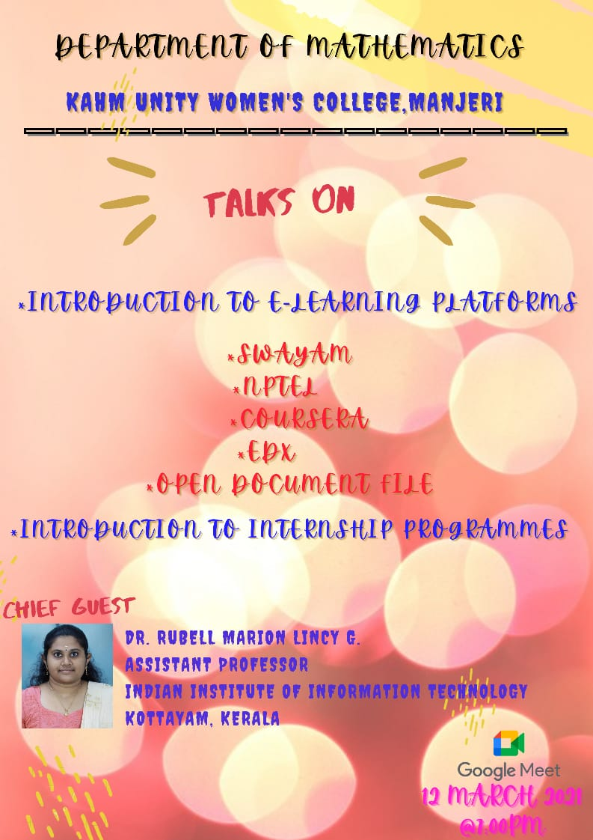
- MATHEAC-Career Path for Mathematics Majors- Phase-1
MATHEAC- Career Path for Mathematics majors was an initiative of the Department of Mathematics to motivate the students to do their higher studies in the reputed institutions. Three phases were planned: state level, national level and international level. In each level a student who got admission to the said institutions share their preparations for the entrance and the experiences they undergone.
In the first phase 7 students interacted with students and shared their experiences.
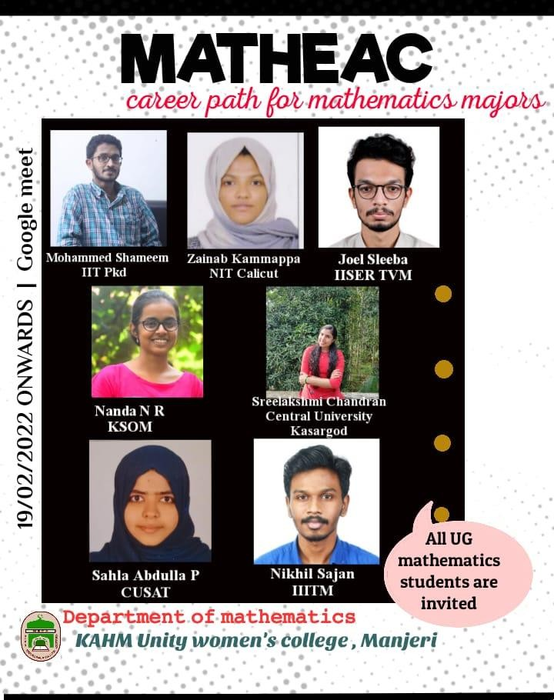

Sl No | Date | Guest | Institution of Affiliation | Course Introduced | No of Students attended
1 | 19/02/2022 | Ms. Nanda R | Kerala School of Mathematics, Calicut | Integrated MSc+PhD | 40
2 | 05/03/2022 | Mr. Nikhil Sajan | IIITM, Trivandrum | MSc Computer Science | 39
3 | 08/03/2022 | Ms. Zainab Kammappa | NIT Calicut | MSc Mathematics | 41
4 | 10/03/2022 | Mr. Mohammed Shameem | IIT Palakkad | MSc Mathematics | 40
5 | 12/03/2022 | Ms. Shahla Abdulla P | CUSAT, Cochin | MSc Mathematics | 40
6 | 14/03/2022 | Mr. Joel Sleeba | IISER Trivandrum | MSc Mathematics | 40
7 | 09/04/2022 | MS. Sreelakshmi Chandran | Central University of Kerala, KAsaragod | MSc Mathematics | 41

- Pie Day Observation:
Department of Mathematics and Malayala Vedi in Collaboration with IQAC organized a talk on ‘Ganitha Yukthiyum Malayalathinte Arivuvazhikalum’. Ms. Chinju Surendran, Research Scholar, Thunchath Ezhuthachan Malayalam University, Tirur.
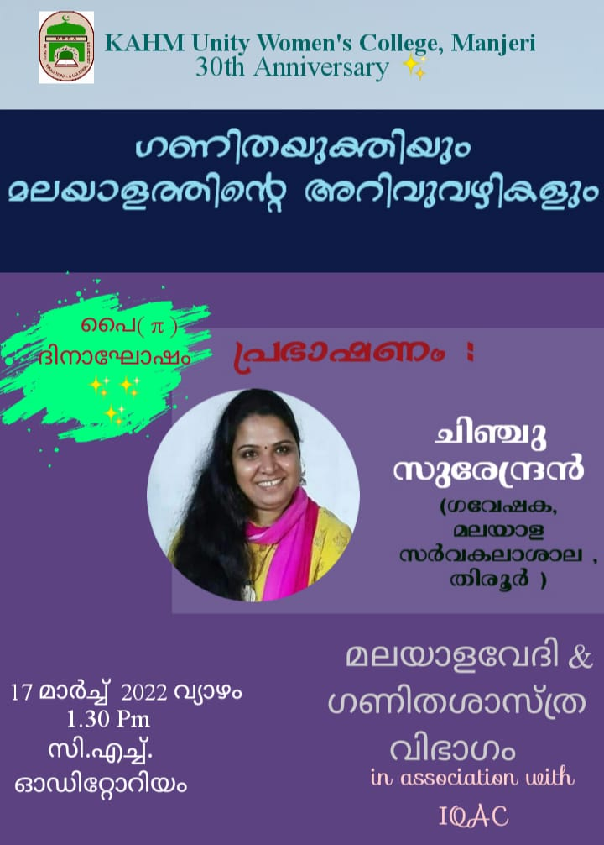

- Association Inauguration and Cultural Fest
The Mathematics Association of the academic year 2021-22 was inaugurated by Ms. Rafiya P, Assistant Professor, Department of Mathematics, DGMMES Mampad College on 22nd March 2022. Meritorious Awards were distributed to the toppers of 2020-21, Fathima Jubi, Shahanas MP and Janna V. Fathima Fidha and Thanshida were given awards for completing about ten courses through online mode in the covid 19 pandemic period. Cultural events were performed by the students.

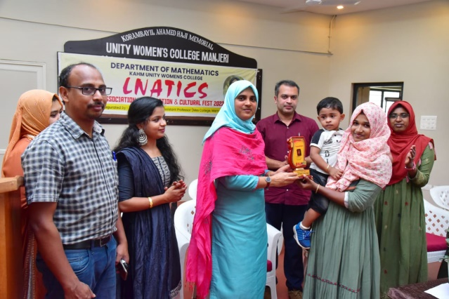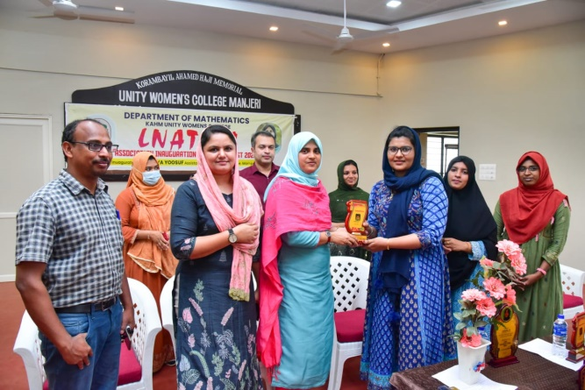
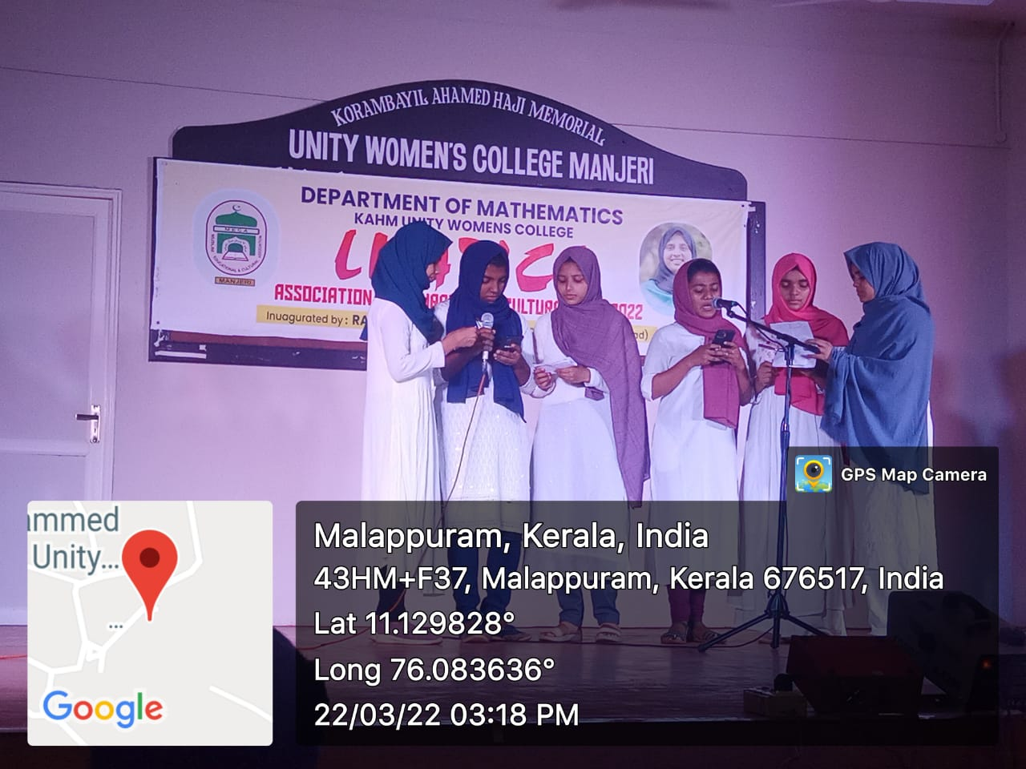

- Invited lectures by Faculty Members
- Mr. Abdul Rof V, Assistant Professor, Department of Mathematics has delivered a talk on “ Cosequences of Weierstrass Approximation Theorem” organised by Department of Mathematics, Nilgiri college of Arts & Science on April 01st 2022.

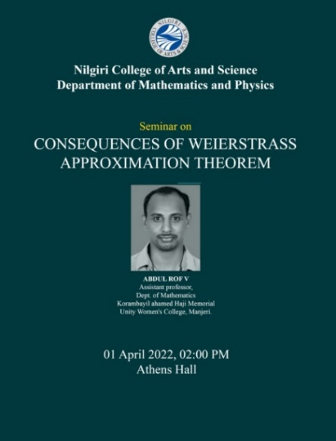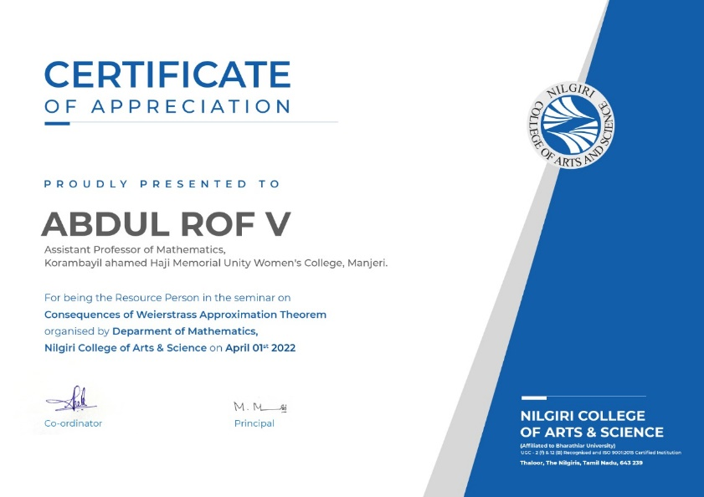

- Dr. Bajeel P N, Assistant professor, Department of Mathematics has delivered an Invited Extension Lecture on “Mathematical Careers in Business, Industry and Government” at Mar Ivanios College (Autonomous), Thiruvananthapuram on 16/12/2021 for the undergraduate mathematics students.
- 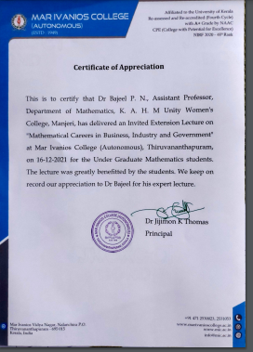
- Dr. Bajeel P N, Assistant professor, Department of Mathematics has delivered an Invited lecture on “MATHEMATICS THE CAREER AHEAD” at Government Arts and Science College, Kondotty on 10/03/2022 conducted by the PG department of Mathematics.
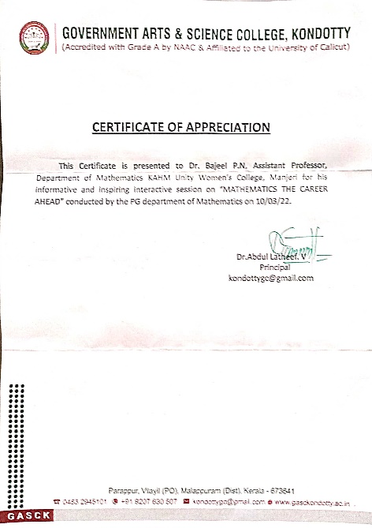
- Dr. Bajeel P N, Assistant professor, Department of Mathematics has delivered an Invited Talk on “Introduction to Linear Algebra for Machine Learning” as part of the “National Seminar on Linear Algebra” jointly organized by the Department of Mathematics and Mathlets- Mathematics club, Co-operative Arts and Science College, Madayi on 14th March 2022.

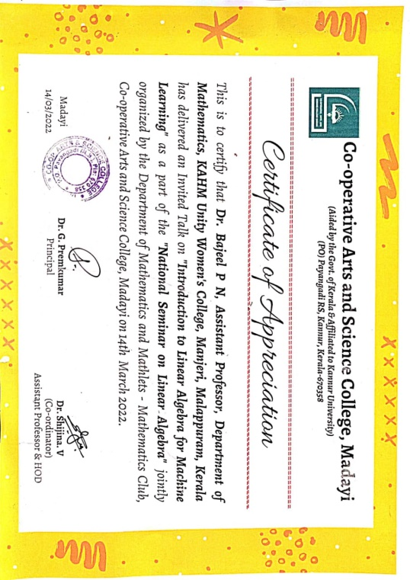

- Paper presentation
- Dr. Bajeel P N, Assistant professor, Department of Mathematics presented a paper on the title “Application of degradation growth model in the estimation of Bayesian system reliability” in MESMAC International Conference, edition 6 held at MES Mampad college (Autonomous) from 20th to 31st January 2022.
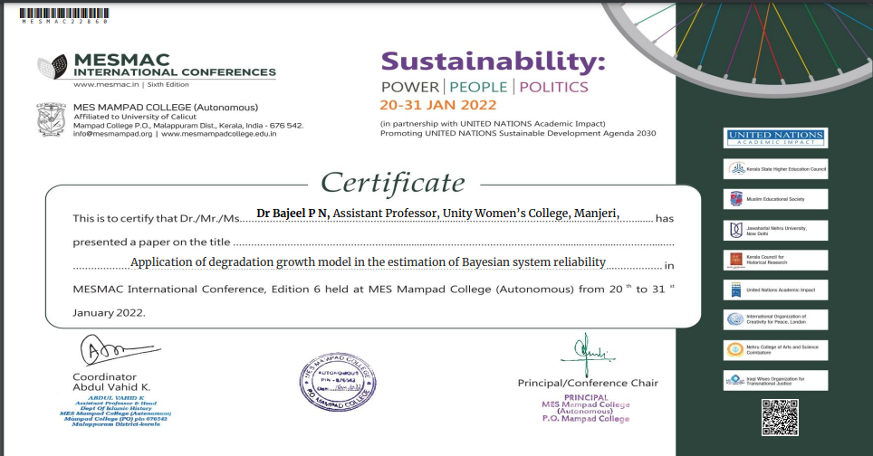

- Teachers’ participation in seminars/ conferences/FDP
- Dr. Bajeel P N, Assistant professor, Department of Mathematics participated and delivered an Invited Talk on “Introduction to Linear Algebra for Machine Learning” as part of the “National Seminar on Linear Algebra” jointly organized by the Department of Mathematics and Mathlets- Mathematics club, Co-operative Arts and Science College, Madayi on 14th March 2022.

- Ashitha P A, Assistant Professor, Department of Mathematics attended a one-day national level FDP on” How to publish high impact research articles” organized by Research Consultancy and Extension Cell, Sullamussalam science college, Areecode on 15th January 2022.

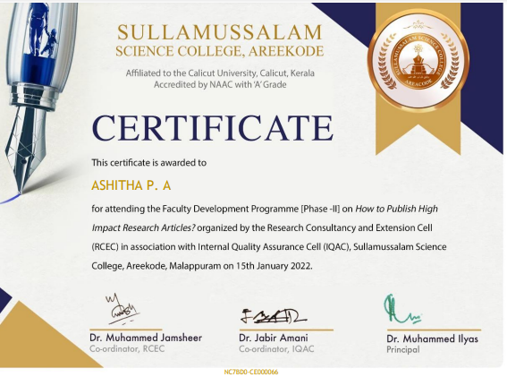
- Ashitha P A, Assistant Professor, Department of Mathematics attended a one-day national level FDP on” Teaching in Higher Education, Research and Professional Development” organized by KAHM Unity Women’s College, Manjeri on 9th March 2022.

0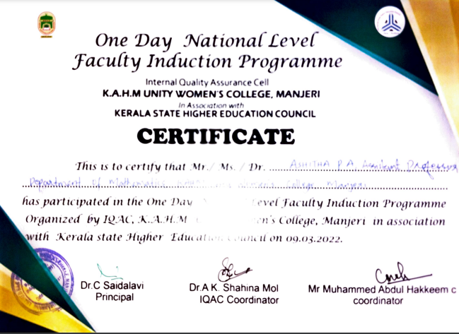
- Ashitha P A, Assistant Professor, Department of Mathematics attended a one-day national seminar on” NAAC Reaccreditation and Quality Enhancement Initiatives” organized by the management committee of KAHM Unity Women’s College, Manjeri on 9th May 2022.

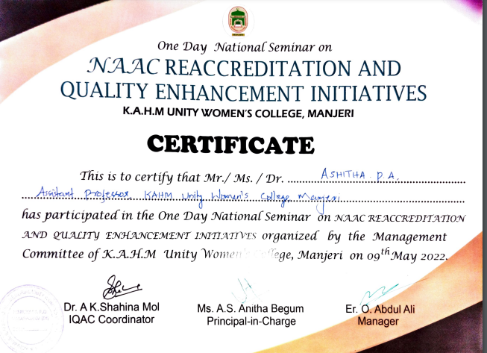
- Dr. Bajeel P N, Assistant Professor, Department of Mathematics attended a one day national seminar on ”NAAC Reaccreditation and Quality Enhancement Initiatives” organized by the management committee of KAHM Unity Women’s College, Manjeri on 9th May 2022.

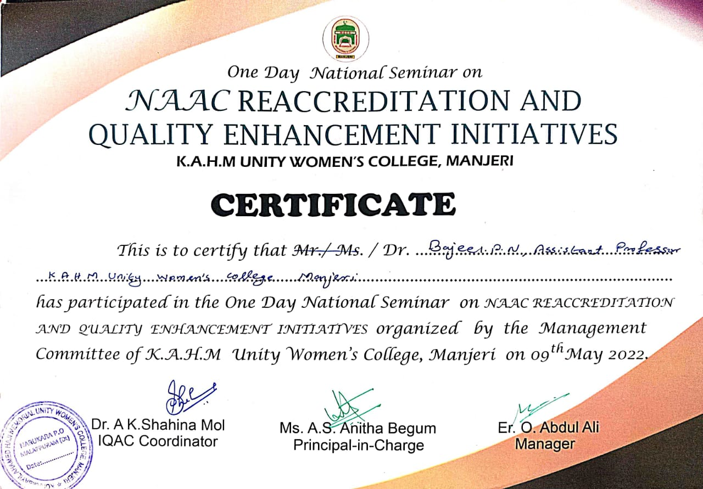

- Dr. Bajeel P N, Assistant Professor, Department of Mathematics attended a one-day national level FDP on” Teaching in Higher Education, Research and Professional Development” organized by KAHM Unity Women’s College, Manjeri on 9th March 2022.
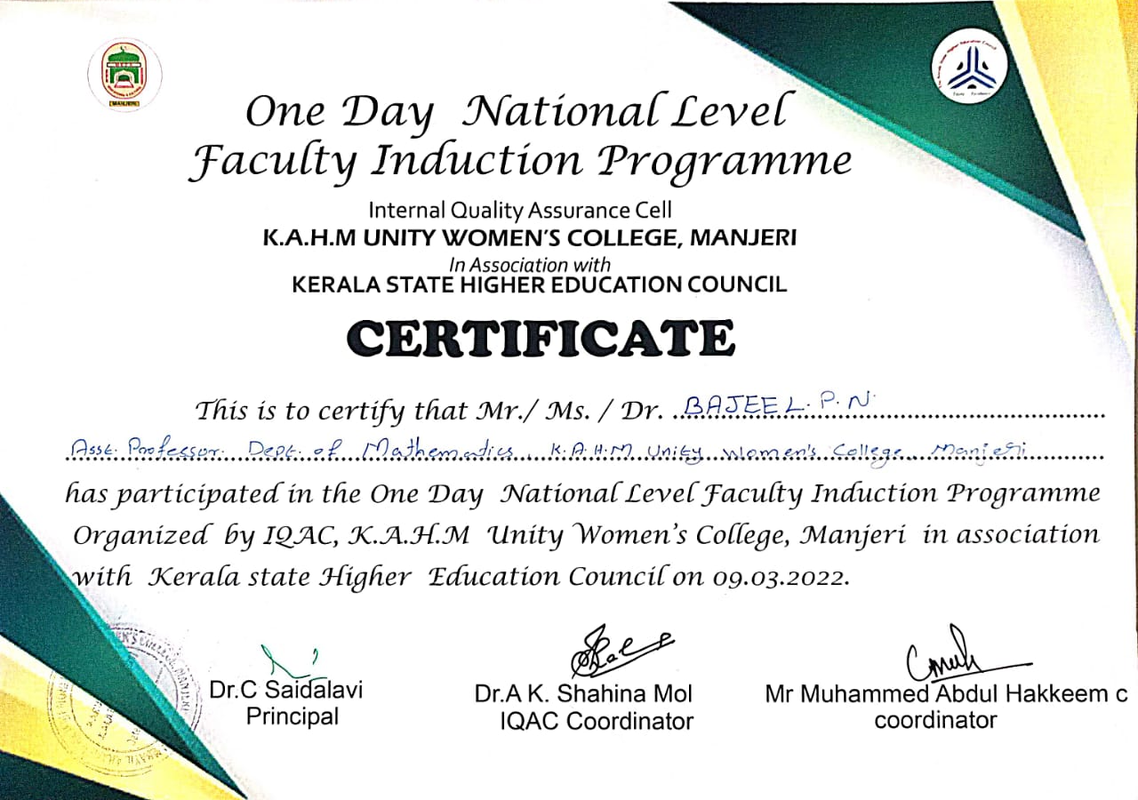

- Dr. Bajeel P N, Assistant Professor, Department of Mathematics attended a one day FDP on” Faculty Enrichment Programme on Workplace Professionalism, Ethics & Team Building” organized by IQAC, KAHM Unity Women’s College, Manjeri on 2nd March 2022.
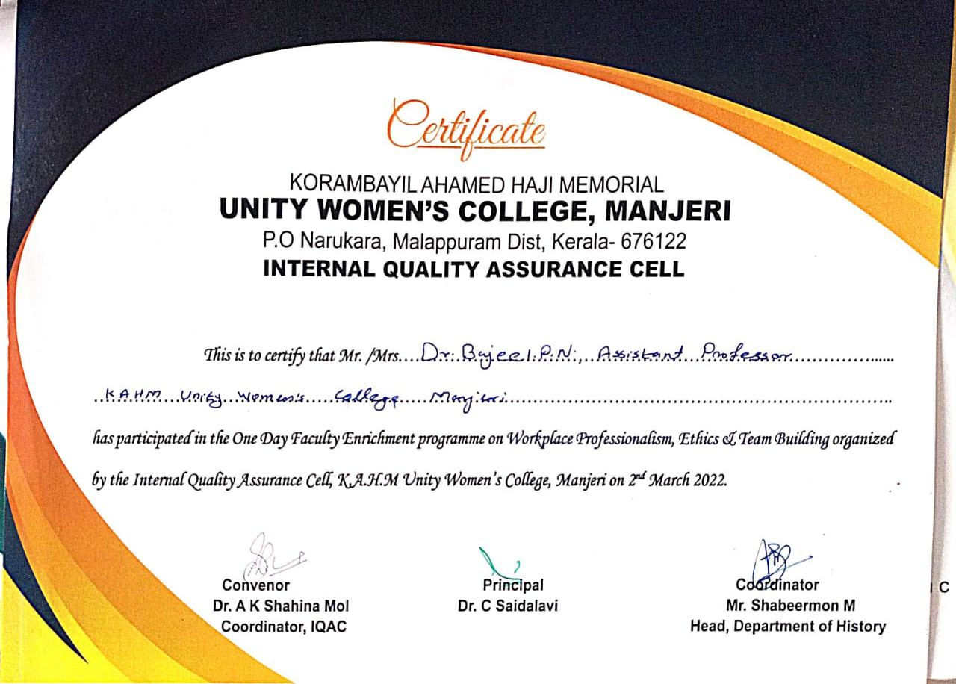
- Abdul Rof V, Assistant Professor, Department of Mathematics attended a one day FDP on” Faculty Enrichment Programme on Workplace Professionalism, Ethics & Team Building” organized by IQAC, KAHM Unity Women’s College, Manjeri on 2nd March 2022.

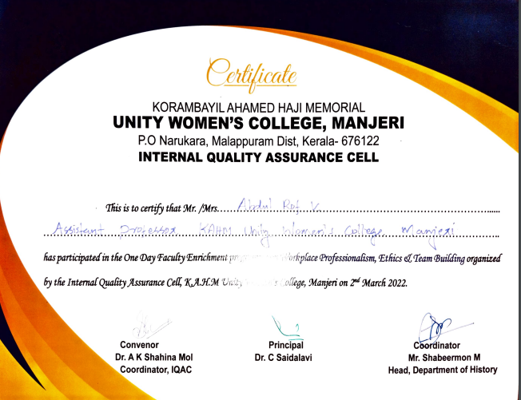

- Abdul Rof V, Assistant Professor, Department of Mathematics attended a one day national seminar on” NAAC Reaccreditation and Quality Enhancement Initiatives” organized by the management committee of KAHM Unity Women’s College, Manjeri on 9th May 2022.

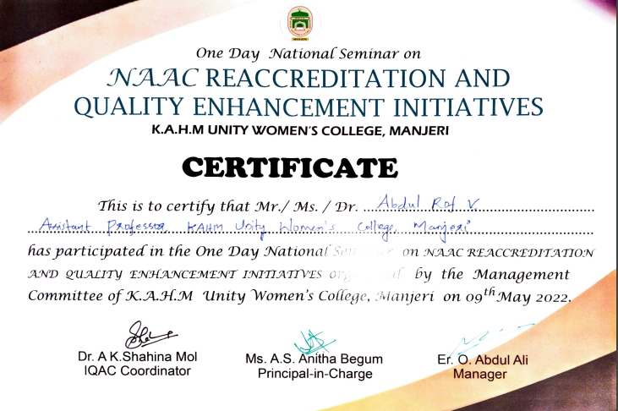

- Meritorious Awards by the Department
Name of Student | Achievement
Fidha Fathima and | Completed more than ten certificate courses through online mode in the Lockdown period.
Thanshida M | Completed eight of certificate courses through online mode in the Lockdown period.
Fathima Jubi E | Class topper of 2018-2021 batch
Shahanas M P | Second class topper of 2018-2021 batch
Janna V | Third class topper of 2018-2021 batch

- Co-curricular Activities

Date of event/activity (DD-MM-YYYY) | Name of the event/activity and a brief report | Name of the student participated
02/09/2021 | Third prize winner in the state level poster making contest conducted by WHD in collaboration with KAHM Unity Women's College, Manjeri as a part of “World Moral Day” annual celebration on 2nd September. | Anjala Farha
 | EBSB Club best student coordinator title | Shamila Rustha T
20-24 August 2021 | Charithronam Quiz competition- First prize in the quiz competition Conducted by Department of History, KAHM Unity Women’s college, Manjeri. | Fathima Nasriyah K V
15/08/2021 | Third place in the pencil drawing competition on India@75 conducted by EBSB club , KAHM Unity Women’s college, Manjeri. | Shamila Rustha T
 | IQAC recognition for completing most number of certificate courses through online mode in the Lockdown period. | Fidha Fathima
02/10/2021 | Gandhi Jayanthi Quiz competition – Won prize in the quiz competition conducted by Department of History, KAHM Unity Women’s College, Manjeri | Usna Farvi

