1. Knowing Yourself- (Association Programme)
On June 23, 2022, Mr. Noushadali, Head of the Arabic Department at Unity Women's College Manjeri, kicked off the activities of History Association for the Academic year 2022–2023. The event was organised by the second-year BA History students in Room 9. Association Secretary Nafla T. P. welcomed everyone to the event. Mr. Noushad Ali spoke around 40 minutes on the subject of "Knowing Yourself." In his presentation, Noushadali discussed many methods for identifying the unique self, and he also inspired students to advance in their academic careers. The event was felicitated by third-year BA History student Vajeeda Jabin, and Ahla, II year BA History student, rendered the vote of thanks. Teachers from the department took part in the programme as well.
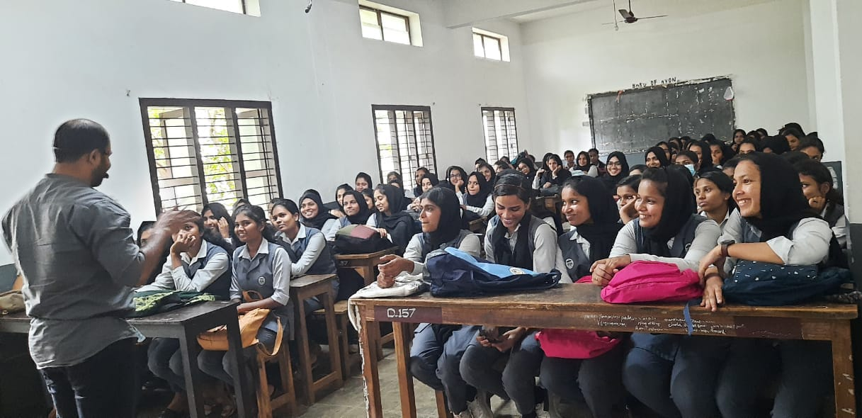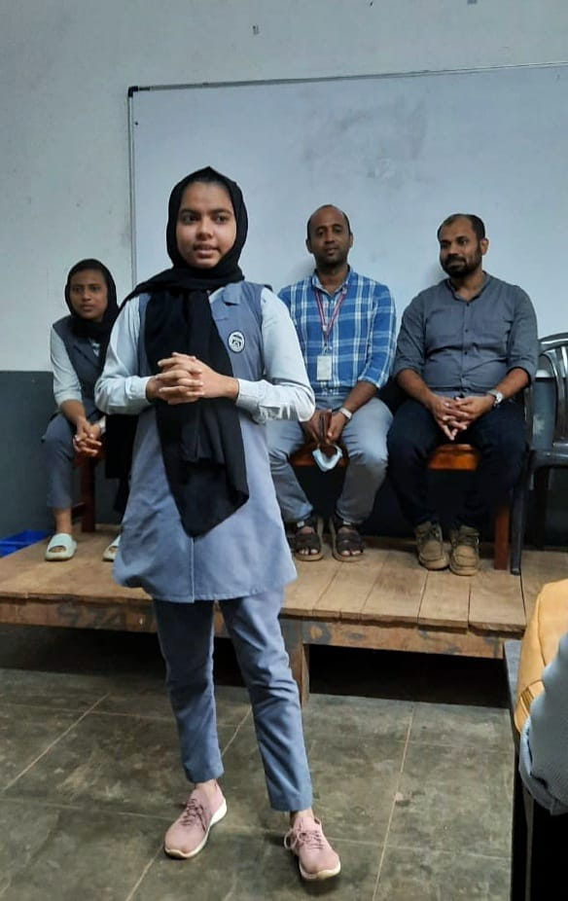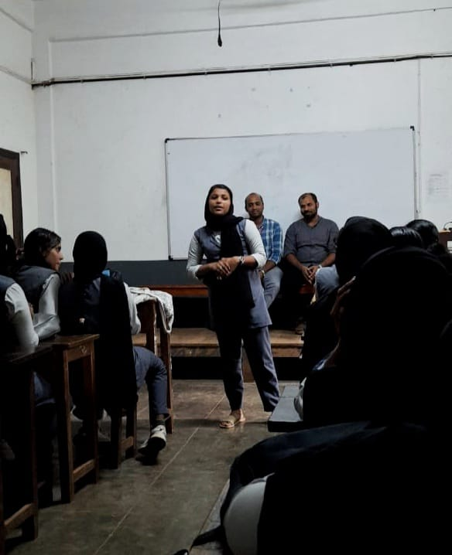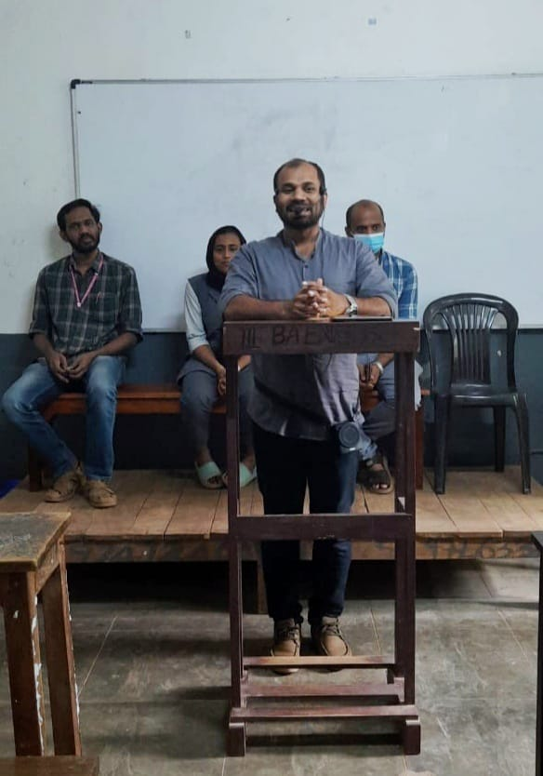

2. Just A Minute (Association Programme)
On 30 June 2022, History Association organized a program in the Association Class Classroom. The event titled “Chade Pade" was an impromptu speech (Just a Minute) where the speaker is supposed to express the idea on a given topic within the duration of a minute. This platform helped students to expand their thinking abilities. Speakers were able to inspire, provoke, and persuade the listeners on various topics. Representing the third year BA History, Fathima Najwa and Shabna and Najiya and Huda Sherin from Second year UG have participated in the program. After the event, few students sang various songs (Mufeeda, Maimoona, Pavishna and Sabeeha) that was enjoyed by the audience. Final year and Second Students of the department and teachers attended the event. Hanna Mariyam Welcomed the gathering and Shahala rendered vote of thanks.
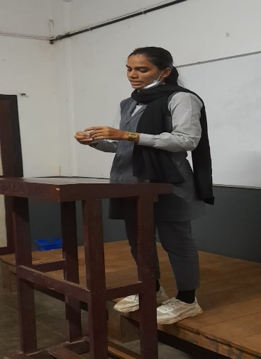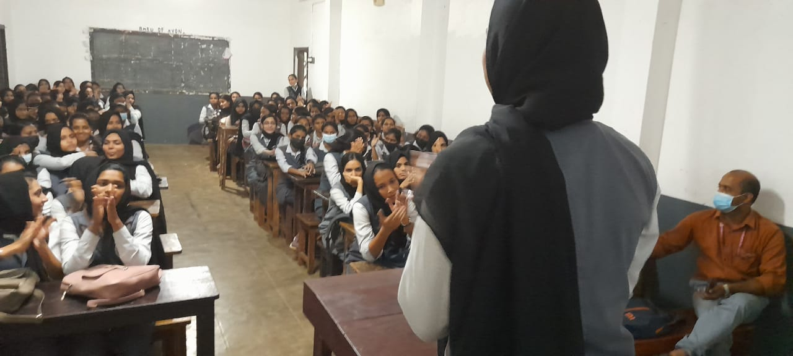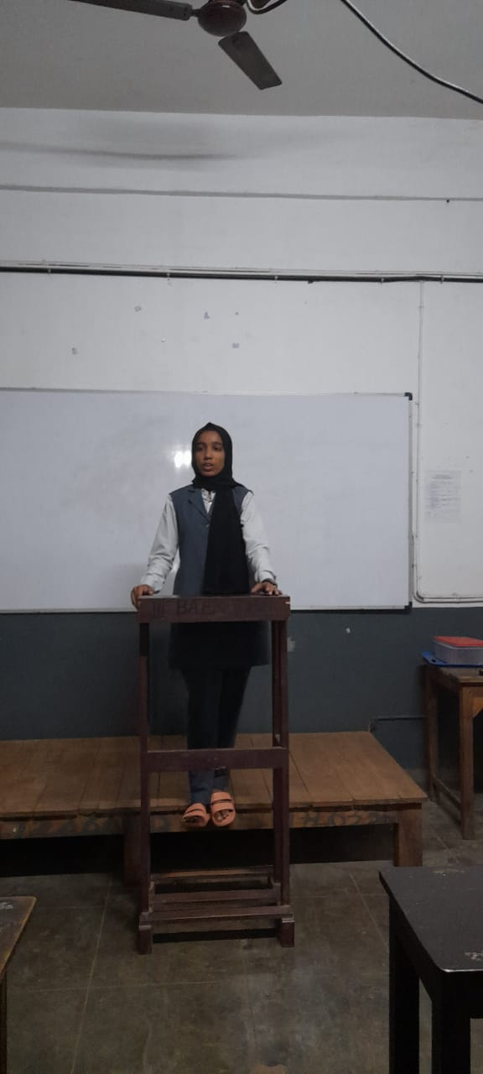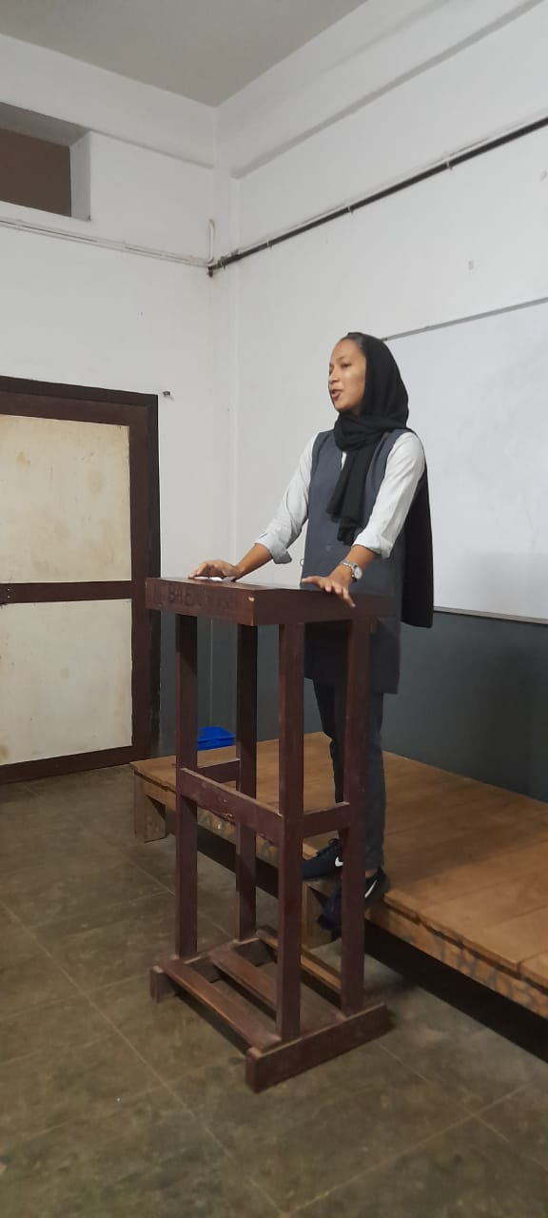

3. Inter Collegiate Quiz Competition Winner
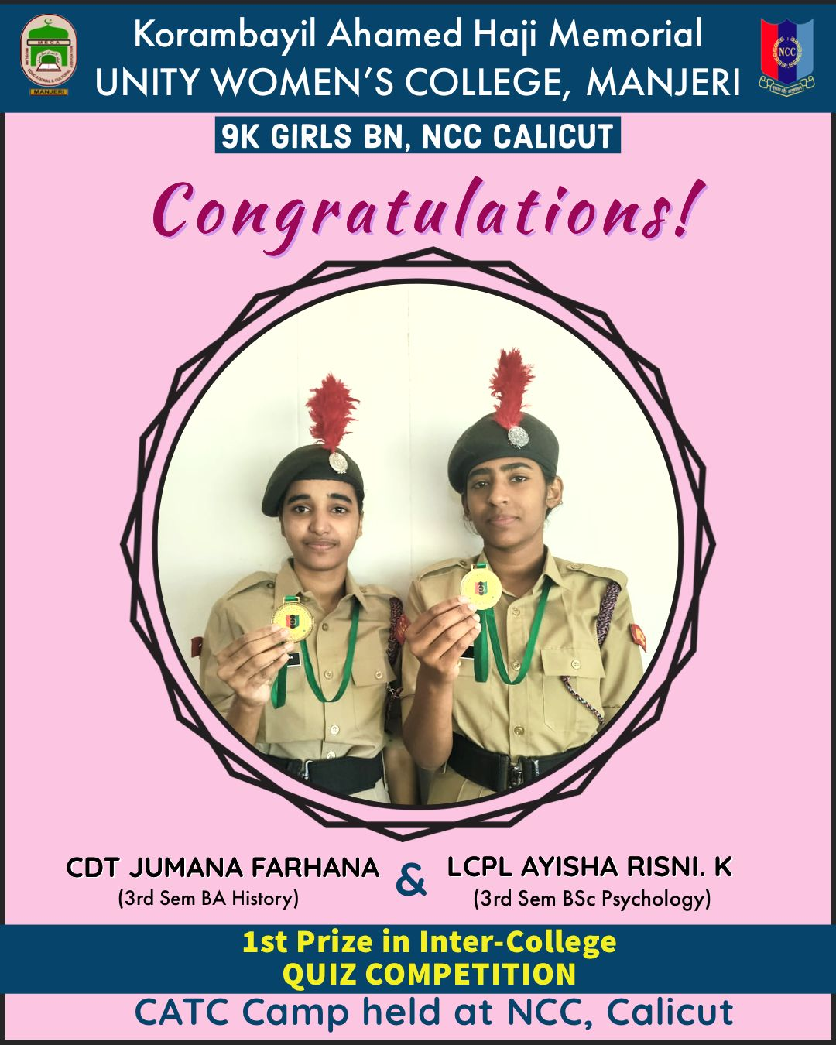
Jumana Farhana of 3rd Semester BA History won first prize, along with Ayisha Risni of 3rd Semester BSc Psychology, in the Inter College Quiz Competition held at NCC CATC Camp, Calicut on 26th July 2022.
4. 'Stand-up Comedy' (Association Programme)
On thursday 14 th July 2022, fourth History Association program was organized in the Association Class room. The event titled 'Stand-up Comedy' was anchored by Anusha from 3 rd Semester BA History. The program began with a welcome address by Rizwana Sherin. Then Jumana Farhana, Nafla and Shahana Shirin performed stand-up comedy on the stage. Performing stand-up comedy in front of the friends was an exciting new experience for them. The fun atmosphere of the event was a rare chance for the students to share past experiences. As we know that telling joke is a great way to relieve stress. Not only that the event also provide the participants the chance to gain confidence to talk in public. The event was concluded with the songs of Ramya, Mufida, Maimuna and Shifa. Association teacher in-charge Mr. Shabeermon, Jaseena miss and Rafiq sir participated.
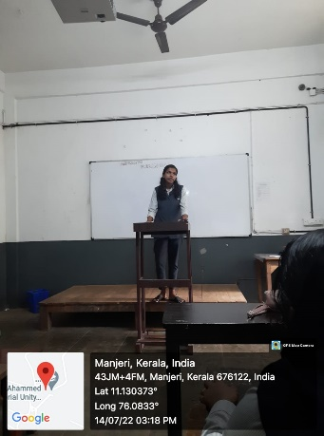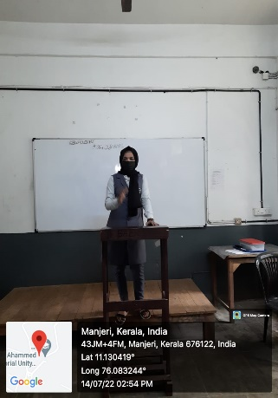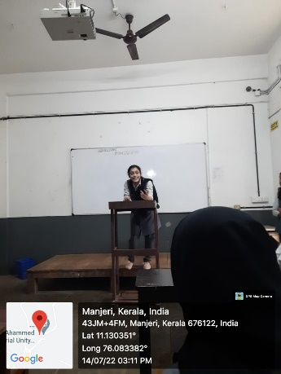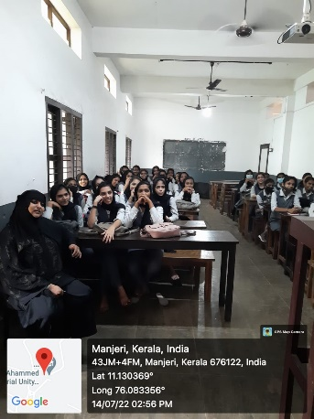

5. Workshop on Digital Poster Making
On 18 July 2022, Mr. Shabeermon M, Head, Department of History, acted as the resource person for the Workshop on Digital Poster Making organized by the Department of Mathematics, K.A.H.M Unity Women’s College. The program was organised with the support of MEILES PROJECT and Unity IQAC.
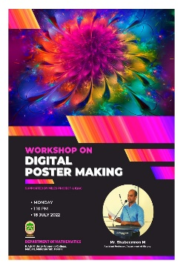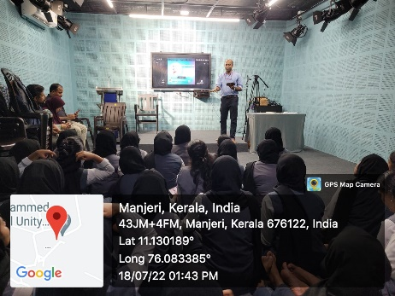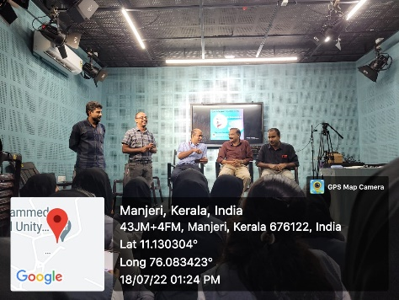

6. PTA Meeting
P.T.A General Body meeting of Unity Women's College was held on Thursday 21 July 2022 at 1.30 PM in the College Auditorium. Principal Dr. Basheer Ummathur presided the meeting. More than 400 parents attended the meeting which was followed by the Class PTA. Final year and Second year Class PTA of BA History Program was held in Hall number AB 06 at 3 pm. Progress Card of each student was distributed in the meeting. Head of the department Mr. Shabeermon, Class tutors Mr. Faisal Tk and Jaseena C interacted with parents. 102 Parents representing final year and Second year participated in the meeting.
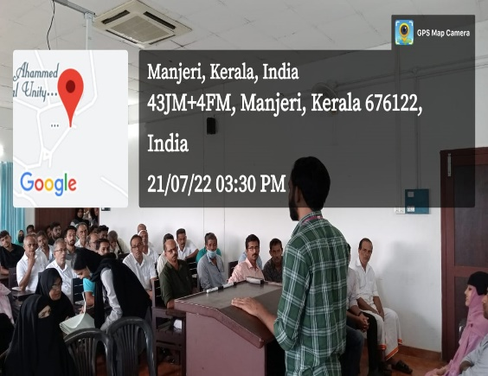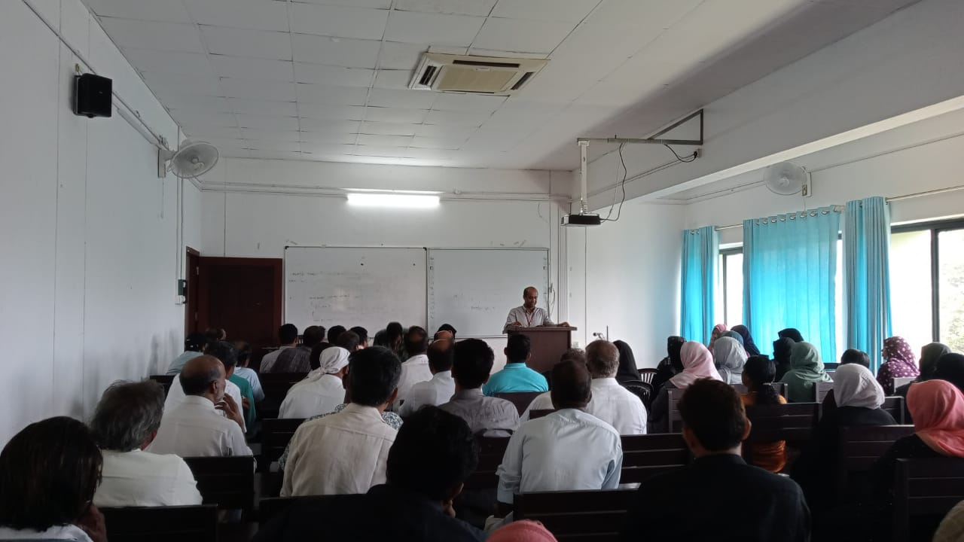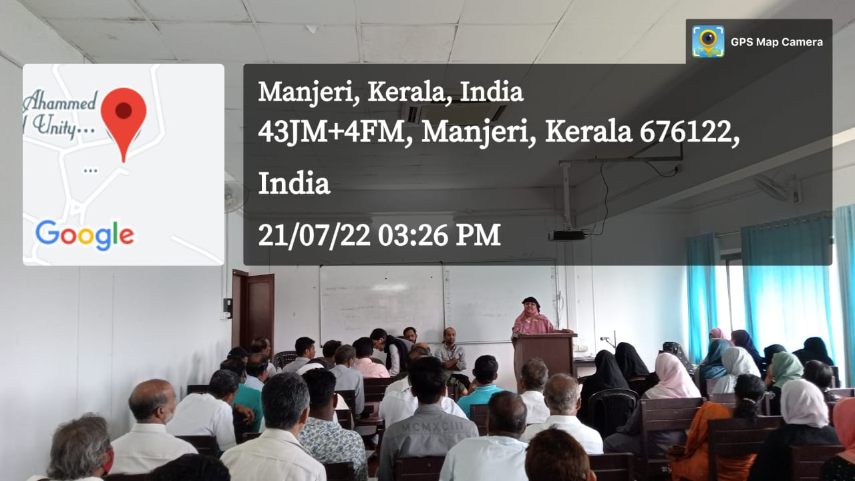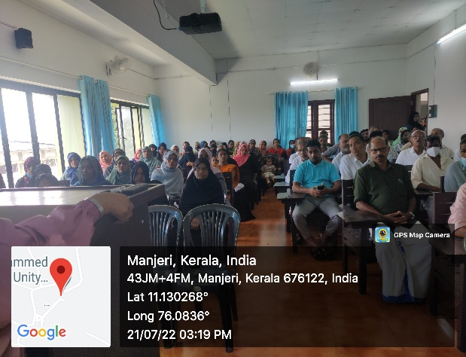
7. Local History Workshop
In connection with Final year UG Project, Department of History organized a Local History workshop on 27th July 2022 in Hall No. AB07. Dr. Rajesh K P, Assistant Professor of History, NSS College Manjeri has interacted with the students on the various methods and techniques of doing a project in History. He spoke about the significance of Historical research and use of those research for the academic purpose. The research findings of Historians play an important

role in the making of future generation. He taught the students how to frame research questions on a specified topic. The workshop was inaugurated by Principal Dr. Basheer Ummathur. Ms. Jaseena C welcomed the gathering and Mr. Faizal TK felicitated the program. Final year students Najva, Rinshida, Shahana, Fida and Vajeeda interacted with the resource Person at the end of the session.
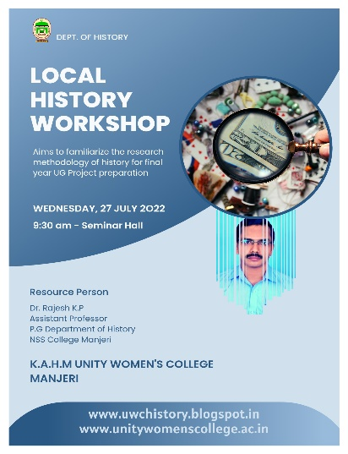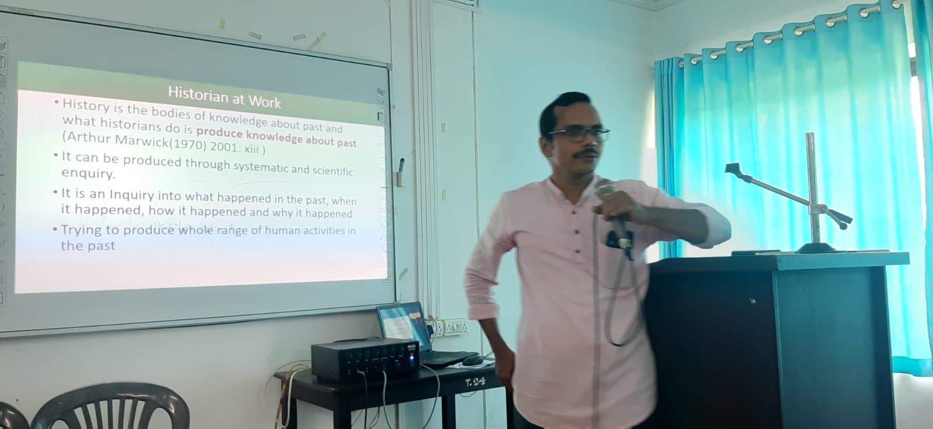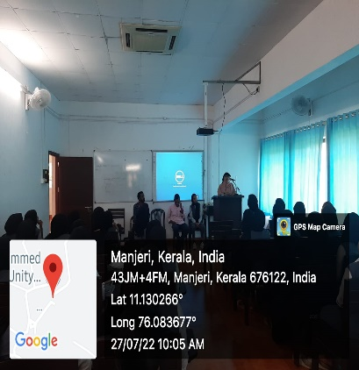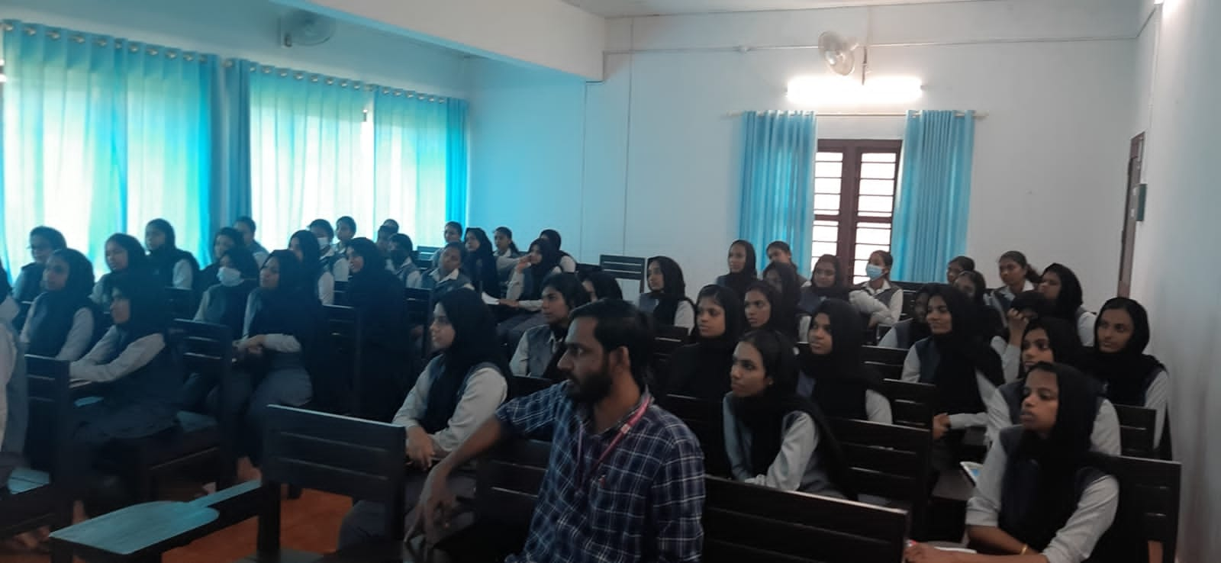
8. Quit India Day Observation (Association Programme)
On Thursday 4 th August 2022, the fifth History Association program was organized under the name "Remembering quit India Movement day". The program, presided over by Fatima Subhana, began with a welcome address by Swadika Semiya. Quit India Memorial Talk was given by Final year BA History student Ashwati.P. She has explained the background, course and the impact of the movement on the India's Struggle for Independence. The Talk was followed by a short Documentary presentation on the various aspects of Quit India Movement. The program was ended with the vote of thanks of Ansha Shery of Second year BA History. Students and teachers of the department attended the program.
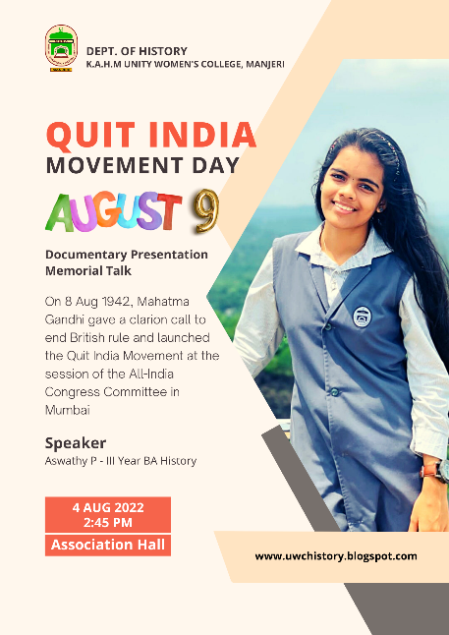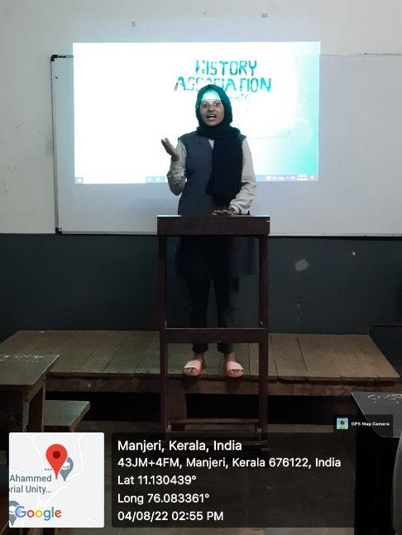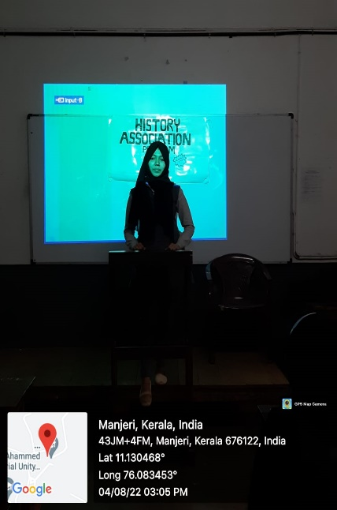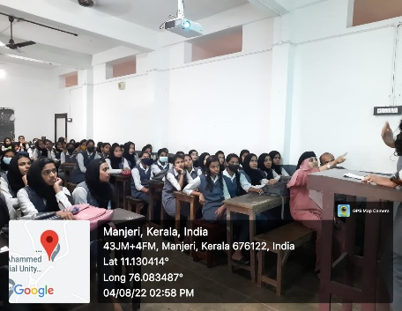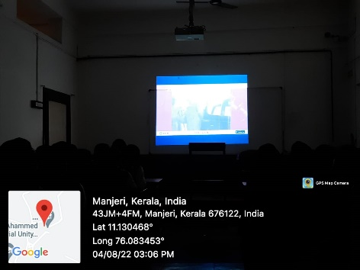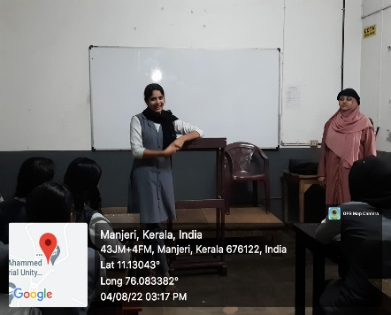
9. Poster Release
Department of History in collaboration with IQAC released Poster of One Week celebrations of the 75th Anniversary of Indian Independence Day was held today (10-08-2022) in Seminar Hall. Poster was released by College Manager Engineer O Abdul Ali. Principal, Teaching Staff and members of management committee etc. attended the event.
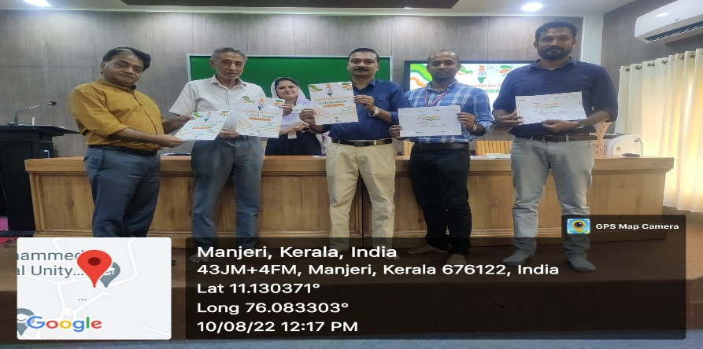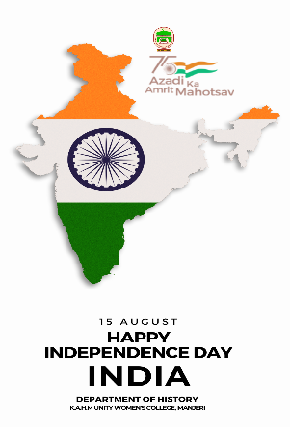

10. Why English Matters
On Thursday 11 August 2022, the sixth History Association program titled "Why English matters?" was organized in the Association Hall. Resource Person of the program, Mis Sangeeta, Assistant Professor, PG Department of English, spoke about the significance of learning English for a better life. It was a session to enlighten the students on the relevance of mastering English language skills in the contemporary world scenario. The event was presided over by T.P. Shamna, second year UG student. Association Secretary, Nafla welcomed the gathering. Teachers and students of the department attended the program.
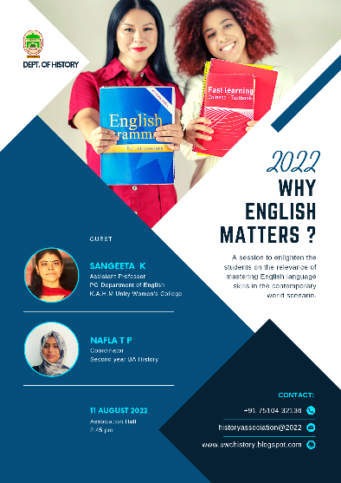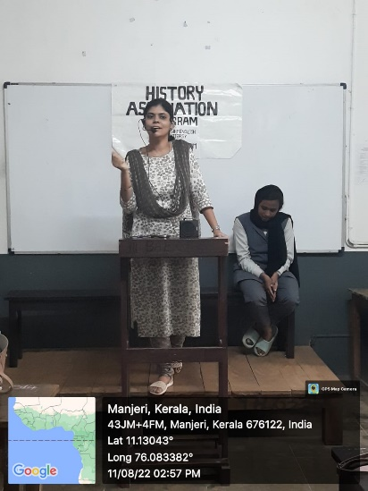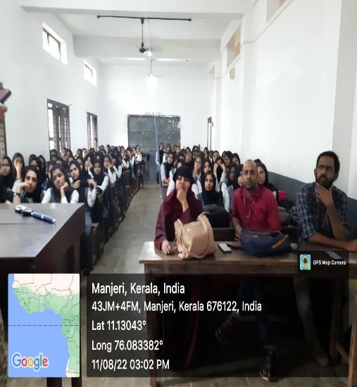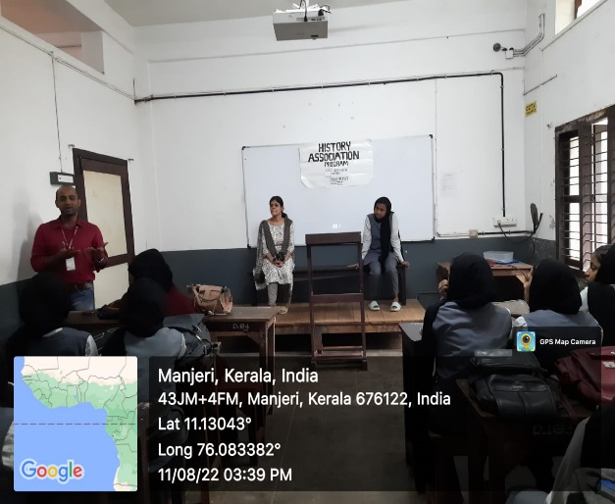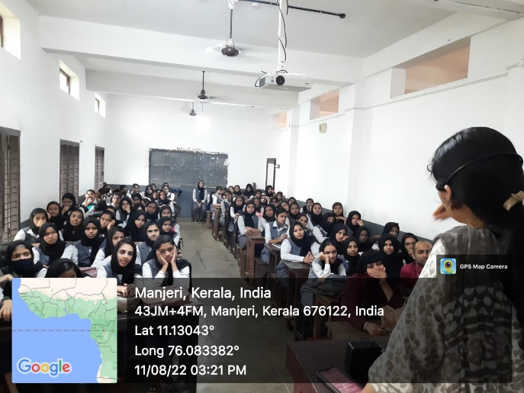

11. 75th Independence Day Celebrations
75th Independence Day Celebrations at KAHM Unity College Manjeri was inaugurated by Dr. K. S. Madhavan, the renowned historian and public intellectual who took the audience on an awakening and enlightening journey of the spirit of freedom and independence highlighting the concept of "Swaraj" as envisioned by legendary leader like Jawaharlal Nehru, Mahatma Gandhi, B. R. Ambedkar and the like. He highlighted that constitutional values such as secularism, justice and cultural inclusiveness must be celebrated in the wake of 75th Independence Day celebrations. The Anti-colonial perspective and the inclusive democratic spirit which led the freedom fighters and the people alike formed the rock bed of revolutionary movements in Indian History which he said should be laid down as sharing memories in every Indian's consciousness especially among the youth. Chief Guest of the day Dr. K. S. Madhavan inaugurated the Azadi Square and visited the Freedom Wall. Sri. O. Abdul Ali, College manager, declared the winners of the Freedom Wall Painting. Er. O. Abdul Ali, Manager, Dr. A K. Shahina Mol, IQAC Coordinator, Ms. Jaseena, Staff Secretary, Mr.Basheer Hussain Thangal, Non-teaching staff representative, and Mr. Musthafa, PTA Vice president felicitated the programme. The inauguration was followed by cultural events and competitions including Elocution Competition, patriotic song, Tableau, Quiz Face painting, fusion dance and Cultural Mix. IQAC, Department of History, Arts Club, EBSB Club, NCC, NSS and students from all departments added special flavour to the occasion with multiple events that promoted the theme of national integration. Mr. Shabeer Mon, HoD of History, formally welcomed the gathering and Mr. Siddhique, Convenor of Arts Club, rendered vote of Thanks.
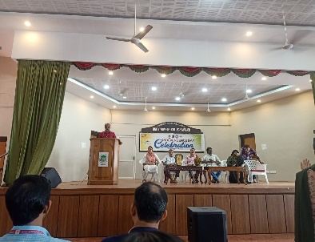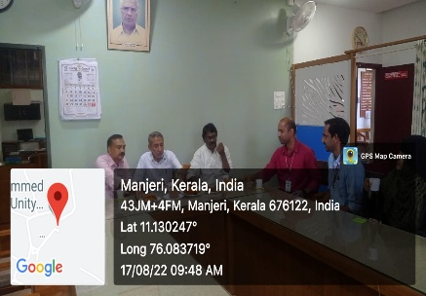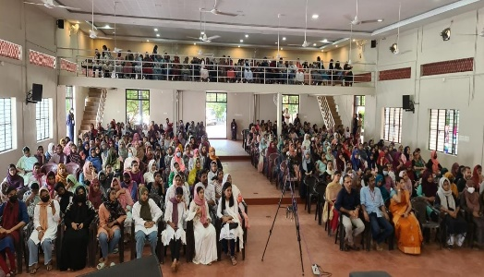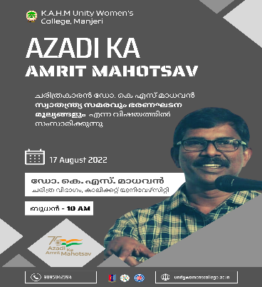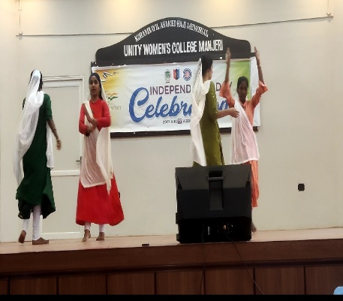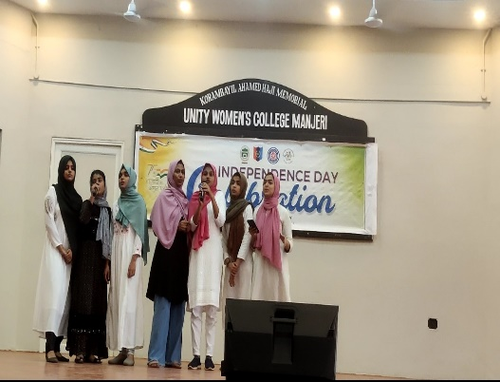

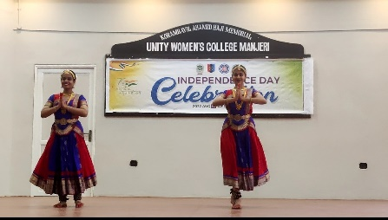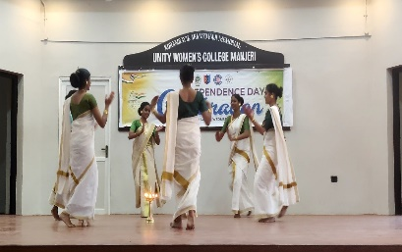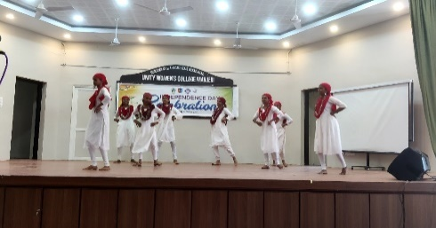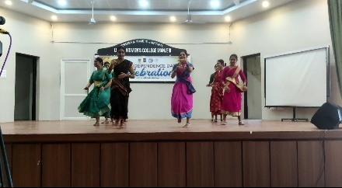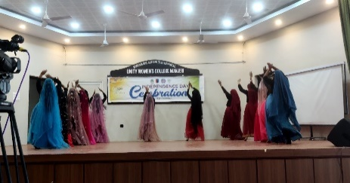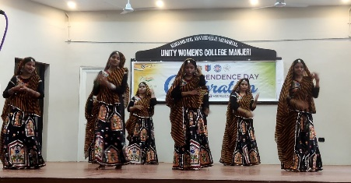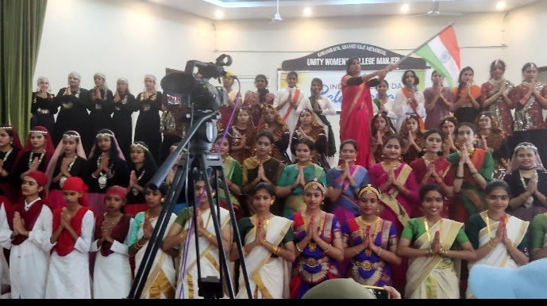

12. The Freedom Wall was unveiled at Unity College

As part of the Azadi ka Amrit Mahotsav celebrations on the 75th Anniversary of Indian Independence, Korambayil Ahamed Haji Memorial Unity Women's College IQAC, History Department and NSS Units jointly built the Freedom Wall on 12 th August 2022. The students depicted scenes of the National Freedom Struggle and different scenes of the Malabar Struggle at the Freedom Wall. The mural painting covers an area of 200 feet. Muhammad Basheer Ummathur inaugurated the program in which about fifty female students from ten departments participated by drawing pictures. Manager Engineer. O. Abdul Ali, IQAC Coordinator Dr. Shahinamol AK, Head of History Department Mr. Shabeermon, N.S.S. Program Officer Dr. V. Hikmatullah led the program. NCC Officer Ms. Lucia, Dr. P. Poornima , Mr. T K Faisal also spoke on the occasion.

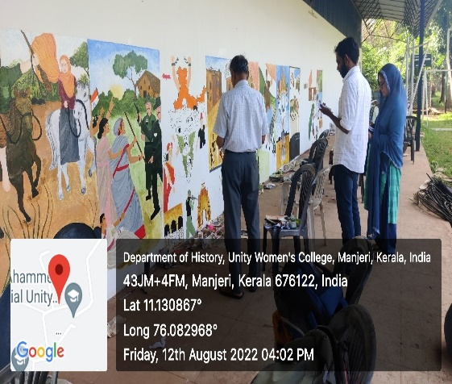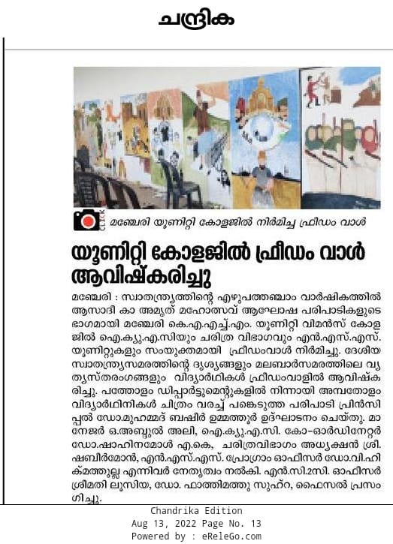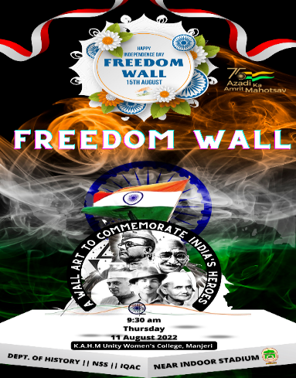
13. Certificate Course
In the 2022-23 Academic year, Department has decided to introduce three Certificate Courses and three Add On courses. Details of the Courses are given below.
Sl. No | Course | Code | Coordinator | Starting Date | End Date
1 | HIS1CC01 | Understanding Modern Kerala | Shabeermon M | 28 June 2022 | 30 October 2022
2 | HIS1CC02 | Understanding Modern World | Faizal T K | 20 June 2022 | 31 October 2022
3 | HIS1CC03 | Writing Scientific History | Jaseena C | 17 June 2022 | 29 October 2022
4 | HIS2AC01 | Kerala Renaissance | Shabeermon M | 08 Nov, 2022 | 10 March 2023
5 | HIS2AC02 | Principles of Archaeology | Faizal T K | 10 Nov, 2022 | 09 March 2023
6 | HIS2AC03 | Methodology of Social Science | Jaseena C | 14 Nov 2022 | 07 March 2023

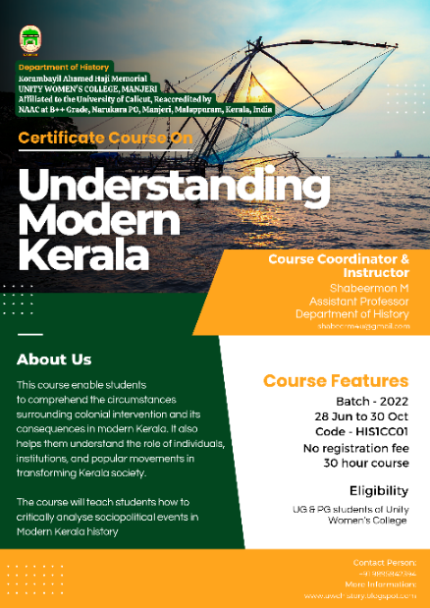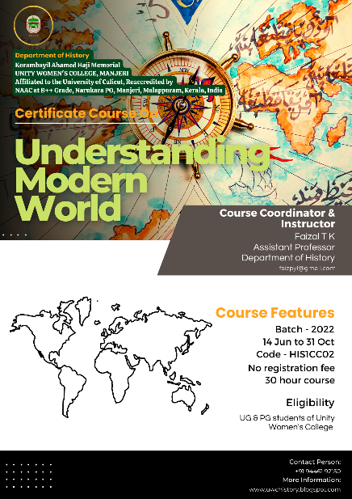

14. Rare replica handed over to History Museum

Dr. Mohammadali Korambayil, Vice President of the College Management Committee, handed over the replica of the American Declaration of Independence and Declaration of Human Rights to the newly constructed History Museum at the Department of History, K.A.H.M Unity Women's College, Manjeri. The said hand written rare copies were available to the doctor during his visit to the US Congress in 2019.

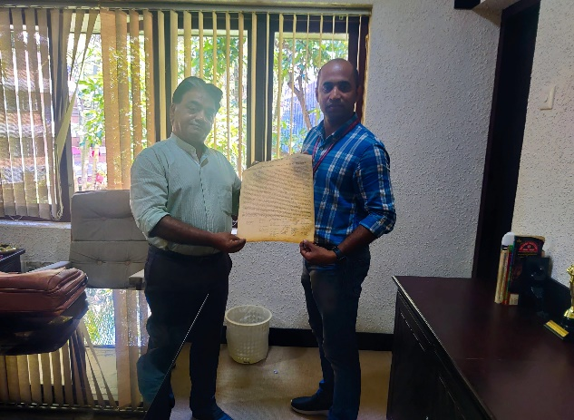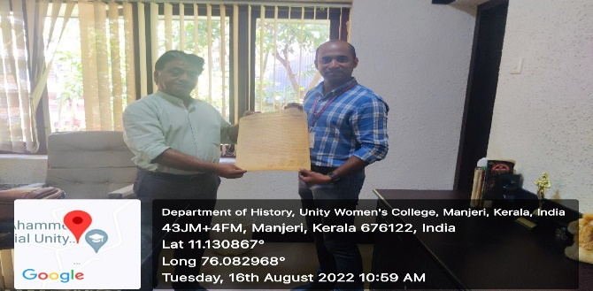

15. Inaugural Talk of Alumni Lecture Series

On 30th August 2022, Department of History, K.A.H.M Unity Women's College, has introduced Monthly Alumni Lecture Series with the idea to host the alumni, having all sorts of diverse profiles, to provide to the current batches a glimpse of what they are doing & what students can expect in the area they wish to pursue in the future. Each month, a prominent Alumna of the History department will join the Series and expected to present an hour long talk on a relevant topic. The first presentation of the Series was held on Google Meet platform. Principal Dr. Mohammed Basheer Ummathur inaugurated the Alumni Lecture Series. Shabana Jasmin (PhD Research Scholar), BA History Batch 2013-16 presented a talk on the topic “History of Epidemics with special reference to Malabar". She has mentioned history of few major Epidemics that have visited Europe. The focus of her presentation was the Epidemics happened in the British Malabar. The response of the British government towards the Epidemics and response of the local people against the challenges posed by the Epidemics were part of her presentation. Overall the presentation was an insightful one for the audience. Head of the department Mr. Shabeermon M, Assistant Professor of History Mr. Faizal TK, final year students Shabana and Vajeeda etc participated in the discussion. Program coordinator & Assistant Professor Jaseena C welcomed the gathering and Association Secretary Nafla rendered heartfelt gratitude to the guest, for sparing his valuable time and delivering an informative lecture to the students.

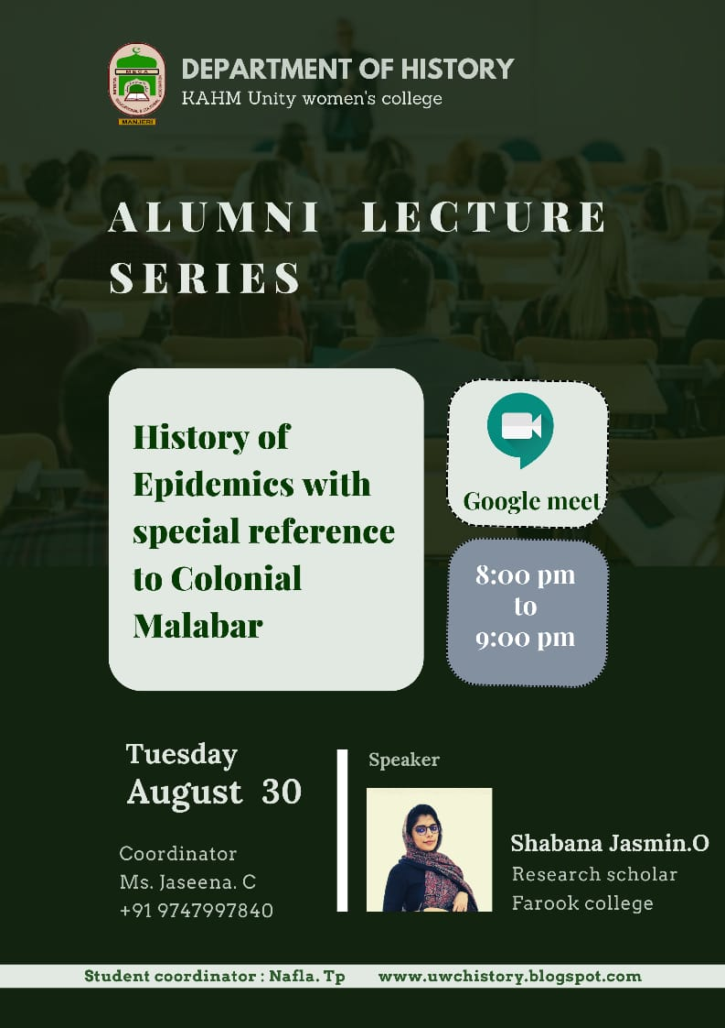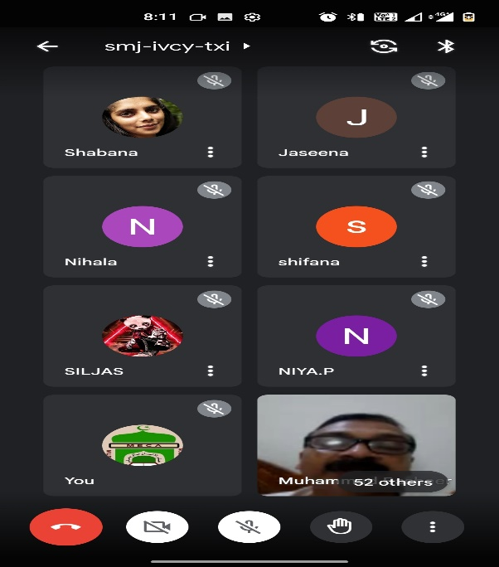

16. Onam Celebrated at Department

On 1st September 2022, students of the Department of History organized Onam celebration. They added colour to the celebration by taking part in various events organized at college level such as dance, tug of war, pookalamatsaram, and serving an Onam feast to the department teachers and students.

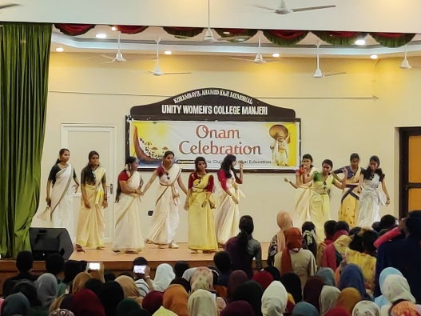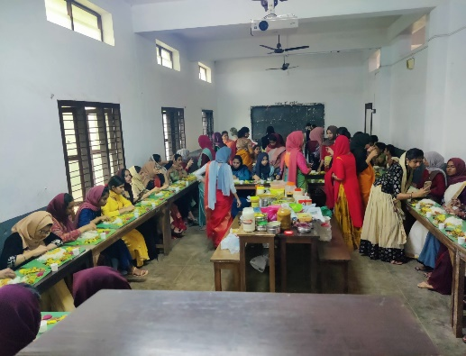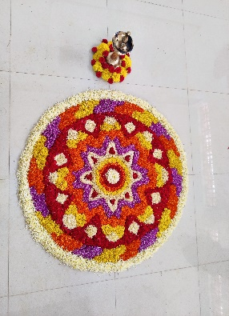

17. Field Visit

The History Association of Manjeri KAHM Unity Women's College has demanded that the Kodakallu, a remnant of Megalithic period located at Pattarkulam, should be preserved. This Stone built Kudakallu, situated on a paddy field 200 meters away from Patarkulam Angadi, had used to bury human dead bodies during the Megalithic period. The Kerala government has decided to declare this Kudakall as a protected monument in 2020. But the related work has not progressed till now. The information is that the owners have informed to give away the place where the stone is located and the road at 3 meters wide. In ancient times, bodies buried in Nannangadi, were surrounded by three or four big pieces of stones and a mushroom-shaped lid on top. Unity Women's College Department of History has urged that such monuments, which shed light on an era, need to be preserved. The students have decided to put up a sign board at Patarkulam.. The students and teachers of BA third year history department visited Patarkulam Kudakallam on 13 th September 2022.

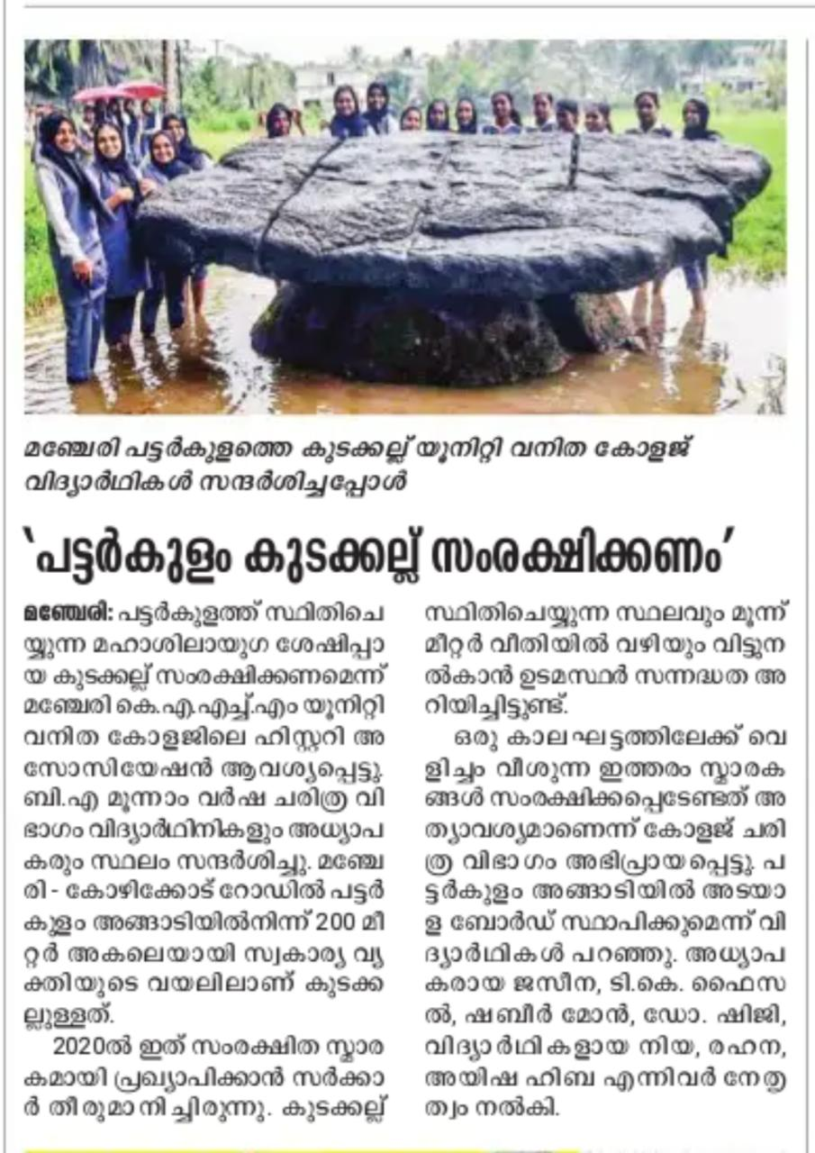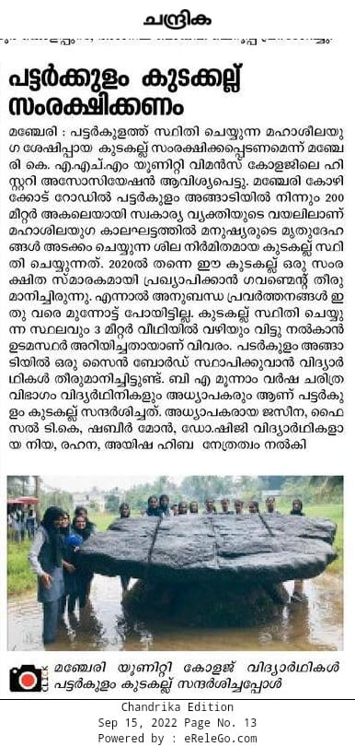

18. Paper Presentations

The faculties of History Department, Unity Women's College Manjeri, presented research papers in the 41st South Indian History Congress held at G.T.N Arts College, Dindigul, Tamilnadu during 26th to 28th August 2022.

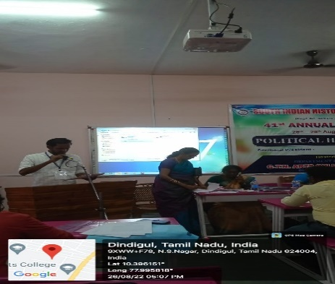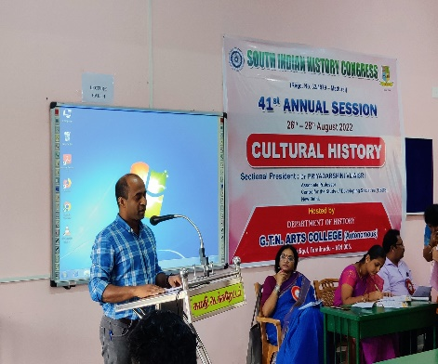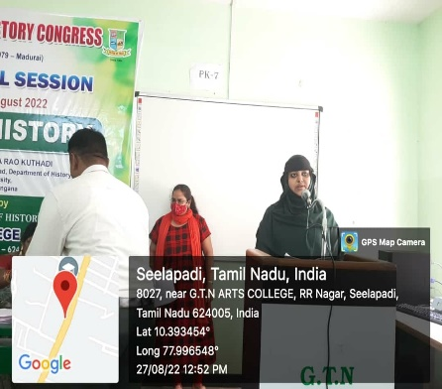

19. Monthly Alumni Lecture Series - Talk 2

As part of the Monthly Alumni Lecture Series, Department of History organised an online Session on the topic “Life Skills for 21st Century Learning” on Thursday 29 September 2022 at 8 pm.. Ms Amina Meetheen (BA History 2017-20 Batch) spoke about the skills required for developing an identity, finding a better job, and living as a responsible social being. She also introduced various learning and life skills for achieving a better life in the 21st century. The session was moderated by the Assistant Professor, Mis Jaseena C. Staff and students of the department attended the online talk that was held on Google meet platform. Aswathy P, Vajeeda Jabin and Fathima Thasni interacted with the guest at the end of the session. Sabna P welcomed the gathering and Najiya Nasrin delivered vote of thanks.

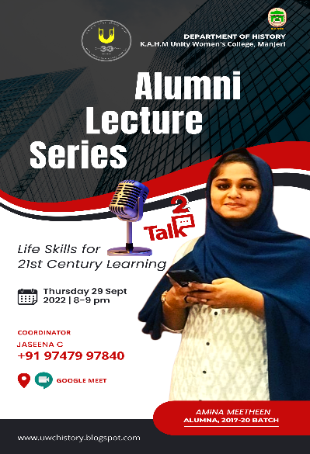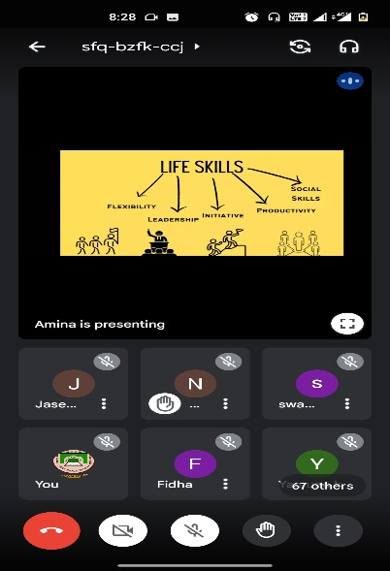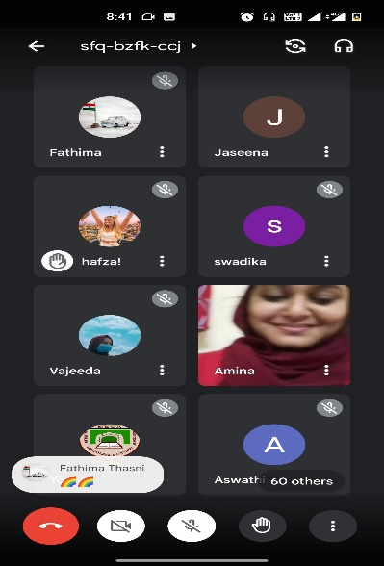

20. Gandhi & Women Empowerment
On the occasion of Gandhi Jayanti, the Department of History hosted an online talk on the topic "Gandhi and Women Empowerment." Ms. Aswathy P, final year BA History student, presented the topic by focusing on Gandhi's views on young widows, women’s roles in social service and progress. Ms Aswathy reiterated what Gandhi said about the role of women in Indian society by using examples from his autobiography. Ms. Shahana P moderated the session. After the presentation, Jaseena C, Faizal TK, Kanniyan Muhammedali, Sabna etc participated in the discussion. Staff and students of the College attended the program. Fathima Najva welcomed the participants and Vajeeda Jabin rendered vote of thanks.
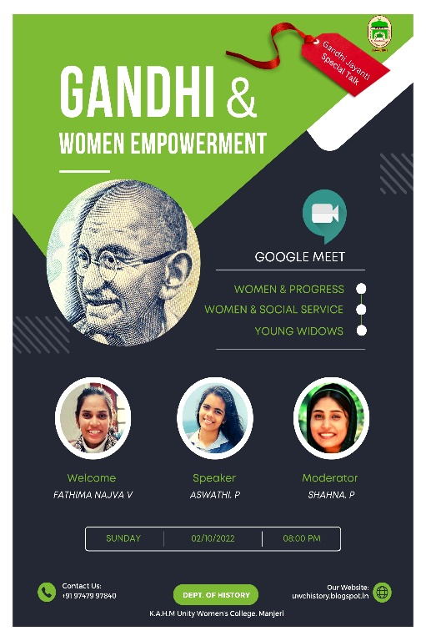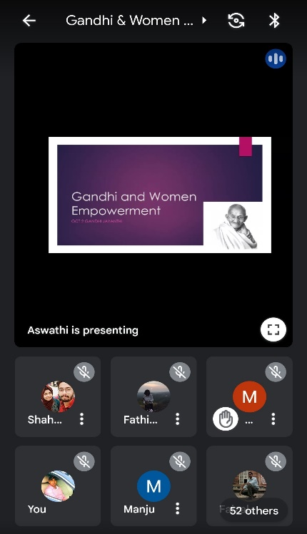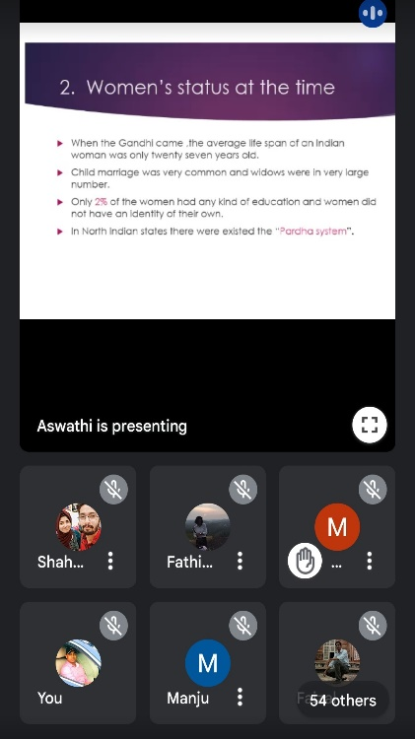

21. Annual Alumni Meet

Department of History organised Annual Alumni Meet on 8th October 2022. The Meet was inaugurated by Mr.Lukmanul Hakim, former department faculty who is currently working at Govt. Arts College Calicut as Associate Professor of History. More than hundred old students including the students from First Batch participated in the meeting. Head of the department of History, Mr. Shabeermon M presided over the get together. Department Faculty Mr. Faizal TK and Jaseena C also spoke on the occasion. Alumni also donated few books to the department Library. A new History Alumni committee was formed to coordinate the activities. Some of the Alumni also participated in the cultural programs held in the college auditorium.

YouTube Video of the get together can be accessed by following the link

https://youtu.be/SKbJdEOMa7k
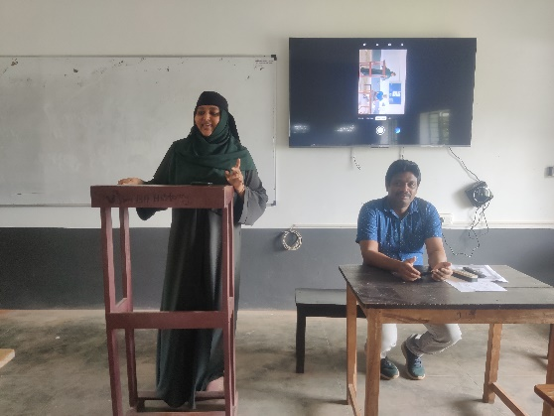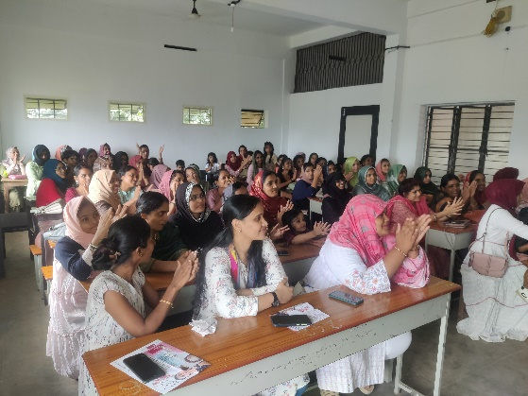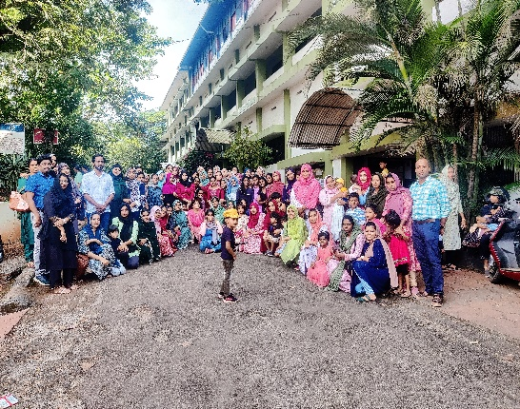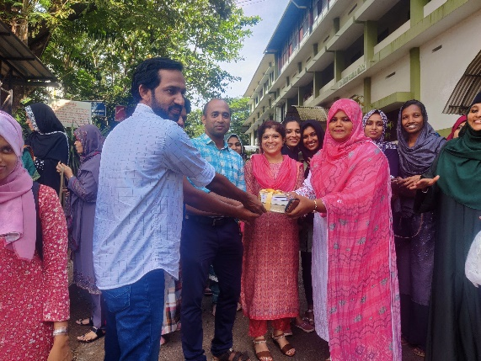

22. World Students Day (Association Programme)

Department of History observed World Students Day on 13th October 2022. A Documentary screening on the Life of Anne Frank, interaction with Dr. Abdul Rasheed, Assistant Professor, Department of History, Psmo College Tirurangadi and speech of Nashwa ( 2 BA History) were the highlight of the celebration. Rinshida (2 BA History) delivered the welcome speech in the and Arshida C rendered vote of thanks. All the department Faculty and students participated in the program that was held in the Association Hall.

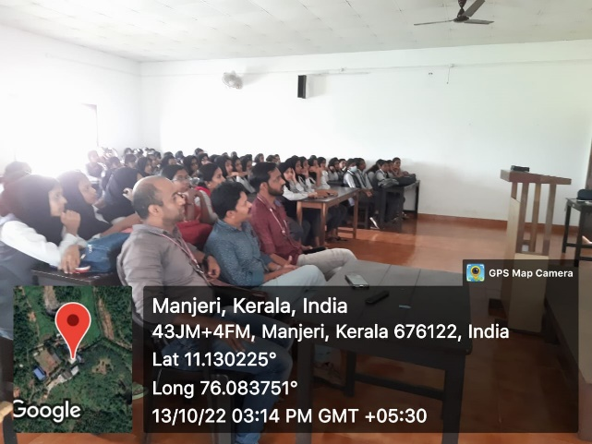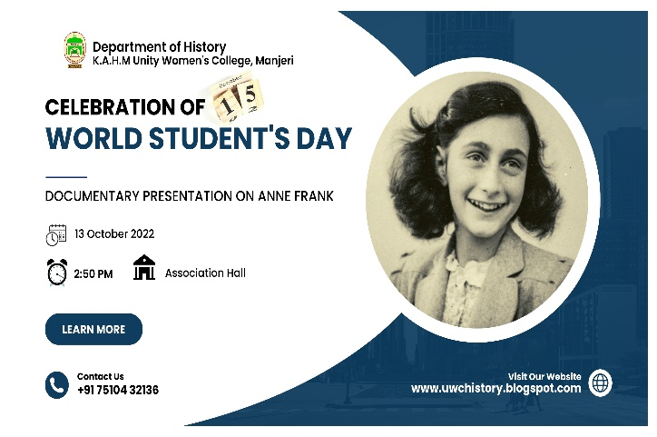

23. Fresher's Day 2022
On Tuesday 18th October 2022 Department of History organised Fresher's Day for the First year BA History students in the Association Hall. Mr. Shabeermon M, Head of the department, inaugurated the celebration which was followed by the felicitations of the teachers and various cultural programs organised by the final year and second year students. Dr. ShijI, Assistant Professor of History taken over the charge of History Association. A Fresher's Day special Cake was also cut and shared with students on the occasion. Nafla, Association Secretary Welcomed the gathering and Jumana Farhan rendered vote of thanks.
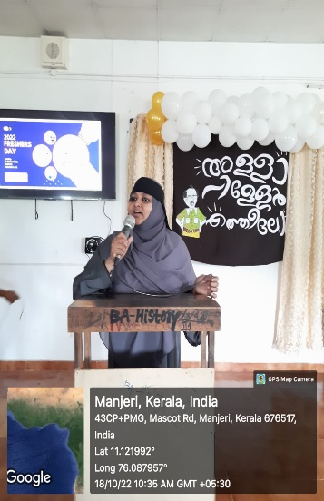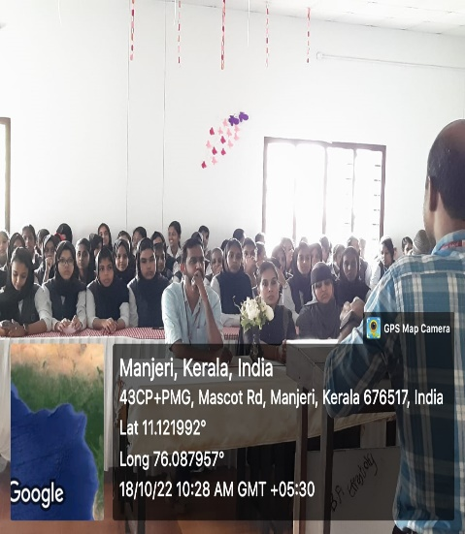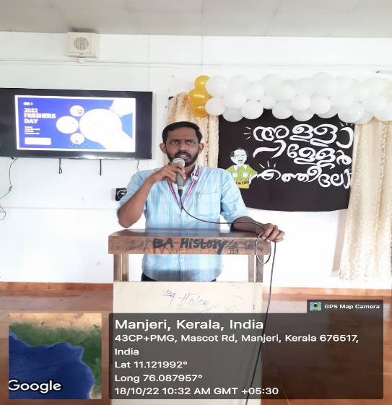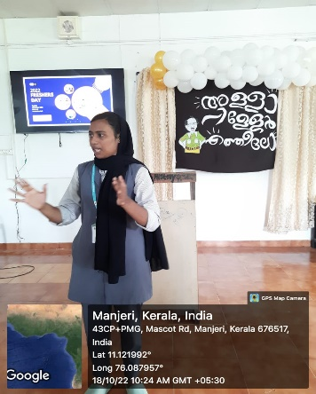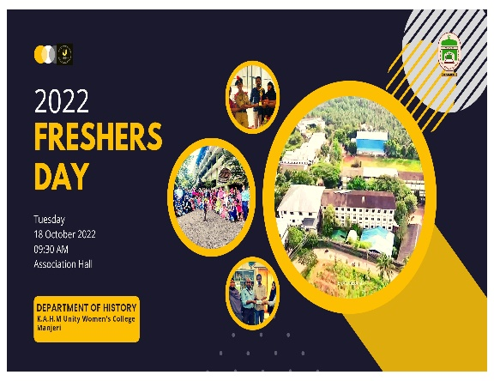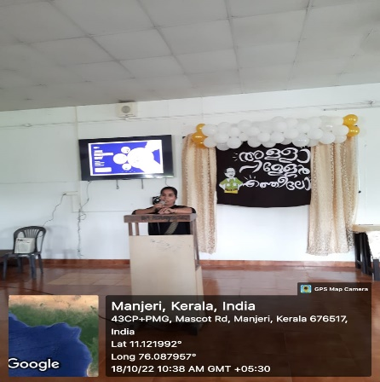
24. Cannibalism in Kerala (Association Programme)
At 2:50 p.m. on Thursday, October 20, 2022, the History Association conducted a discussion on the topic of "Cannibalism in Kerala" in the association Hall. Wajeeda Jebin (3rd year), Jumana Farhana (2nd year), and Fatima Tasni (1st year) spoke about the recent Human Sacrifice in Pathanamthitta district. The panellist discussed the possible reasons for human sacrifice, disasters caused by superstitions, and the consequences of human greed. Dr. Shiji Miss, Faisal Sir, and first, second, and third year history students participated in the session, which was chaired by Nafla TP. Fasna Sherin welcomed the audience, and Najva gave the vote of thanks.
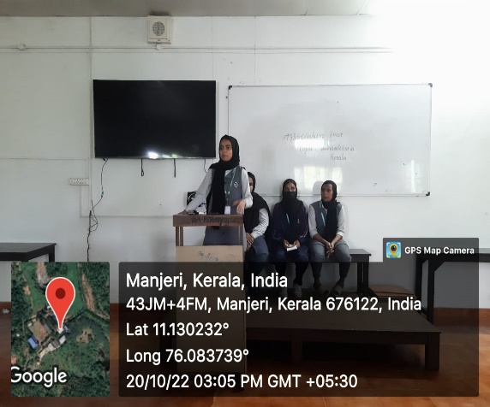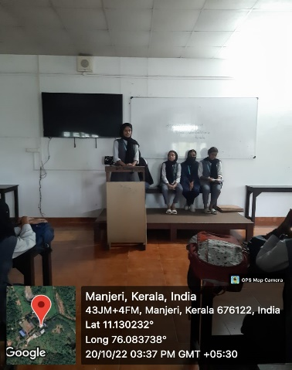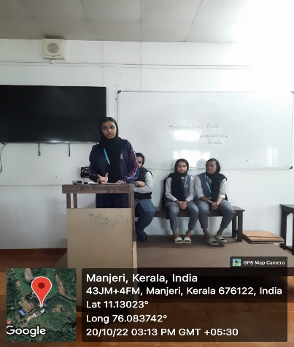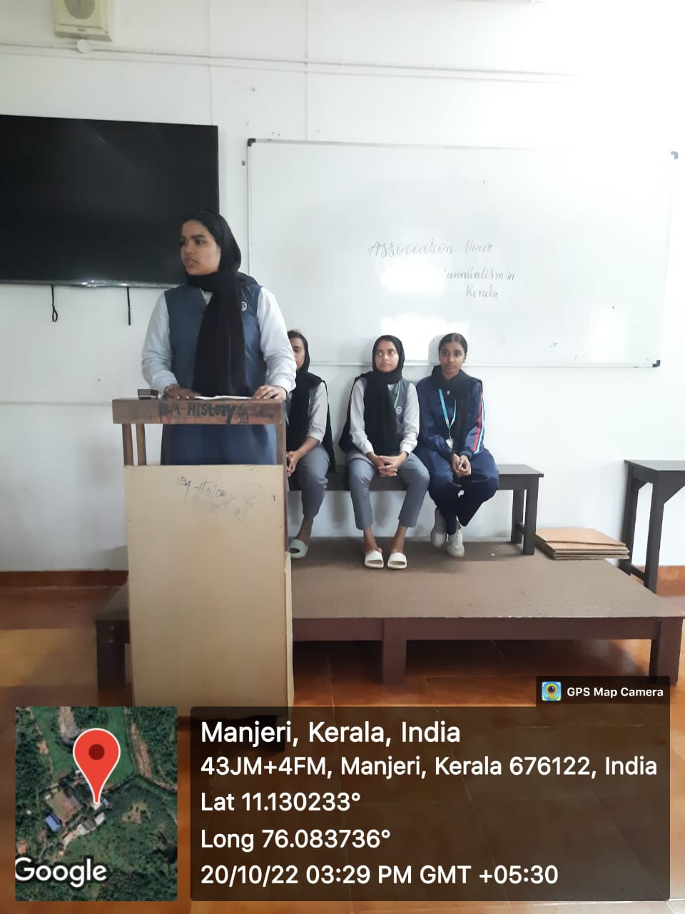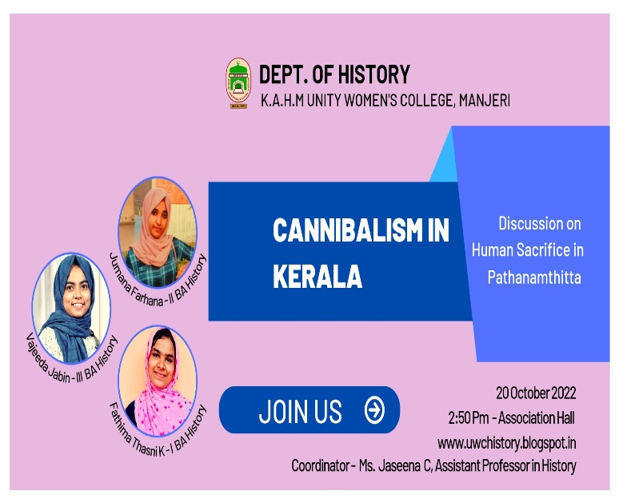

25. Debate on Gender Neutrality (Association Programme)

The History Association conducted a debate on the topic of "Gentral Neutrality" on Thursday, October 29, 2022. First-year BA History students Fatima Thasni, Nida Sherry, Renna, Shifna P, Aneena, and Hamna spoke in favour of gender neutrality, while Ansha, Ahla, NafLa, Mufeeda Maimuna, Farzana, and Najia spoke against it. Sabna, third-year history undergraduate student, moderated the discussion. The debate was surrounded by questions such as, "Is gender neutrality beneficial to women?" and Is gender neutrality a new face of patriarchy?. Rahana, first-year graduate student, gave the program's closing remarks. Association Teacher in Charge Dr. ShijI Mam, Shabeermon, Head of History Department, Assistant Professor Jaseena Miss, and other first, second, and third year graduate students also participated in the program.

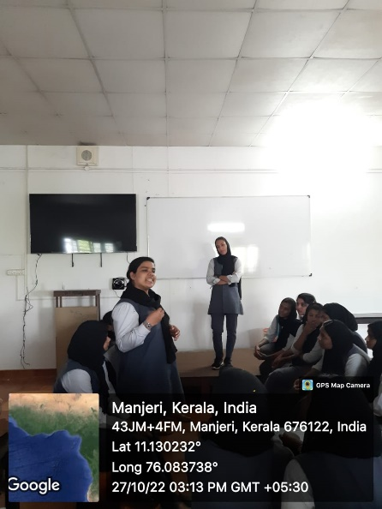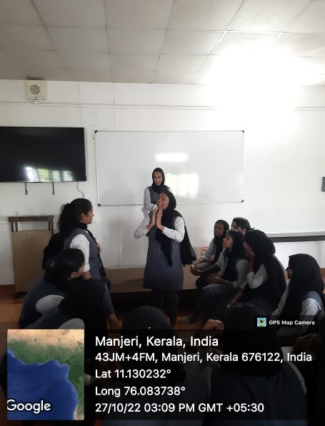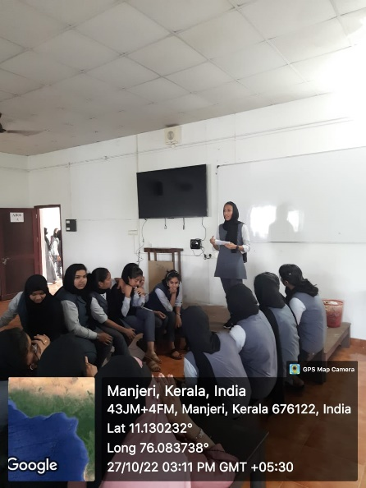

26. Charity Activity

Under the agies of Share and Care charity project, today (13-10-2022) Department of History handed over an amount of 10,000 rupees and grocery items for one month ( 2875 rupees) to the family of a student of our College who is residing in Manjeri. Student representatives of the Department of History; Shifna (1BA History), Huda ( II BA History ), Fathima Najva, Aswathi, Shahna (III BA History), Jaseena C ( Assistant Professor of History) and Kanniyan Muhammedali (NTS) visited the family and handed over the amount and grocery items. The money used for the charity activity was taken from the September month's (2022) collection of Share and Care project.

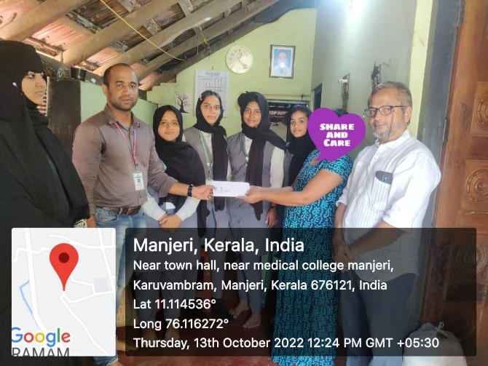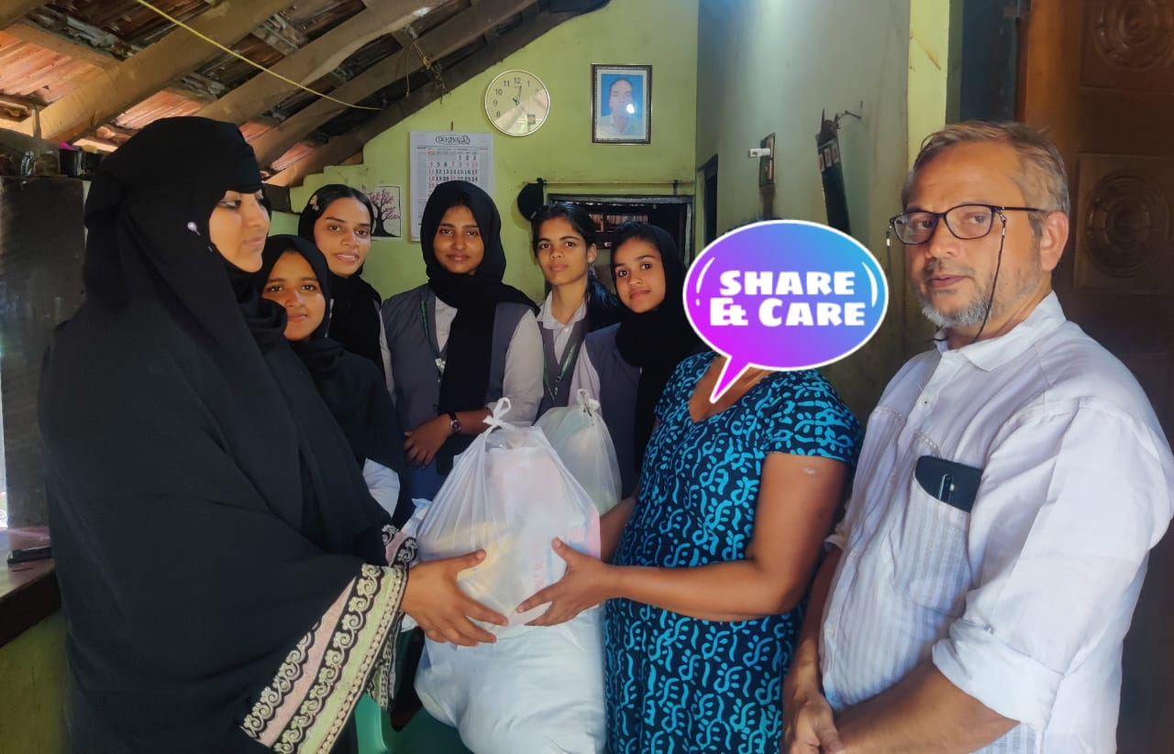

27. Charity Activity (Donation to Manjeri CH Center)
In the meeting of the share and care charity project held on 13th September 2022, it was decided to bear the expense of two patients undergoing Dialysis treatment at Manjeri CH Center every month (2500 rupees). As per this decision, today (13-10-2022) staff and students of the department of History handed over the amount to the Secretary of Manjeri CH Center, Mr. Kanniyan Muhammedali
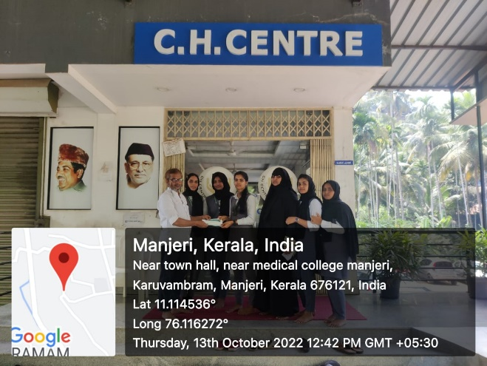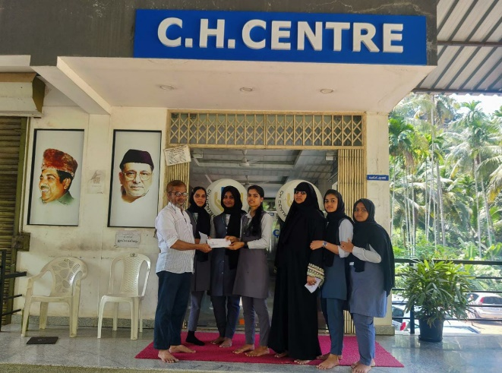
28. Talk on Language & Dress Code
On 23rd November 2022, a session on the topic “Language & Dress Code " was conducted by the Commerce Association, Unity Women's College Manjeri. The session was led by Shabeermon M, Assistant Professor of History, Unity Women's College Manjeri in the Association Hall.
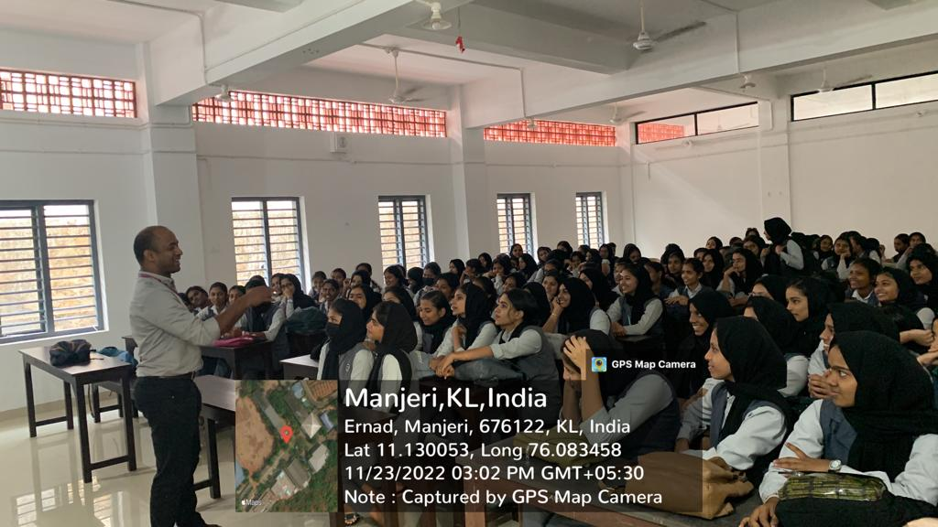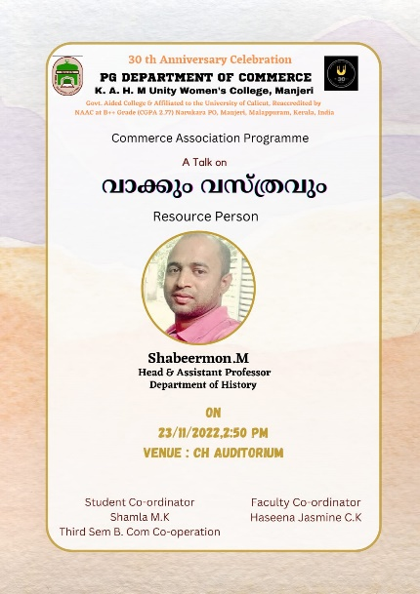

29. Talk on Contemporary Kerala (Association Program)
On Thursday 17 November 2022, History Association, K.A.H.M Unity Women's College Manjeri organised a talk on 'Contemporary Kerala' in the Association Hall. Irfana, a second year student of Chemistry Department delivered the talk.A hla, new Association Secretary moderated the session. Final year student, Nafla rendered vote of thanks. Students and staff of the department attended the program.
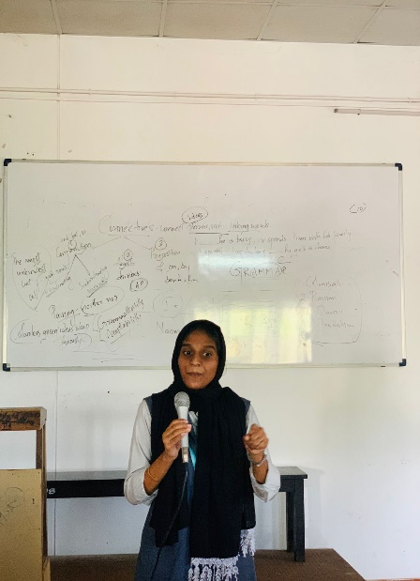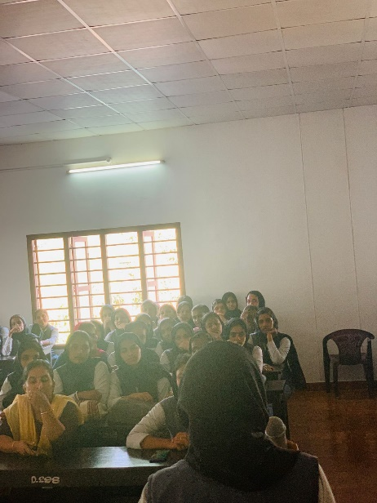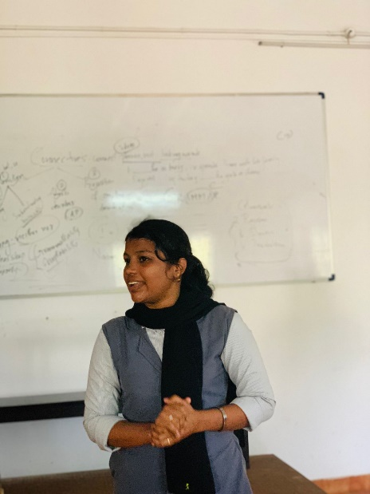

30. Celebration of Constitution Day
On Saturday 26 November 2022, an Online Celebration of Constitution Day and Fundamental Duties was jointly organized by the department of History and department of Political Science, Korambayil Ahamed Haji Memorial Unity Women's College. The Celebration, conducted on Google Meet platform was inaugurated by Mr. Abdul Rasheed CK, Assistant Professor, PG Department of History, Government College Malappuram. He delivered a lecture on the significance of Indian Constitution in the Contemporary Scenario. Principal Dr. Muhammed Basheer Ummathur addressed the gathering by focusing on the importance of celebrating the constitution day and fundamental duties. Mufeeda Maimuna P, II BA History and Banisha C, I BA History recited the Preamble to the Constitution and Fundamental Duties respectively. Aneesa minnath Beevi, Chairperson ( Elected ) offered felicitations. On the occasion, Assistant Professors of the department of History, Mr Faizal T K & Mis Jaseena C shared their thoughts on the importance of celebrating the constitution day at College level. Head of the Political Science department, Grace Mary Jose welcomed the gathering and student cordinator Nafla T P of II BA History proposed the vote of thanks. Shabeermon M, coordinator of the program anchored the online event.
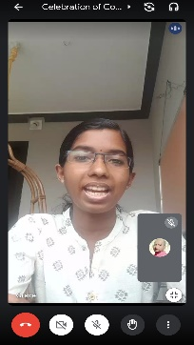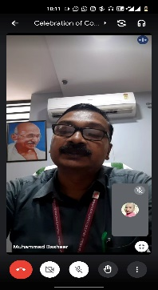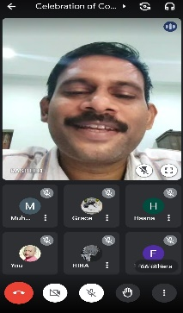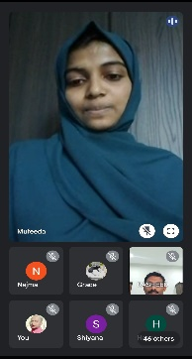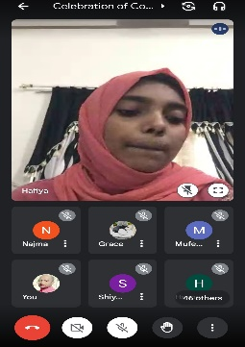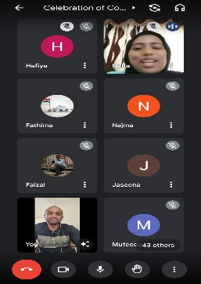

31. Alumni Lecture Series -3

The third presentation of the Alumni Lecture Series of the Department of History, K.A.H.M Unity Women's College Manjeri, was conducted on 29th November 2022. Former student of the department, Shahabas Banu CK (Batch: 2018-2021) interacted with the students about the Scope of History. The Presentation, held on Google Meet platform, was moderated by the Assistant Professor of History, Mr. Faizal TK. Lecture series coordinator Ms.Jaseena.c, Welcomed the gathering and the student coordinator Nafla T P rendered vote of thanks.

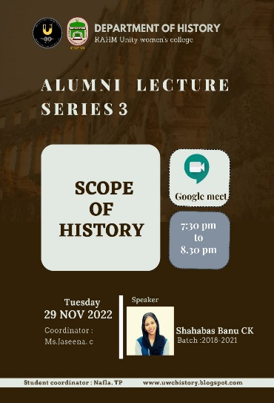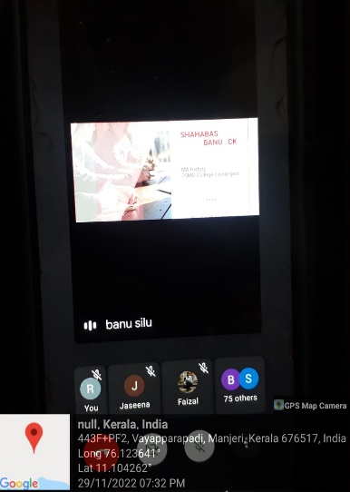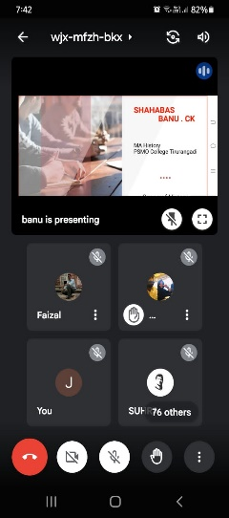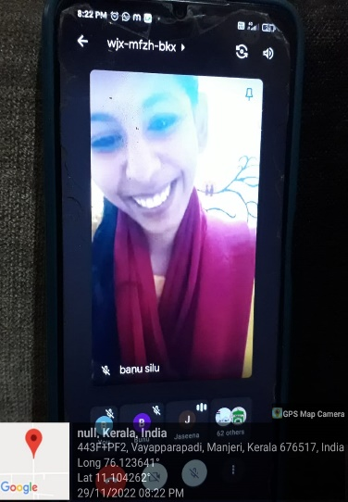

32. Alumni Lecture Series- Talk 4

On 23 Rd December 2022, department of History organized Talk number 4 of Alumni Lecture Series involving various old students of the department. Rasha Fathim P of 2019-2022 Batch, delivered an online talk on the topic "How to prepare net and central university entrance exame at higher education". The talk was moderated by Dr. SHIJI P, Assistant Professor of History. Staff and students of the department attended the talk that was conducted on Google meet platform at 7:30 pm.

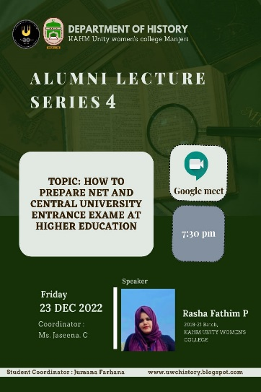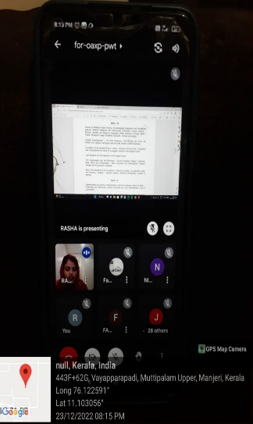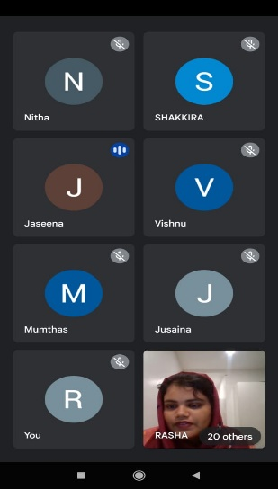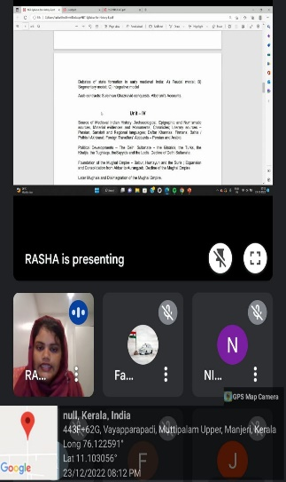

33. Speak for India Intercollegiate Debate Competition

Department of History hosted the 7th edition of Speak for India Intercollegiate Debate Competition jointly organized by the Mathrubhumi News daily and Federal Bank on 27 January 2023. 57 students from various colleges participated in the block Level Competitions held at College Auditorium. 5 students from the Unity Women's College Manjeri qualified for the District level competition scheduled to be held at Engineering College kuttipiram on 13th February 2023.

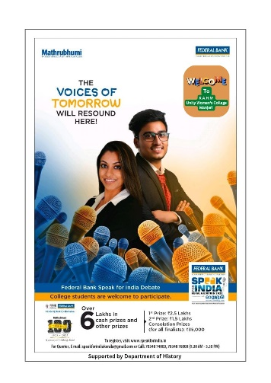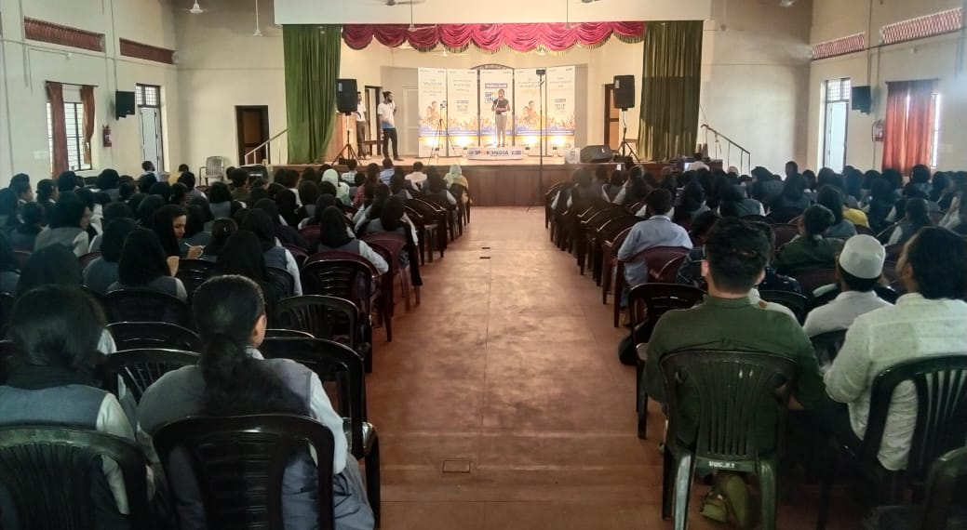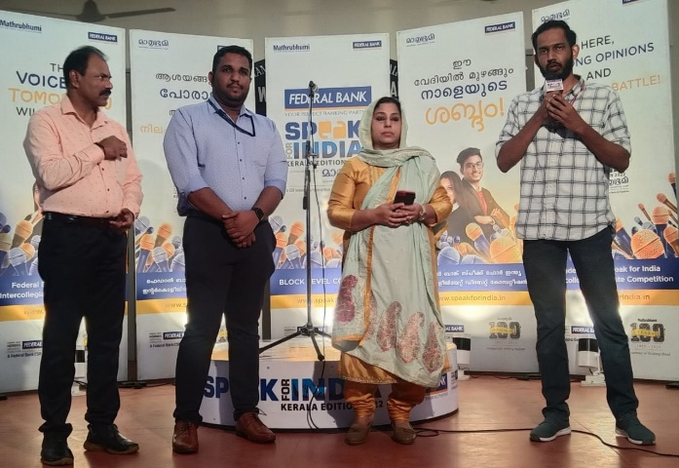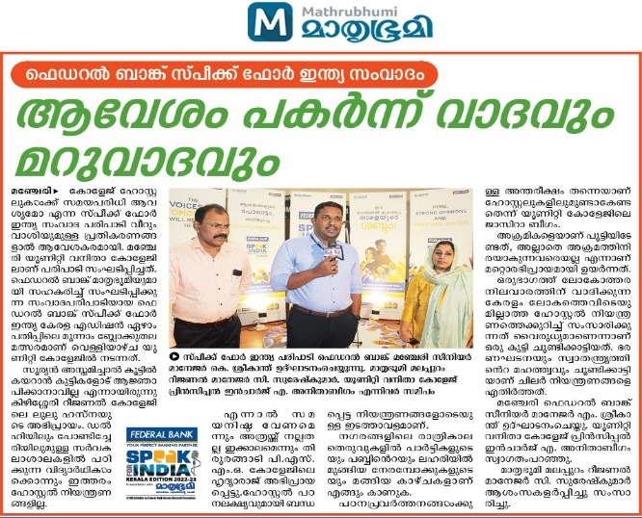

34. 101 St Martyrdom day of Variyan Kunnan
Malappuram Block Panchayat President Adv. Karat Abdurahman stated that it will be impossible to live if we disrespect our society's history. He was speaking at the 101st Martyrdom Commemoration of Wariyam Kunath Kunjahammad Haji, which was co-organized at Manjeri Unity Women's College on 20th January 2023 by the Wariyam Kunath Foundation of India and the History Department. Dr. Muhammad Basheer Ummatur, principal, presided the function. While delivering the keynote address, Dr. Sivadasan P, Professor, Calicut university, stated that what responsible people in India are doing today is distorting real history, making it absent, and rewriting history by including things that do not exist, and this trend will destroy our country. Warian Kunnath Kunjahammad Haji, he added, was a brave patriot who cherished patriotism, and the history of the country's freedom struggle cannot be told without mentioning Warian Kunnan. College manager Engineer O. Abdul Ali, Chairman Wariyamkunnath Foundation Mr. Alavi Kakkadan, IQAC Coordinator Dr. Shahina Mol AK, Staff Secretary Jasina C, Non-Teaching Representative Adam Tanari, College Union General Secretary Ashwati P, Foundation office bearers Mohan Isaac and Cheriappu Mankada all extended greetings. Mr. Shabeermon M, Head of History Department, welcomed everyone, and Mr. Faisal TK, Assistant Professor of History presented the vote of thanks.
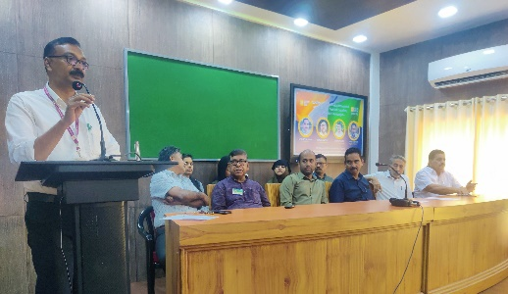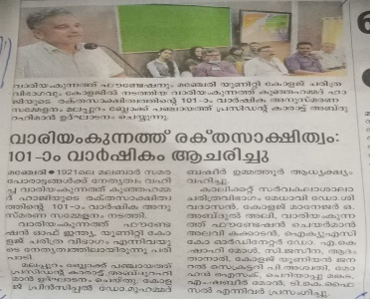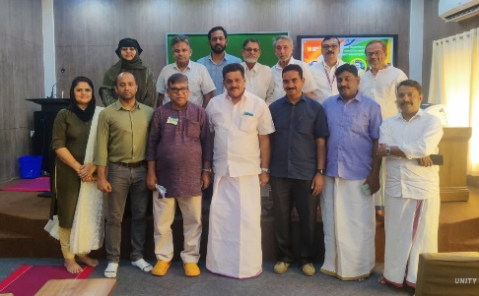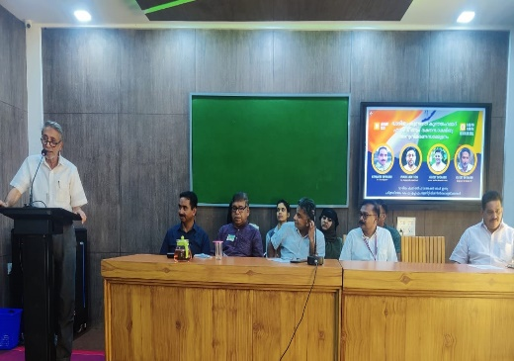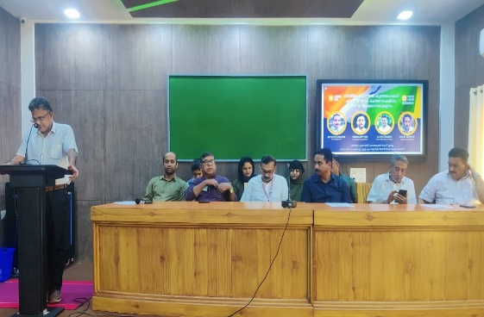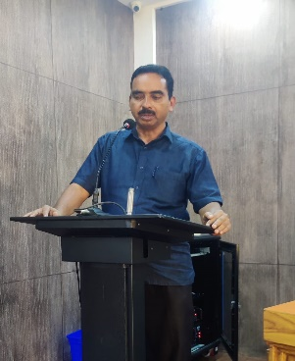
35. Compulsory Study Trip to North India
From 30th December 2022 to 08th January 2023, as part of the academic activity, Final year students and Teachers of the History Department conducted Study tour to Agra, Delhi and Manali. 35 students of the final year BA History and three teachers of the department participated in the compulsory Study tour.
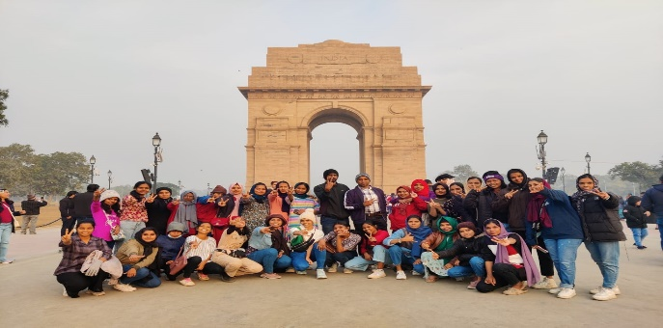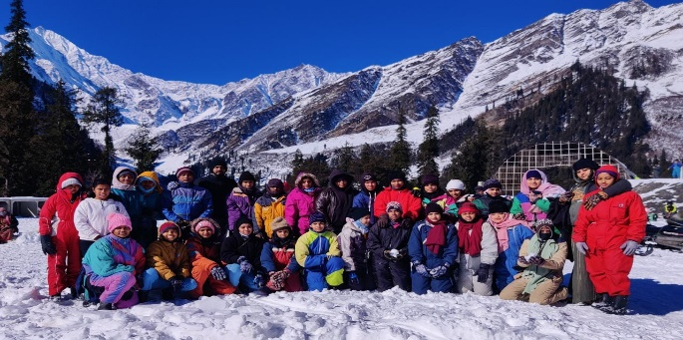
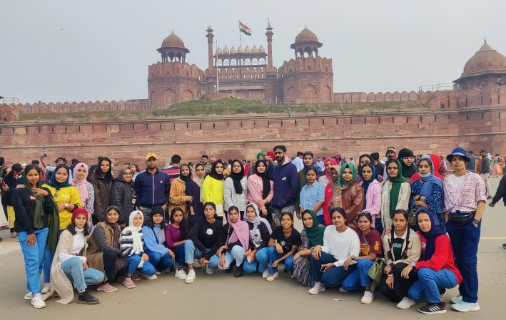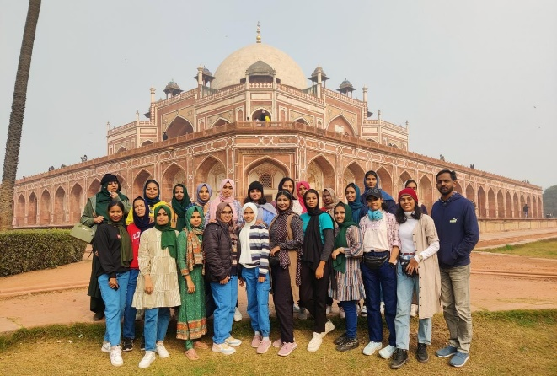

36. Observance of Martyers' Day

On the occasion of the Death Anniversary of Mahatma Gandhi, on 30 Jan 2023, Department of History observed Martyers' Day with 2 minute silence at College Level. All the Staff and students of the College took part in the day observance.

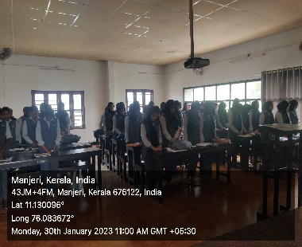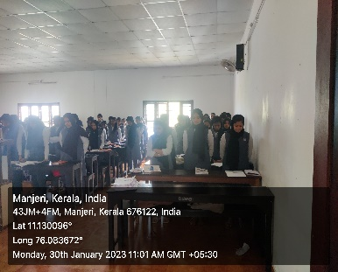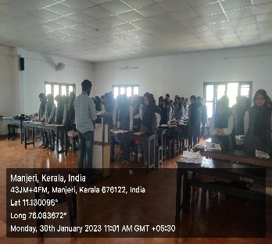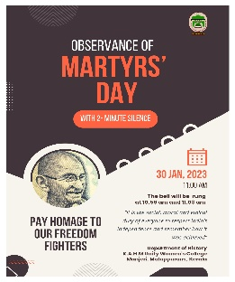

37. Talk on Writing Food History

On Friday 03rd February 2023, Shabeermon M, Head of the Department of History inaugurated History Association 2022-23 at Govt College Malappuram. He also presented a talk on "Writing Food History".

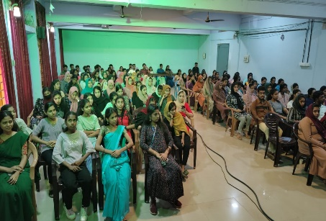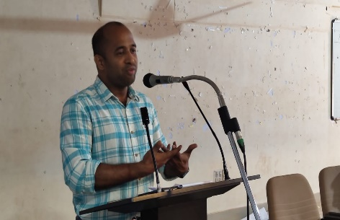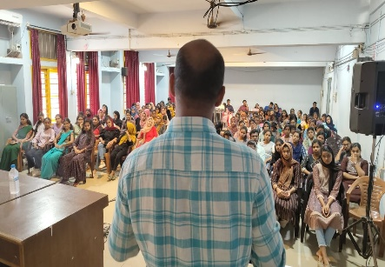

38. Sarvodaya Scholarship

Aswathy P of III Year BA History won the 44th Rank in the Sarvodaya Scholarship Examination conducted by Gramaniketan

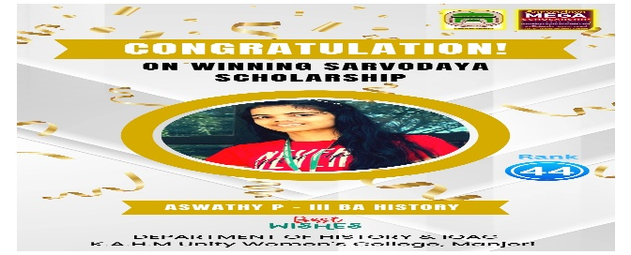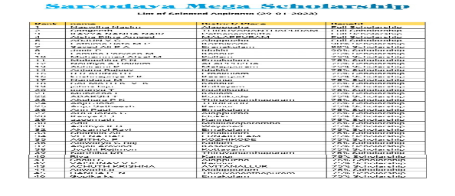

39. Experiential Learning Trip
Second semester B. A History students of the Department visited the historical site Edakkal Caves and 900kandi Eco-park, Wayanad on 11th February 2023. Students experienced the habitat and Stone Age carvings of Neolithic people and biological diversity of Wayanad.
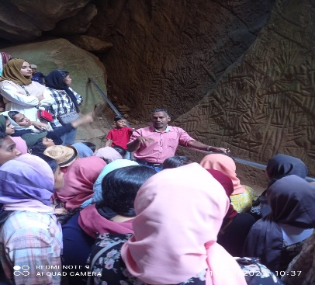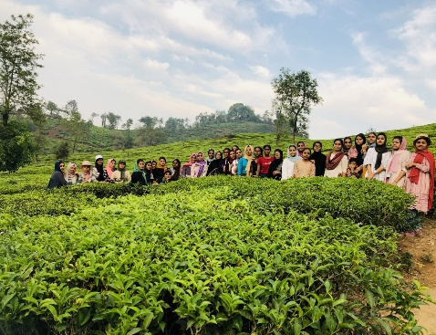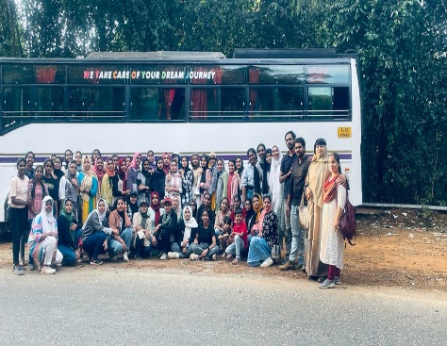
40. Extension Activity
On17-02-2023, 5 students from the department of history visited HMS Higher Secondary School Thurakkal with an aim to introduce the significance of History as an academic discipline. III year students and program coordinator Jaseena Miss interacted with the Plus One Humanities students of the school about the career opportunity in history.
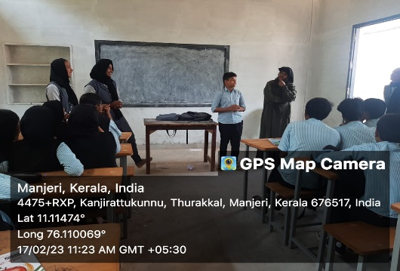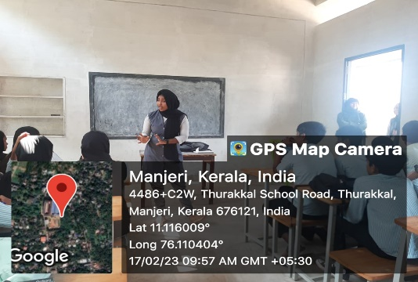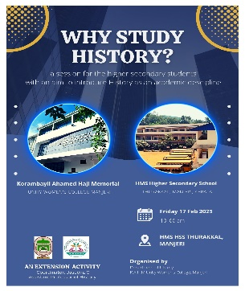
41. History Association 2022-23 Inauguration
On 27th February 2023, History Association was inaugurated by Dr. T Mohammed Ali, Head, Department of History, Farook College, Kozhikode. He also delivered a talk on Recent Developments in the Kerala Historiography. Head of the Department, Mr. Shabeermon M presided over the programme. Manager O Abdul Ali, Principal Dr. U Mohammed Basheer, Advo. Abdurahiman Karat, Adam Tanari, Jaseena C, Shiji P, Faizal Tk , Vajeeda Jabin, Ahla P etc spoke on the occasion.
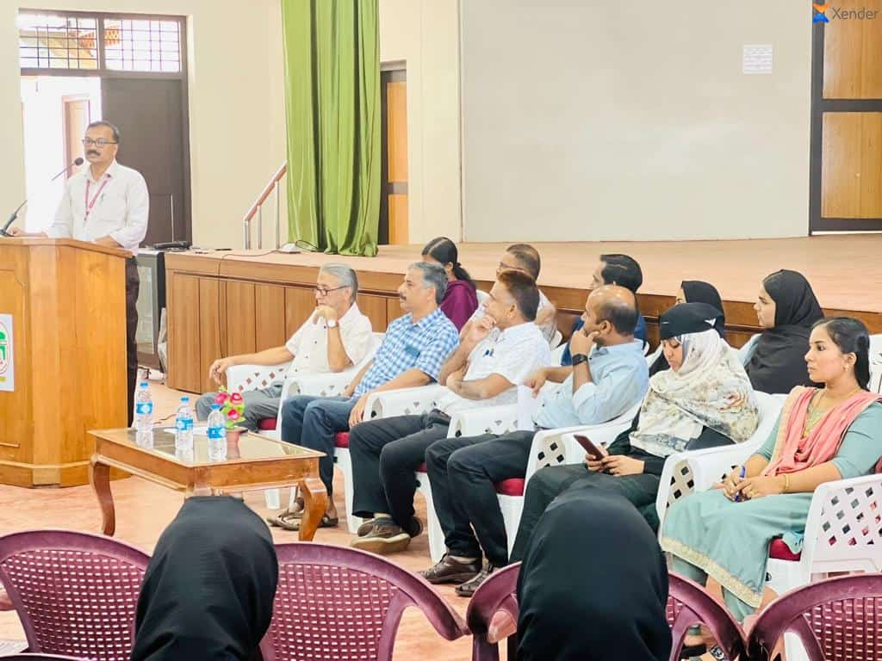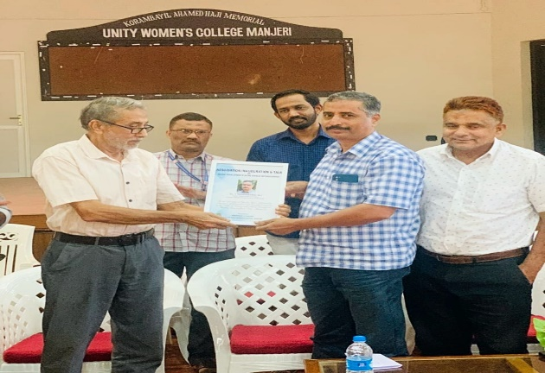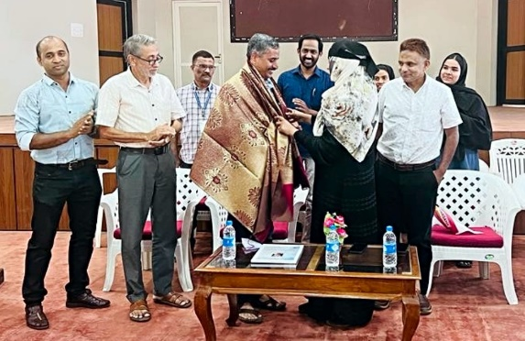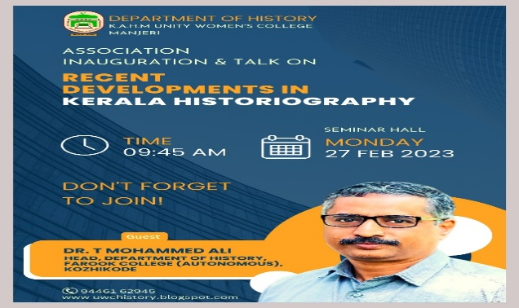
42. Madhura Malayalam (Association Programme)
On 23rd February 2023, the History Association organised a program called Madhura Malayalam in which the representatives from three history classes are asked to present a topic without using a single Malayalam word. Students from first year Tasni, Shifna and Vismaya and Najia and Jumana from the second year participated in the program. Ansha of second year BA History presided over the association program. Mufeedah, Shifa, Jaseera etc spoke on the occasion. Program Officer Miss Shiji, Head of History Department Shabir Sir, 1st year 2nd year V students participated in the program which ended with Henna's vote of thanks.
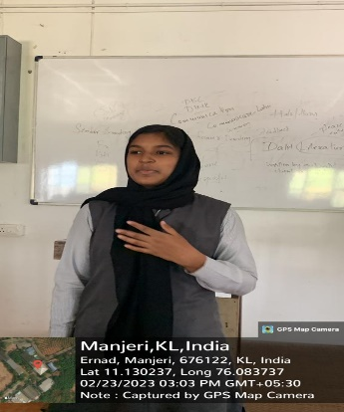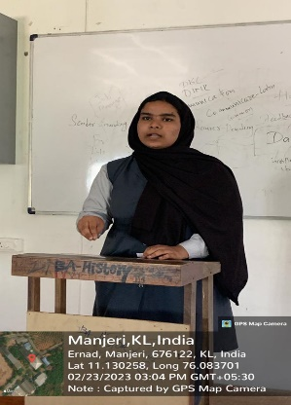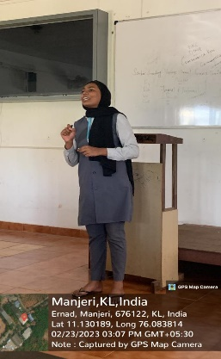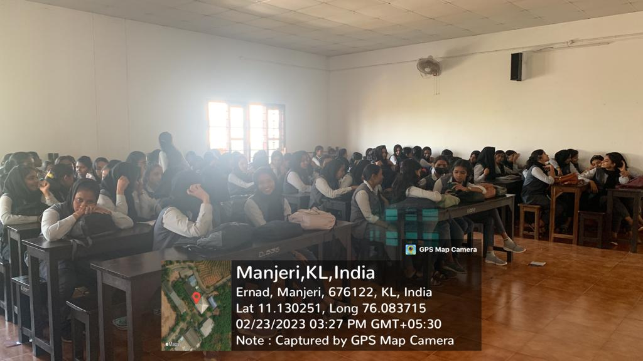

43. Why Study History?
The fifth talk of the Alumni Lecture Series was organized by the department on 28 February 2023. Shibna Jasmin, alumna of BA History 2016-19 Batch spoke on the importance of studying history. Coordinator Jaseena c moderated the session which was attended by the students and staff of the department. Ahla, Awsathy P and Sabeeha also spoke on the occasion.
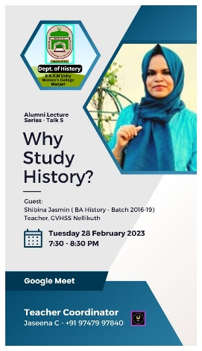
44. On 22nd Wednesday 2023, Shabeermon M, Head, Department of History delivered a talk on the topic “Good Personality for the Market” in the Association Programme organized by the Department of Computer Science, Unity Women’s College Manjeri.
45. State Level Media Seminar
Students and Staff of the Department of History actively participated in organizing the state level media seminar jointly hosted at Unity Women’s College by the Media Club and Manjeri Press Club.

