ANNUAL REPORT 2020-21
PG. DEPARTMENT OF ENGLISH
KAHM Unity Women’s College, Manjeri.

- Book Buddy- An event in connection with reading day to promote reading among faculty and students- 22 July 2020
As part of the State Reading Week Celebrations, the Department of English, KAHM Unity Women’s College conducted a book review event, titled Book Buddy on July 22, 2020. The faculty members of various teaching departments of KAHM Unity Women’s College, the Non-Teaching Staff members and students from the English and other departments participated and presented the reviews of book they have read. One pre requisite of the books to be reviewed is that it should be a recent publication published on or after 2018. The event was really an informative one when the books of various genres like fiction, poetry, drama, biography, other nonfiction categories like courtesy books and books about predictions of how our future life will be were reviewed. Apart from books in printed form, audio books, books in PDF format etc. were reviewed by teachers giving the students an idea about what books would be like in a paperless society. Mrs. Awasthi MP, the teacher-in-charge of the English Association delivered, the welcome note. Dr. Rajani R., the event co Ordinator introduced the books and the speakers. Miss Khadeeja Dilna, the English Association Secretary proposed the vote of thanks.

2—9. English Association - Activities 2020-21: (Inauguration 14 Jan 2021)
English Association at KAHM Unity Women’s College, Manjeri is a creative endeavour of the enthusiastic student community of English Department. The major focus of the platform is to function as a catalyst to shape the talents of the students towards perfection. Ms. Khadeeja Nidha of Third Semester BA English and Ms. Aswathi M.P., the faculty member of the department, are the coordinators of the year 2020-21. The Pandemic scenario troubled the Association activities initially as the team has to envisage new patterns and medium which fulfill the requirements of the programme in the changed context. Selecting Google Meet as the platform for the exchanges, forming a what’s app group of all the class leaders and teachers for this specific purpose and fixing it as a fortnightly event on alternate Wednesdays at 12.30 pm, the crisis was resolved. Starting with third semester BA English batch each class performed various programmes such as Book reviews, talks of contemporary relevance such as “Either side of Online Classes”, “New Education Policy”, Discrimination”. “Gadgets and Depression” etc., film reviews, and literary quizzes. Dr. Arya Gopi, the award-winning poet was invited for the formal inauguration of online Associations on 14 January 2021.

Ms. M.K.Vineetha, the faculty member of the department delivered a session on 07 October 2020 which the students felt as really beneficial to them. The most significant initiative of the Association is the programme organized on 31 March 2021 to honour the Alumni members who qualified NET/SET/Ph.D. Ms. Ashika, Ms. Nasila Jasmin, Ms. Abida Abdullah, Ms.Nilofer and Ms. Shabna K.P. received mementoes from Dr. M.Nasar, Pro-vice chancellor of Calicut University. Along with that the Association honoured Dr. Shahina Mol A.K. who is both a teaching faculty and Alumni and Dr. Krishna Sunder, a faculty member of the department for being awarded Ph.D. in the academic year. The programme motivated the student community of the department to aim high and achieve their goals. The student involvement in the programme enabled them to develop leadership skills along with showcasing their talents in the show.

No. | Date | Name of the event | No. of students participated
2 | 22/07/2020- Wednesday | Book Buddy | 85
3 | 05/08/2020-  Wednesday | Lockdown and Life: Student lectures | 82
4 | 26/08/2020-  Wednesday | World Literature: Quiz | 75
5 | 23/09/2020  Wednesday | Quiz on Literary figures | 89
6 | 02/10/2020  Friday | Gandhi Quiz | 87
7 | 07/10/2020  Saturday | Lecture on Life skills by M.K. Vineetha | 74
8 | 28/10/2020  Wednesday | Debate | 80
9 | 14/01/2021  Friday | Association Inauguration by Dr. Arya Gopi, Assistant Professor of English, Zamorin’s Guruvayurappan College and Celebrated Poet | 95
10 | 31/03/2021  Thursday | Merit Award Distribution | 78
English Association Events 2020-2021

11 . Project/ Dissertation Writing – National Workshop
The club has organized an Online Dissertation Management Workshop “Author It Yourself” for Degree and PG students of English Language and Literature on 26 August 2020. Dr. A.K. Shahina Mol, Head, Department of English handled the workshop and students from various colleges participated in the same

12 . Three-day International webinar on

“Perspective Matters: Unlearning Unicentrism in collaboration with KSHEC ( 14, 15, 16 Sep 2020)

The three-day international webinar on Perspective Matters: Unlearning Unicentrism organized by the Department of English, KAHM Unity Women’s College, Manjeri was inaugurated by Sayyid Munavvar Ali Shihab Thangal. Dr. Sabrina Lei, Italian author and director of Tawasul Centre for publishing, Research and Dialogue at Rome delivered the inaugural keynote on “Cultural Criticism, Social Structure and Identity.” Her lecture focused on the construction of power, cultural assimilation and the methods of resistance offered to the new social order imposed upon the Malayali community by the Colonial masters with reference to the first Malayalam novel Indulekha. The inaugural session was presided over by the Principal of the College, Dr. C. Saidalavi. Manager of the College Management Committee Er. O. Abdul Ali, Head of the Department Dr. Shahinamol A. K, Coordinator of the webinar Ms. Krishna Sunder, and the IQAC coordinator Dr. Annie Ninan spoke during the session.
Dr. Ravi A. Palat, Sociologist and Professor at Binghamton University, keynote speaker for the second session mentioned that Universities which are the centers of knowledge production has a big role in building and sustaining the cultural capital. Analyzing the history of university education across the world, he pointed out that modern Universities though promote multiculturalism are inclined to monetary benefits, which can be hazardous. He also pointed out that multidisciplinarity of modern education system proposed by NEP is blind to the marginal sectors like Dalit studies, Women Studies etc.
Dr Abdel Latif, writer and executive board member, Maqasid Institute of philosophy of law, Italy the keynote speaker for the first session of the second day spoke on identity politics, power politics, media politics and the role of public intellectuals in demystifying power by challenging xenophobia, radical nationalism and radical racism.
Ms. Ann Susan Aleyas, the plenary speaker from St Stephen’s College, Delhi focusing her lecture on twentieth century women’s writing in English commented that the essence of women’s writing in India is its polyphony . She added that women’s writing is caught in the politics of translation, and emphasized the need for looking at translation not only as a social, cultural, creative activity, but also as an ethical project.
Twelve papers were presented by students, research scholars, and teachers in the third day, 16 September in two sessions chaired by Dr. Betsy Paul C., Head and Research supervisor of the PG Department of English at St Aloysius College. Around 250 delegates from Kerala, Tamil Nadu, Telangana, Maharashtra, Chandigarh, Karnataka, Odisha, Delhi, Punjab, West Bengal and Dubai participated and presented papers in the various sessions of the webinar. The webinar was coordinated by Ms. Krishna Sunder and Ms. Poornima R, Assistant professors of the department.

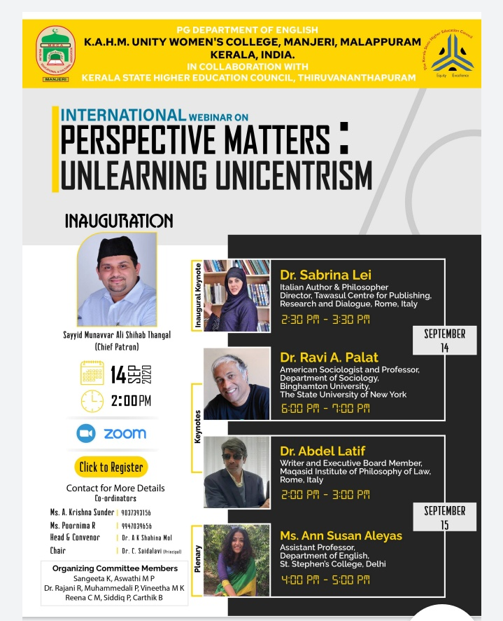

13- 20. Research Club Activities 2020-21

Research Club in collaboration with Department of History, K A H M Unity Women’s College has organized Online Inter/National Interdisciplinary Lecture Series on different topics. Dr. Meghan Sharma, Director, Centre for Women’s Studies, Maharaja Ganga Singh University, Rajastan, has delivered the inaugural lecture titled ‘The Real Story of Women Empowerment: Reflections from Indian History’ on 18th September 2020. The following lectures were held as a part of the series.

Online Interdisciplinary Lecture Series | Webinar-  The Real Story of Women Empowerment | National | Dr. Megna Sharma(Bikaner University, Rajasthan) | 18-09-2020 | Google Meet | 171 | Dept. of History & Research Club of English | Shabeermon & Muhammedali
“ | Webinar –EIA 2020 | “ | Abdul Shukur M  (Director, Garcinia Foundation) | 19-09-2020 | “ | 110 | “ | “
“ | Webinar- Poetry of the other: New Writing in Indian English | “ | Ajmal Khan AT, Asoka University, New Delhi | 26-09-2020 | “ | 97 | “ | “
“ | Webinar-Indian Partition: A Perspective from the North-East | “ | Dr. Binayak Dutta( NEHU, Shillong) | 03-10-2020 | “ | 132 | “ | “
“ | Webinar- Transnational football & its discontents | “ | Jushna Shahin ( Spain) | 10-10-20 | “ | 76 | “ | “
“ | Webinar- Reflections on the Question of Regional Identity in contemporary India | “ | Dr. Muhammed Afsal p (BITS, Pilani, Rajasthan) | 17-10-2020 | “ | 99 | “ | “
“ | Webinar- Styles of Imagining: Community & Political Solidarity | “ | Muhammad Shah  (Virginia, USA) | 24-10-2020 | “ |  | “ | “
“ | Webinar- Narrative in Performance & Folk Tradition | “ | Dr. Rajesh Komath  (M. G Unive;rsity, Kottayam) | 31-10-2020 | “ | 84 | “ | “
“ | Webinar- English Studies in English | “ | Dr. Sudeesh K, ICFAI Univrsity, Nagaland | 07-11-2020 | “ |  | “ | “

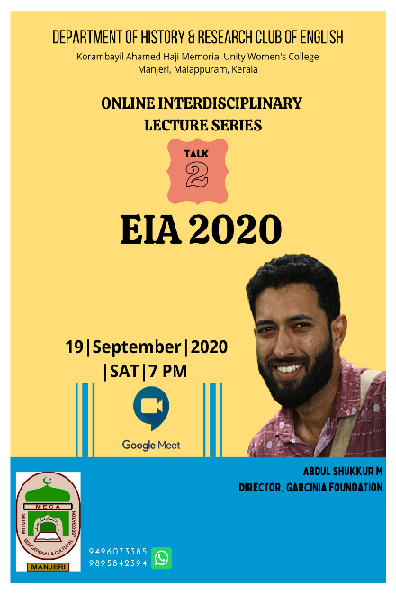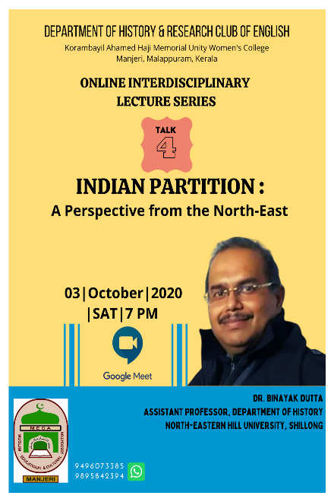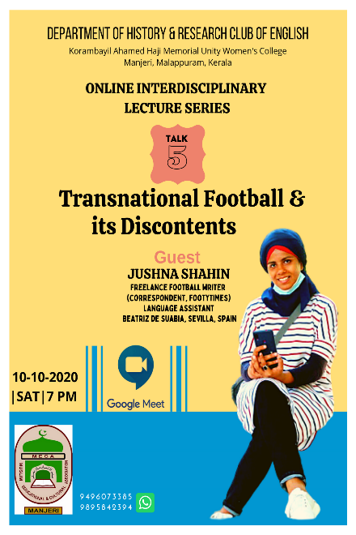
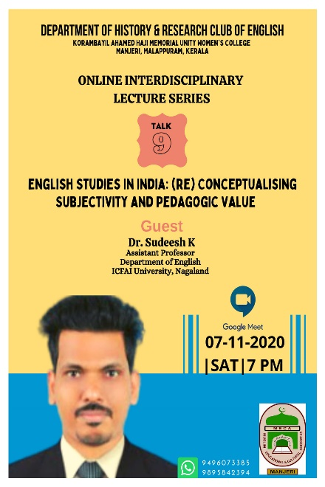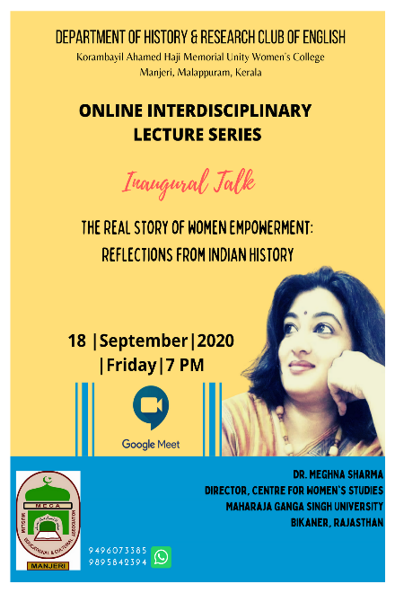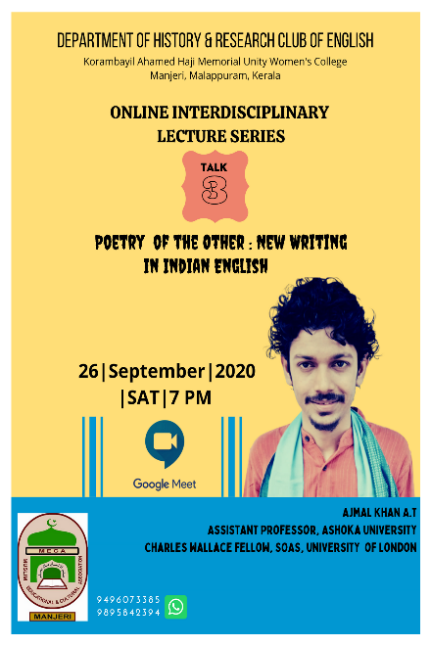
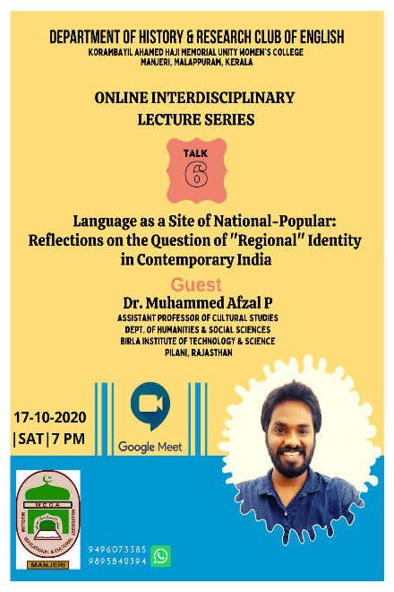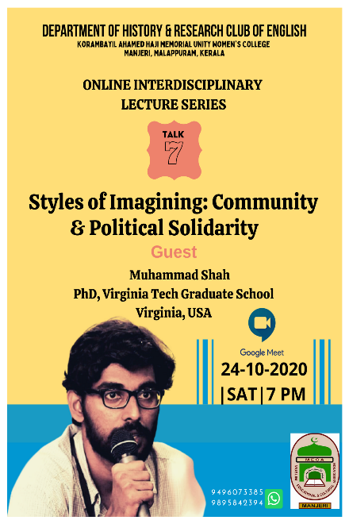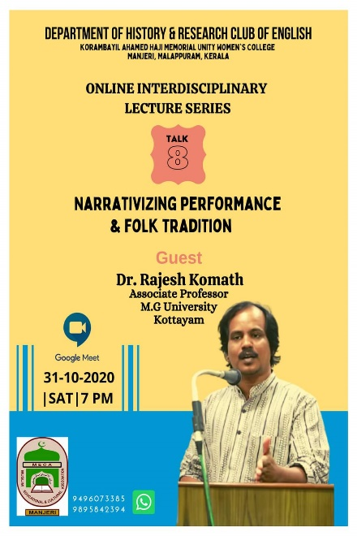

21. PG Seminar Club activities: The seminar club has been formed to polish and perfect the presentation skills and critical thinking of the students of MA English met every Tuesdays and Thursdays during the academic year 2020-21. Third Semester MA English students presented the papers in the club. Each presentation was evaluated by two of the faculty members. Google meet was the platform.

22. National Workshop on Sign Language- 30 Sep 2020
By joining hands with the Department of History, PG department of English organized a National Level webinar titled “Linguistic Minority & Sign Language Rights” on 30 September 2020. Nazaria T P, Media one Channel News Interpreter led the workshop that was hosted on Zoom platform. 56 participants from different parts of the country attended the workshop. Shabeermon, Head of History & shahina Mol A K , Head of English were the coordinators of the event

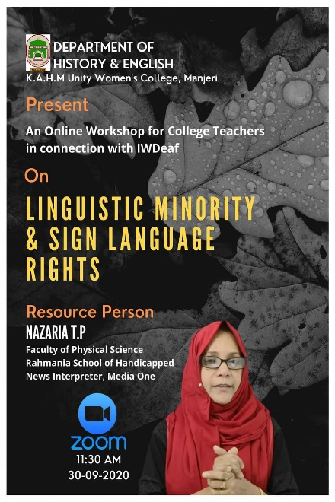

23. Unity Active – Capacity building programme for students and staff in relation with Fit India Movement 2020- 2 October 2020
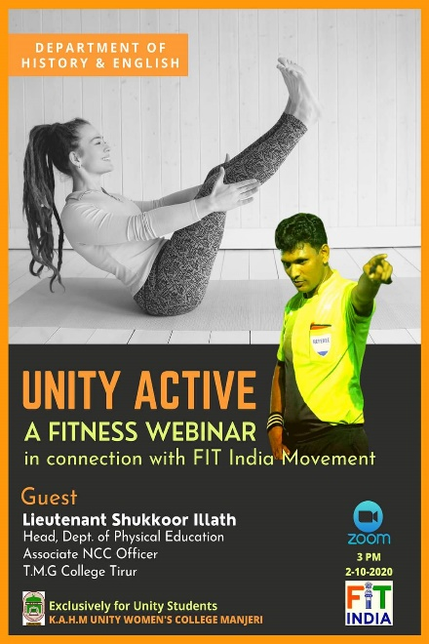
As part of Fit India Movement of the Govt. of India, a Webinar titled Unity Active was
organized jointly by the department of History and English on 2 October 2020. Lieutenant
Shukur Illath, Assistant Professor, Department of Physical Education, Govt. College Tirur was the Resource Person. The webinar was organized on Zoom platform in which 26
delegates attended. Shahinamol A K and Shabeermon Head of English and History respectively were the coordinators of the event.

24. Gandhi Jayanti Quiz- 2 October 2020
As part of Gandhi Jayanti Day observation, Department of History & Research Club of English jointly organized a Live Inter Departmental Online Quiz competition on google meet in which 9 students represented various departments at Unity. Mr. Lukmanul Hakim, Assistant Professor of History, Govt. Arts College, Calicut attended the event as Chief Guest. He spoke about the relevance of Gandhian Ideology in the Contemporary World. The event, under the coordinatorship of Shabeeron & Muhammedali, was organized on October 2, 2020.
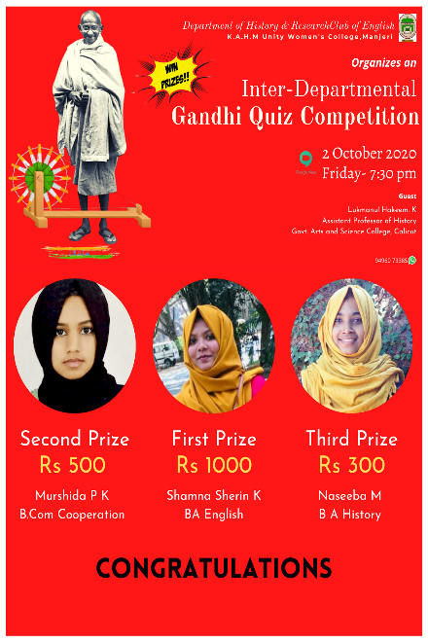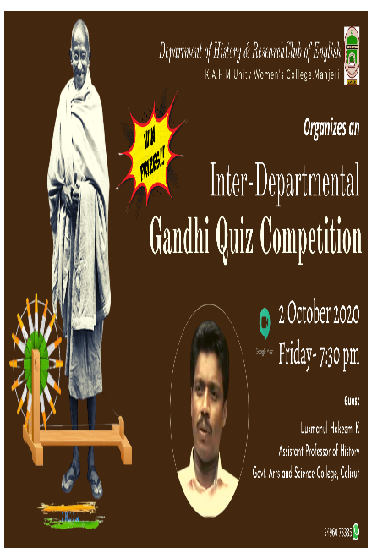

- Hridayaragam- 20 October 2020
An Online Music event titled Hridayaragam was organized jointly by the Department of History & Research Department of English on 20 October 2020 in which Singer Deepthi Madavan joined and spent around one hour with the audience by singing songs and sharing her musical experience. The event, organized on google meet, was attended by 99 participants. Muhammedali and shabeermon were the coordinators of the event.

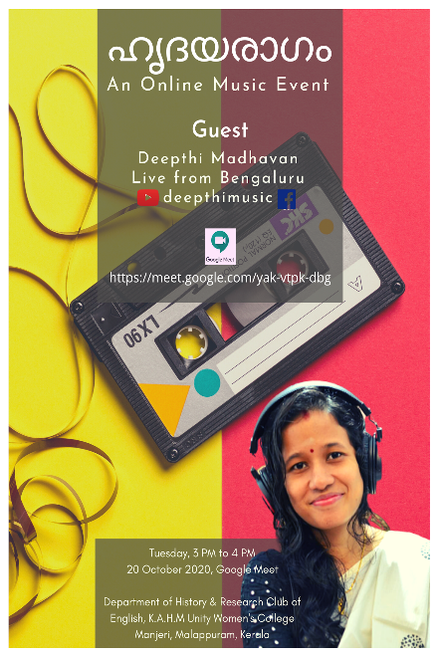

- Elocution Competition- 2 November 2020

An Elocution competition on the topic Kerala Culture: Heritage & Relevance was conducted on 02 November 2020. 6 students representing from various departments participated in the competition. This event was jointly organized by Department of History & English on google meet platform. Shabeermon & Shahina Mol were the coordinators of the event.

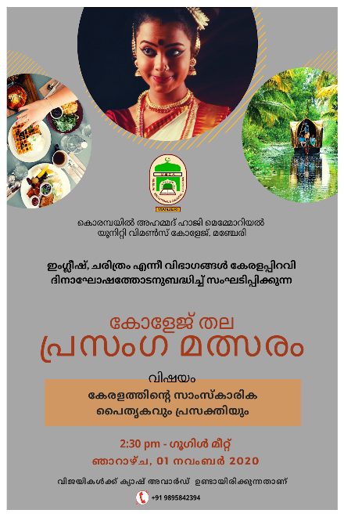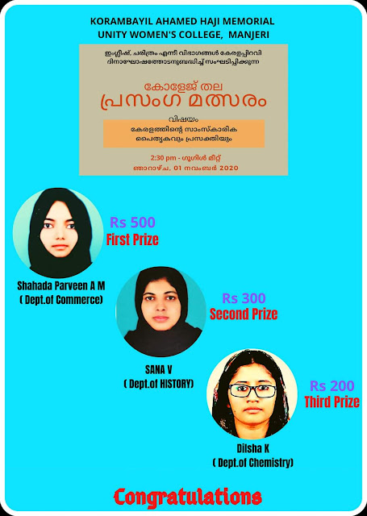

- UG and PG bridge course:

UG and PG department level bridge courses were organized for the freshers on the topic Learning Literature Today and Why English Language and Literature? respectively on 4 November 2020 and 23 November 2020. All the faculty members and the HOD interacted with students The session was followed by cultural activities and feedback by students.

- Campus to Career: Landing your Dream Job- Interaction with successful Alumnae of Department of English

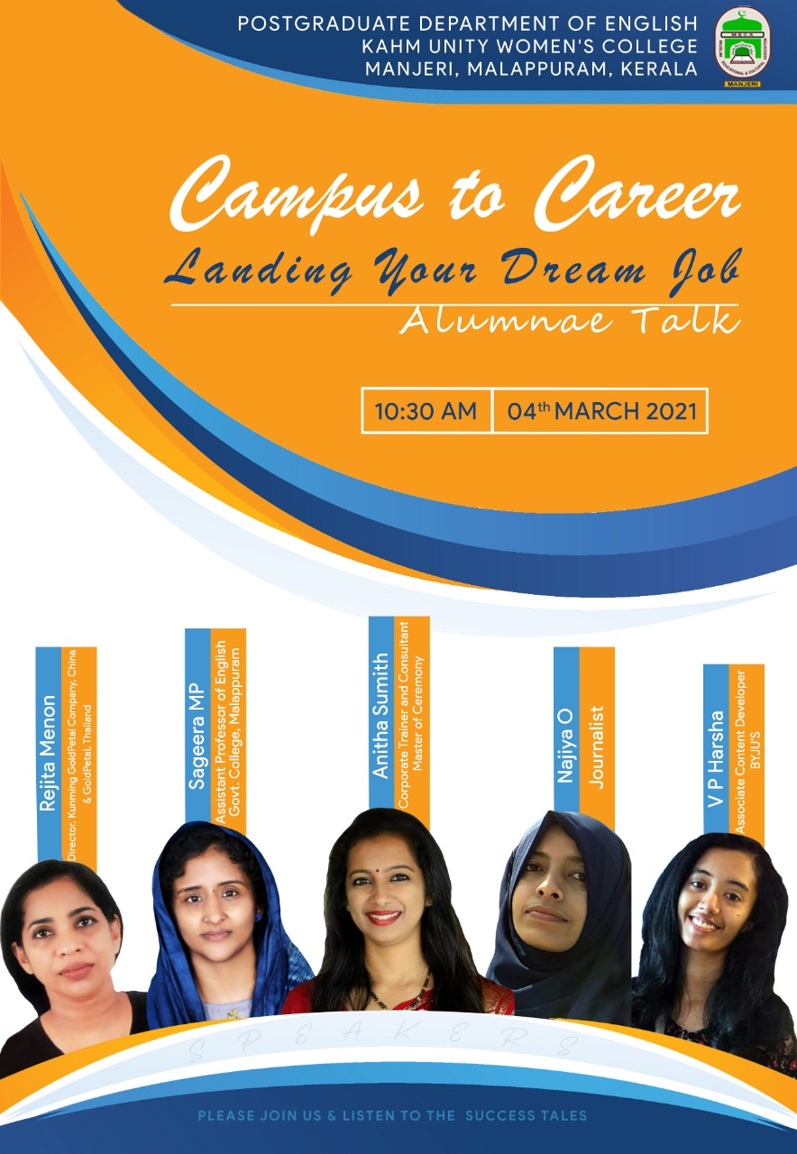The Postgraduate Department of English, KAHM Unity Women’s College has organized an Online Alumnae Talk Campus to Career: Landing Your Dream Job on 4th March 2021. The invited panelists, who proved their mettle in diverse careers, were the former students of English Department. Mrs. Rejita Menon, Director, Kunming Gold Petal Company, China and Thailand, Mrs. Sageera, Assistant Professor of English, Govt. College, Malappuram, Mrs. Anitha Sumit, Corporate Trainer and Consultant, Mrs. Najiya O., Freelance Journalist, and Mrs. V P Harsha, Associate Content Developer, BYJUS, were the panelists. The speakers have shared their stories of building up a career in their respective fields and the struggles and joys they have had in their life while achieving their dreams. The talk was followed by an interaction with the audience. Mrs. Athira Krishnadas of First Semester M A English and Dr. A K Shanina Mol, Head, Department of English have delivered welcome note and presidential address in the programme. Mrs. Nafiya Farsana of B A English delivered vote of thanks.
29. Yaara 2021 and Annual Department Alumnae Meet- 13 February 2021
UCCA, alumnae of K A H M Unity Women’s College, has organized its annual get together YAARA 2021 on 13th February 2021. As a part of the event, English department has convened its departmental meeting of the alumnae and 38 members attended the same. The meeting has deliberated on the future plans of the Department Alumnae and decided to start new initiatives.

30. COMMUNITY OUTREACH PROGRAMME- 26 March 2021

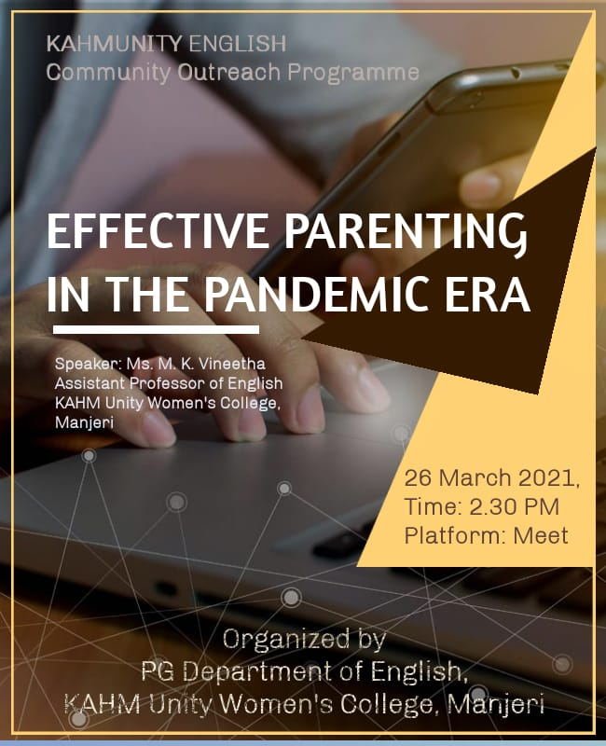

An online session on 'Effective Parenting in the Pandemic Era' was given to the parents of the first year Under Graduate students of the college with the motto of equipping parents to better guide their children during the pandemic, and to keep them aware of the frustrations and difficulties their children face owing to social distancing and online classes. The Principal of the college Dr. C.Saidalavi inaugurated the event. The session was handled by Ms. M. K. Vineetha, Assistant Professor of English. The event was held on 26 March 2021 through Google meet. Around 40 parents participated in the event. The session was highly interactive. Dr. A. K Shahina Mol, Head of the Department also addressed the gathering . The coordinator of the event Ms. Sangeeta K welcomed the gathering, and Ms. Safeeda of VI Sem BA English delivered the thanks note.

31. Korambayil Ahmed Haji Memorial National Dissertation Awards 2019-21

The open defence for best Dissertation Awards was conducted on 5/10/2020 on Zoom. The honorable jury consisted of Dr. Abadul Latheef V. Head, PG Dept of English Kondotty, Govt. College Vilayil and Dr. Raheena KK, Assistant Professor of English, Govt. Arts and Science College, Mankada. The first prize was bagged by Malavika K. Nambiar of Govt. Brennen College, Thalassery, Kannur. Second prize was awarded to Archana Vinod. Jawaharlal Nehru University, New Delhi and the third place was scored by Anish T. Babu Christian College, Chengannur. The programme was inaugurated by Dr. C Saidalavi. Principal, KAHM Unity Women’s College. Reena C M, Assistant Professor coordinated the programme. DA presentation ceremony was held on 30 March 2021. Dr Nasar, Pro V C of University of Calicut was the chief guest. Dr C saidalavi principal, Dr Muhammedali Korambayil , the patron of the event, Engineer O Abdul Ali, manger, Dr Shahina Mol A K, Head of English and Ms Reena C M , coordinator of the event talked at the occasion. Two members of Department of English, Dr Shahina Mol A K and Dr A Krishna Sunder , were also honoured for securing their Phd .

